Properties of WMAP cross-sections in the field of the RATAN-600 survey

© M.L. Khabibullina ^{1,2}, O.V. Verkhodanov ^{1,3}, Yu.N. Parijskij ^{1,4}

¹Special Astrophysical Observatory of RAS, Nizhnij Arkhyz, Russia
²Email: rita@sao.ru
³Email: vo@sao.ru
⁴Email: par@sao.ru

Abstract: One-dimensional sections of WMAP maps – ILC and background components (synchrotron, free-free radiation and dust emission) are investigated and their correlation properties on various angular scales are analyzed. Sections of the ILC map are found to correlate significantly with the maps of Galactic background components at the δ=41° declination of RATAN-600 survey. The confidence level of the correlations found is estimated by analyzing random realizations of the Gaussian process that describes the microwave background. A method for identifying correlated intervals from maps on the sphere as a function of angular scale is proposed. This method can be used to search for non-Gaussian features (spots) found in the distribution of microwave background and radio sources in the same coordinate areas. The approach described can be used to search for such non-Gaussian sources in observational programs performed on RATAN-600 radio telescope.

1. Introduction

The WMAP (Wilkinson Micro-wave Anisotropy Probe) space mission is dedicated to the study of cosmic microwave background (CMB). The WMAP satellite orbits around Lagrangian point L2 and measures the distribution of the temperature of microwave background on the celestial sphere. By now, the WMAP team has made available for the astronomical community the initial data and the results of the annual and three-year cycles of CMB temperature measurements [1, 2, 3, 4, 5]. To reconstruct the CMB signal from multifrequency observations, the above authors used the method of Internal Linear Combination method (ILC) of background components to obtain the map of background radiation, which is also referred to as the ILC map and which is used to analyze low harmonics with multipole numbers ℓ ≤ 100. The ILC map was constructed using the data obtained in five observational channels: 23 GHz (the K band), 33 GHz (the Ka band), 41 GHz (the Q band), 61 GHz (the V band), and 94 GHz (the W band).
In their papers dedicated to the analysis of the ILC map and of the signal statistics in this map a number of authors [6, 7, 8] pointed out that there is serious evidence indicating that the residual contribution of background components should be present on various angular scales on the map considered and that this very contribution is responsible for the observed deviation from Gaussian distribution. The contribution in question may also show up in the form of earlier found relation between the cleaned map of microwave background and Galactic emission components in the quadrupole [9, 10, 11]. However, the ILC map is the only cosmic microwave background map with a resolution of ℓ ≤ 100, and it is reconstructed from observations made in five frequency intervals on the entire celestial sphere. The maps of background components (synchrotron, free-free, and dust emission) for all the bands observed obtained via decomposition are freely available at the WMAP mission site (http://lambda.gsfc.nasa.gov).
The ILC map can be used to analyze the properties of the microwave background distribution on large angular scales and, in particular, to study the properties of microwave radiation at the declination of the RZF (RATAN-600 Zenith Field) survey performed at the radio telescope RATAN-600 (δ ~ 41°) [12]. This survey involves the study of both the sky brightness distribution at centimeter wavelengths and statistical properties of the radio sources [13].
Moreover, it is also of interest to see whether the background components show up in one-dimensional sections of the ILC map and (if they do) what is their level of statistical significance does this happen. Such a study will make it possible to assess the scope of applicability of the method of the decomposition of components by analyzing one-dimensional data vectors. The domain of the RZF survey in Galactic coordinates is shown by the narrow white strip in the map of synchrotron emission (Fig. 1).
In this contribution, following the paper [14] we analyze in the one-dimensional sections of the RZF survey the correlation properties of the CMB maps and maps of radiation components (synchrotron, free-free, and dust emission) obtained by the WMAP team. We also compare these sections to the simulated data generated by random Gaussian fields on the entire sky sphere in terms of the ΛCDM cosmological model in order to assess the level of statistical significance and admissible variations of the correlation coefficients.
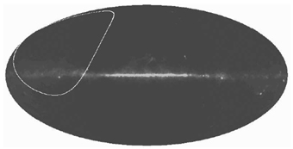

Fig.1. Domain of the RZF survey (the white ring strip) on the map of synchrotron radiation in Galactic coordinates.

2. Cross-correlation of one-dimensional sections

To study the properties of the cosmic-microwave background, we use the data for synchrotron and dust radiation in the bands where the corresponding radiation provides the maximum contribution, namely: the K- and W-channels for the synchrotron and dust emission, respectively. We analyzed the contribution of free-free radiation using the corresponding V-band maps.
We use the standard method to compute the correlation coefficients kt for one-dimensional sections:

,

where is i-th element of the one-dimensional section of the ILC map written as the array for the given coordinate interval t; is a similar quantity where vector is based on the map of the background component instead of the ILC map; and are the average values of the data arrays of the sections of the ILC maps and of the background component, respectively and а and are their dispersions.
We analyze the correlated signal on 6-minute and 1-hour right-ascension bins at the declination of the RFZ survey, δ = 41° (Fig.1). We chose the bin sizes based on the durations of point-source observing sets and the durations of the surveys. Figure 2 shows the corresponding correlation coefficients computed for the sections of the ILC maps, dust radiation, free-free and synchrotron radiation for 1-hour bins. Figure 3 shows the similar coefficients for 6-minute bins. It is evident from the figures that the sections of ILC maps exhibit significant correlations and anticorrelations with the maps of Galactic background components, i.e., one-dimensional scans extracted from the ILC map contain a residual signal due to other background radiation components: synchrotron, dust, and free-free emission. To determine the significance level of the correlations found, we simulated 100 realizations of random Gaussian field in terms of the ΛCDM cosmological model. Our choice of the number of realizations of the Gaussian process is rather arbitrary, although even the first estimates based on 40 and 50 models showed that the variations of the correlation coefficient remains virtually unchanged with increasing number of models. We nevertheless doubled the number of realizations to assess the admissible level of variations. We then computed for the maps obtained the corresponding one-dimensional sections in the same coordinates as in the case of the ILC map, and similarly computed the correlations with background component maps. We determined the admissible domain of variations of the random quantity to range approximately from -2/3 to 2/3 of the variations of the coefficients for random data. This interval is shown in gray in Figs.3 and 4. Fig.4 shows examples of sections of domains located in and above the Galactic plane.

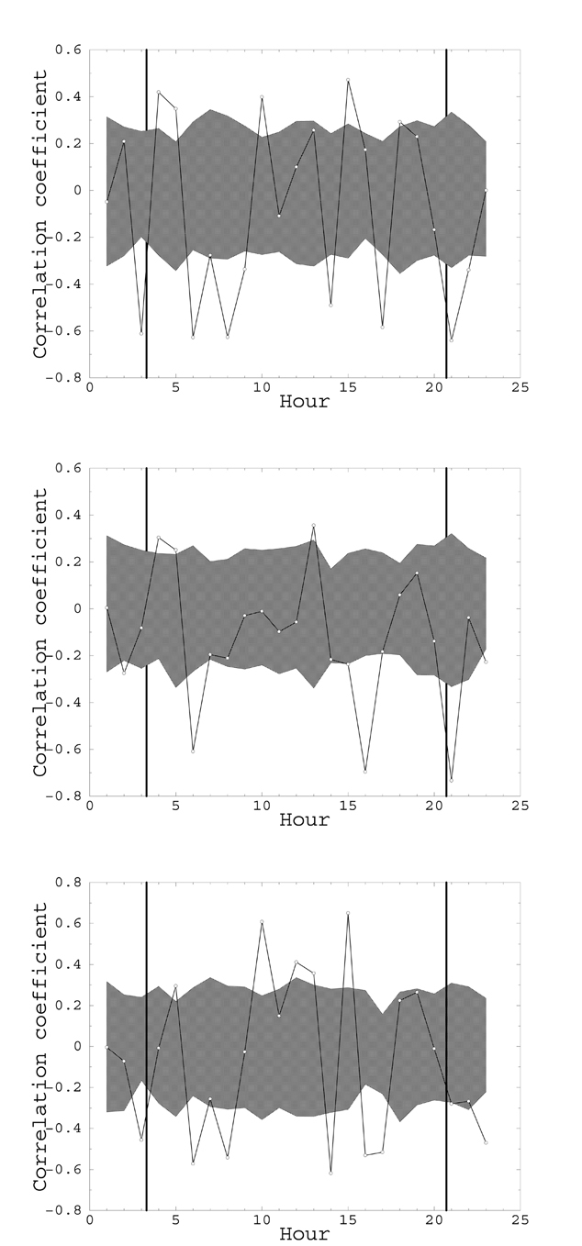

Fig.2. The correlation coefficients (from top to down) for synchrotron, dust, and free-free radiation for 1-hour bins. The thick vertical line shows the intersection with the Milky Way. The solid line shows the correlation between the ILC and the corresponding background component. The hatched domain shows the domain of coefficients as found in 100 realizations of a random Gaussian field.

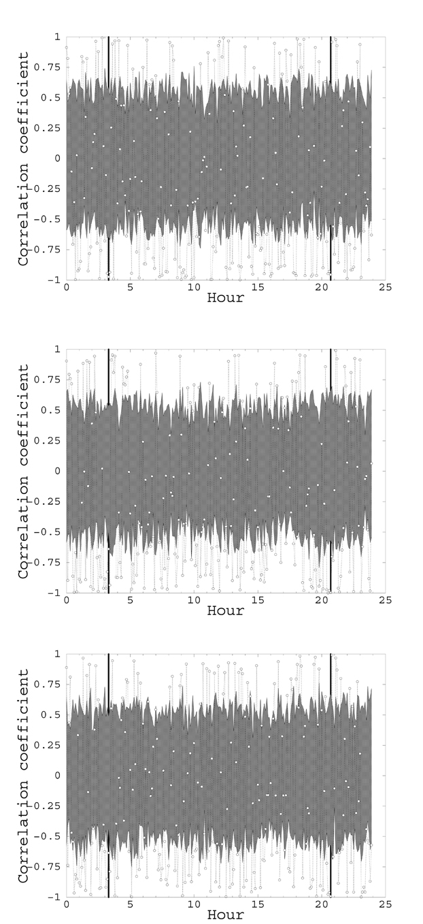

Fig.3. The correlation coefficients (from top to down) for synchrotron, dust, and free-free radiation for 6-minute bins. The thick vertical line shows the intersection with the Milky Way. The solid line shows the correlation between the ILC and the corresponding background component. The hatched domain shows the domain of coefficients as found in 100 realizations of a random Gaussian field.

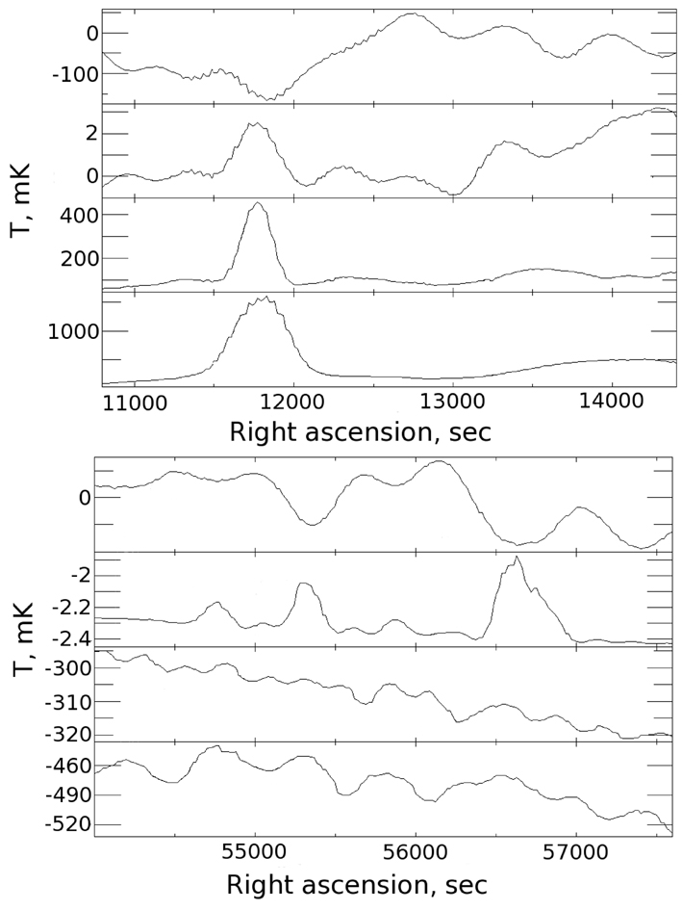

Fig. 4. Sections of the domains located in (top: maximal peak in three lower figures) and outside the Galactic plane (lower panel) in the following radiation maps (from top to down): ILC, dust, free-free, and synchrotron radiation.

We then estimated the number of excesses over the admissible level of correlations in percent as a function of the right-ascension bin size. Fig.5 shows how the fraction of the correlation coefficient values exceeding the admissible level depends on the binning interval. We estimated the multipole numbers ℓ shown in the plots from the corresponding characteristic angular scale of the spherical harmonic crossing the pixel of the given angular size at the given declination. I.e., the pixel size θ²_{a}, where θ_{a} = 15·cos(δ)θ_{t} is the size in arcmin corresponding to the binning interval in right ascension θ_{t} at the given declination δ converted into the number of the maximal harmonic determined on a sphere covered with pixels of the size in question. We use ntot procedure from GLESP package [15] to infer the characteristic number of the multipole from the given pixel size. In the figure shown here the observed maximum of the number of high correlations on short binning intervals close to the antenna beam size may be due to problems with the quality of component separation in the limit case; peaks on 20-50-minute angular scales in right ascension, to stronger effect of Galactic radiation and uncertainty of the removal of its background components. The dependences on 80-minute angular scales in right ascension do not reflect the actual distribution of counts and we show them to demonstrate the limitations of the method in terms of angular size: moving along a circular section yields no new information with increased size of the bins used to compute the correlations.

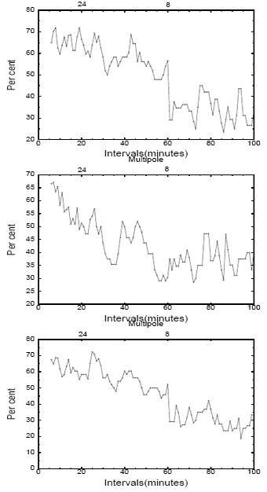

Fig. 5. The number of excesses in percent above the admissible level of variations for (from top to down) dust, free-free and synchrotron radiation In the upper parts of the plots the numbers ℓ of multipoles are indicated that correspond to the angular size. The observed maximum of the number of high correlations over short intervals close to the size of the antenna beam may be due to problems with separating the components in the limit case, and peaks on 20-50-minute angular scales in right ascension, to the stronger effect of the Milky Way and incomplete removal of its background components. Dependences over RA scales exceeding 80 minutes do not reflect the actual distribution of counts and we show them only to demonstrate the limitations of the method in terms of angular size: moving along a circular section yields no new information with increased size of the bins used to compute the correlations.
3. Conclusions

We are the first to apply the method of searching for correlations in one-dimensional sections of WMAP background-radiation maps. We find, in particular, the WMAP map sections at the declination of δ = 41° to contain a signal that is correlated and anticorrelated with the data for the component to be separated. This fact is consistent with the earlier found manifestations of the unaccounted contribution of all the three distributed interfering components [7, 8] and may complicate the comparison of the microwave background data hitherto obtained in WMAP experiment and at RATAN-600 in 6-minute bins in right ascension at the declination of δ ~ 41°. The results obtained corroborate the hypothesis about the non-Gaussian structure of the ILC map in one-dimensional scans [7, 8]. Moreover, significant correlations have been found with Galactic background components on angular scales typical of the Galactic plane (ℓ=10-20). We already demonstrated this in the papers mentioned above by way of cluster analysis. In this paper we show for the first time that correlations are also present on angular scales ℓ ~ 100. This fact is indicative of possible manifestations of residuals when identifying a signal on angular scales comparable to the WMAP antenna beam in the K band.
We demonstrate that the simple and non computer-intensive method of correlation search can be used to qualitatively verify in the one-dimensional case the map of the signal identified. This hitherto unused approach is a powerful supplement to the method of the analysis of non-Gaussianity via Fourier coefficients of one-dimensional ring sections employed by Chiang and Naselsky [16].
This method can be used not only to estimate the level of correlations within the given sections on the sky sphere, but also to search for correlated positive and negative peaks in the distributions of various background radiations and sources on the sphere, e.g., such as the correlated non-Gaussian negative spot in WMAP data and NVSS catalog of sources [17,18].
To estimate the statistical significance of the non-Gaussianity level, we simulated a total of 100 realizations of pure Gaussian signal on the sky sphere. We applied to these random maps the same procedure of search for correlations as we used for the CMB signal studied. We then used the correlation levels at different angular scales to estimate the confidence interval: we interpret the correlations that fall outside this interval as local manifestations of non-Gaussianity at the declination in question. The distribution of the dispersion of the flux density of radio sources (e.g., those of the NVSS catalog) can be substituted for the known distributions of sky background brightness in the given sliding search box – in this case we can apply a similar procedure of correlation search with varying angular scale to detect the coincidence of the locations of spots of various sizes with both the same and opposite signs in the CMB maps and on the maps of the distribution of radio sources. We will publish the results of the application of this method in our next paper.
We acknowledge the use of the NASA Legacy Archive from where we adopted the WMAP data. In this work we used the GLESP package for the analysis of CMB radiation maps on the sphere GLESP [19,15] and FADPS system [20] of the reduction of one-dimensional data. This work was supported by the Program of the Support of Leading Scientific Schools in Russia.

References

1. Bennett C.L., Halpern M., Hinshaw G. et al., ApJS, 148, 1 (2003), astro-ph/0302207.
2. Bennett C.L., Hill R.S., Hinshaw G., et al., Wollack, E. ApJS, 148, 97 (2003), astro-ph/0302208.
3. Spergel D.N., Verde L., Peiris H.. et al., ApJS 148, 175 (2003), astro-ph/0302209.
4. Hinshaw G., Spergel D.N., Verde L., et al., Astrophys.J. 170, 288 (2007), astro-ph/0603451.
5. Spergel D.N., Bean R., Doré O., et al., Astrophys.J. 170, 377 (2007), astro-ph/0603449.
6. Chiang L.-Y., Naselsky P.D., Verkhodanov O.V. and Way M.J., Naselsky P.D., Verkhodanov O.V., Way M.J. 2003.Astrophys.J. 590, L65 (2003), astro-ph/0303643.
7. Naselsky P.D., Doroshkevich A.G. and Verkhodanov O.V., Astrophys.J. 599, L53 (2003), astro-ph/0310542.
8. Naselsky P.D., Doroshkevich A.G., and Verkhodanov O.V., MNRAS, 349, 695 (2004), astro-ph/0310601.
9. Naselsky P.D. and Verkhodanov O.V., Int. J. Mod. Phys. D, submitted (2006), astro-ph/0609409.
10. Naselsky P.D. and Verkhodanov O.V., Astrophys. Bull. 62, 218 (2007).
11. Naselsky P.D., Verkhodanov O.V. and M.T.B.Nielsen, arXiv:0707.1484 (2007).
12. Parijskij Yu.N., Bursov N.N., Berlin A.B. et al., Gravitation & Cosmology v.10, No 4 (40), p.1-10, 139 (2005), astro-ph/0508065.
13. Bursov N.N., Parijskij Yu.N., Maiorova E.K. et al., Astron. Rep. 51, 197 (2007).
14. Khabibullina M.L., Verkhodanov O.V., Pariiskij Yu.N., Astrophys. Bull. 63 (2008)
15. Verkhodanov O.V., Doroshkevich A.G., Naselsky P.D. et al., 2005. Bull. SAO 58, 40 (2005).
16. Chiang L.-Y. and Naselsky P.D., MNRAS 380L, 71 (2007), arXiv:0705.1626.
17. Rudnick L., Brown S. and Williams L.R., arXiv:0704.0908 (2007).
18. Cruz M., Turok N., Vielva P. et al., arXiv:0710.5737 (2007).
19. Doroshkevich A.G., Naselsky P.D., Verkhodanov O.V. et al., Int.J.Mod.Phys.D, 14, 275 (2003), astro-ph/0305537.
20. Verkhodanov O.V. in Proceedings of the International Meeting on Astronomical Data Analysis Software and Systems VI, Charlotsville, USA, Eds. G.Hunt, H.E.Payne, (ASP Conf. Ser., 125, 1997) p.46.

http://www.glesp.nbi.dk
http://sed.sao.ru/~vo/fadps_e.html

