Gamma-Ray Bursts and Practical Cosmology

© A. S. Moskvitin ^{1, 2}, E. Sonbas ^{1, 3, 4}, I. V. Sokolov ^{5,6}, T.A.Fatkhullin ^{1,7}

¹Special Astrophysical Observatory of RAS, Nizhnij Arkhyz, Russia
²Email: moskvitin.alexander@gmail.com
³University of Cukurova, Department of Physics, 01330 Adana, Turkey
⁴Email: edasonbas@yahoo.com
⁵Puschino Radio Astronomical Observatory, Puschino, Russia
⁶Email: ilia333@land.ru
⁷Email: timur@sao.ru

Abstract: Discovery of relation between long γ-ray bursts (GRBs) and supernovae (SNe) is the most important progress in this domain during recent 10 years. Now the search for SNe signs in photometry and spectra of optical transients of GRBs became the main observational direction both for large ground-based telescopes and space platforms. In particular, in the process of study, a new branch of observational cosmology has arisen as a result of investigations of GRB host galaxies. The bursts themselves are already considered as a tool for studying processes of star-forming at cosmological distances up to z ~ 10. Irrespective of specific models of this phenomenon, it might be said now that when observing GRBs we observe SN explosions which, probably, are ALWAYS related to the relativistic collapse of massive stellar cores in very distant galaxies. This report is about one of the most mysterious phenomenon of the modern astronomy – GRBs and the Problems of Practical Cosmology at all. We use mainly the observational results of the research program carried out in SAO RAS since 1997 in collaboration with analogous programs in other observatories.

1. Introduction

Cosmic γ-ray bursts (GRBs) are bright short (from parts of second to hundreds of seconds) bursts of soft γ-radiation with total fluxes (“fluences”) from ~10⁻⁷ erg cm⁻² to 10⁻³ erg cm⁻². Events of such fluences are registered with an average rate of ≈0.8 bursts per day (Fishman et al. 1994). Light curves often show a complicated/multi-peak structure with variability at periods up to tens of milliseconds, energy spectra with maximum up to ~ 1 MeV [1], but the burst radiation is also observed in the X-ray range 2-30 keV [2]. Before 1997 all information about these events was obtained only from observations with all-directional γ-ray detectors settled on space platforms. The problem of identification of burst sources in all other ranges of electromagnetic spectrum and setting of distance scale became important right after their space origin was understood.
After optical identification and recognizing the cosmologic nature of long-duration GRBs, they turned out to be the most powerful explosions in the Universe observable in the electromagnetic range. The luminosity during the burst (of duration from several to 100 seconds) can achieve L ~ 10⁵² erg s⁻¹ (isotropic equivalent), whereas, for example, AGNs can have L ~10⁴⁸ erg s⁻¹ (but during a long time) and SNe can have L ~10⁴⁵ erg s⁻¹ (e.g., one of the modern survey [3]).
The short variability timescales of the γ-ray emission suggest already very small dimensions for the sources of the order of tens of kilometers.
Besides, the Universe is transparent in γ-rays up to z~10. That is why the observation of GRBs is a powerful tool for studying physical conditions of environment and the processes of birth and death of stars at red shifts up to 10 and even more (at present, the red shift of the most distant GRB 050904 is z=6.29 [4]).
Furthermore, GRBs and their afterglows are of great interest for studies related to stellar astrophysics, the interstellar and intergalactic medium, and most important, they reveal themselves as unique probes of the high redshift Universe.
After the first X-ray identifications carried out by BeppoSAX in 1997 [5], the fast localization of a GRB and follow-up observation of their afterglow became possible practically in all wavelengths, from X-rays to radio. The optical range is the most important for studying the relation of GRBs with known objects. For studying GRBs at large red shifts the near infra-red (NIR) range is the most informative because optical spectrum of GRB afterglows (GRB optical transient) shifts here.
Basic directions of the study of optical objects related to GRBs (Astronomy of Gamma-Ray Bursts) and main questions that must be answered by observations and their interpretation can be presented in the form of a scheme shown in Fig.1.
From the very beginning [6, 7, 8], the main objects of study have been distant galaxies and SNe exploding in them and the death rate of massive short-lived stars resembles their formation rate. Thus, the GRB formation rate can be used as a potential tracer of the massive star-forming rate (SFR) in the Universe .
If the long-duration GRBs are extremely powerful explosions associated to collapse of short-lived massive stars, with peak emission at sub-MeV energies, where dust extinction is not an issue, the fluxes of these events can be detected eventually from almost any redshifts. Since γ-rays do not suffer absorption, even in very dense molecular regions, GRBs are expected to trace the massive SFR of any galaxy in the Universe, for example, of the dust-enshrouded actively star-forming galaxies at high red shifts.

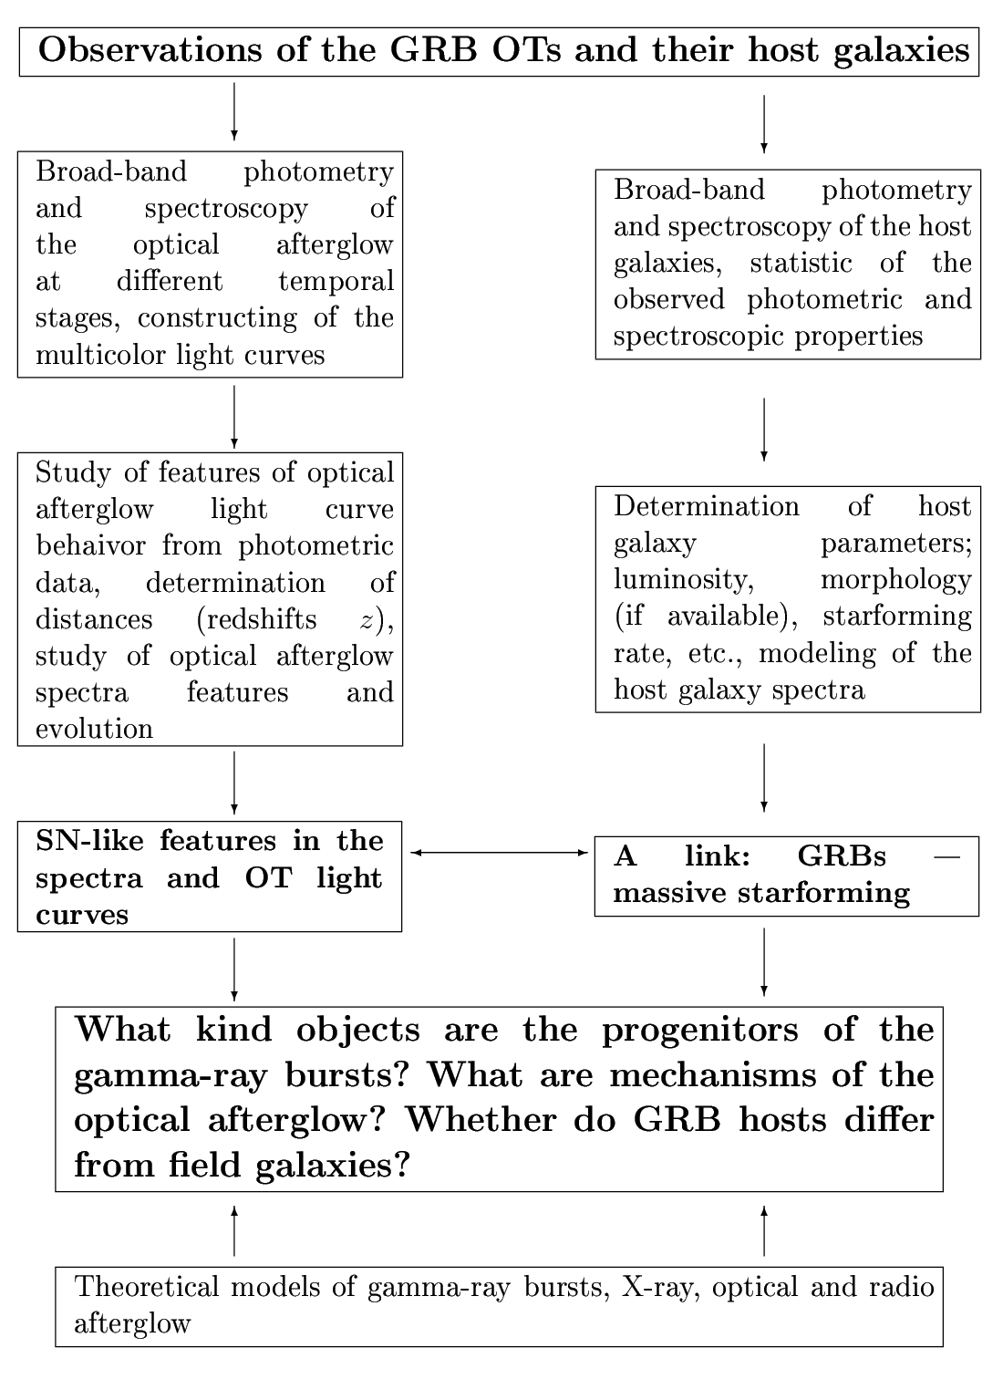
Fig.1. Astronomy of γ-ray bursts.

2. The first stage of optical identification: galaxies with massive star-forming

Fast localization, follow-up observations and measurement of red shifts of GRBs have shown their relation to distant galaxies located in sites of faded transients. The study of physical properties of host galaxies permits determining if they differ from usual galaxies with massive star-forming, which gives us a key to the understanding of conditions in which a GRB progenitor object is born, evolves and dies. It was the first stage of the optical identification [6-9].
At large ref shifts, spectral features typical of optical range shift to the near infra-red range, for example, the Balmer break at z~1.5 leaves the limits of the optical range, and at z~8 the Lyman break is unnoticeable in optical already. The validity of the study of both afterglows and host galaxies in NIR is also related to considerable absorption of optical emission in the intergalactic and interstellar medium [3]. The interstellar absorption is typical of star-forming regions where GRBs are mainly observed.
The most distant galaxies can be often observed only photometrically. In these cases, such physical properties as SFR, law of intrinsic extinction and E(B-V), age, mass and initial metallicity can be estimated only by modelling spectral energy distributions (SEDs) [8].
Recent observational studies show that the neutral ISM around GRBs is not metal poor and enriched by dust [10]. The GRB hosts should not be special, but normal, faint, star-forming galaxies (the most abundant), detected at any z just because a GRB event has occurred [6, 7, 8, 10]. The main conclusion resulting from the investigation of these galaxies is that the GRB hosts do not differ in anything from other galaxies with close values of red shift z: neither in colors, nor in spectra, the massive star-forming rates [8, 9], and the metallicities [10]. It means that these are generally star-forming galaxies (“ordinary” for their red shifts) constituting the base of all deep surveys. In point of fact, this is the first result of the GRB optical identification with already known objects: GRBs are identified with ordinary (or the most numerous in the universe at any z) galaxies up to ≈ 26 stellar magnitudes [11].

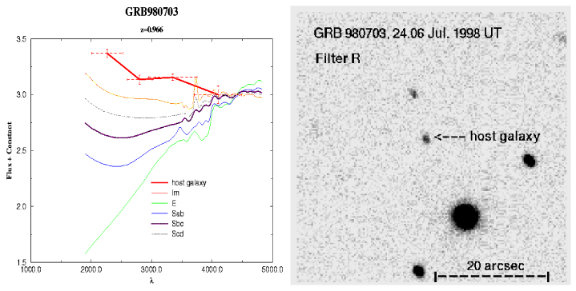

Fig.2. Multi-color photometry and the R_{c} image of the GRB 980703 host galaxy field from BTA observations in July 1998. The comparison of energy distribution obtained from BVR_{c}I_{c} fluxes (with consideration for the shift in the ultra-violet part of spectrum for z=0.966) of this galaxy with energy distribution in spectra of galaxies of different Hubble types is shown. The half-widths of each filter for its λ_{eff} with consideration for its left shift for z=0.966 are denoted by dotted horizontal segments with bars [11].

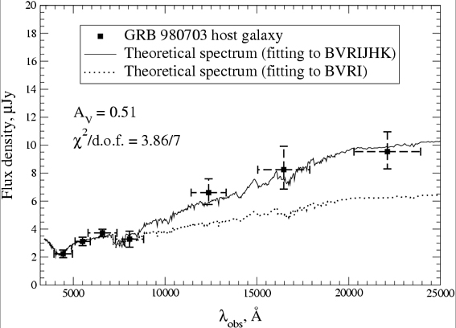

Fig.3. Comparison of modeled and observed fluxes in the filters BVR_{c}I_{c}, J, H, K for the GRB 980703 host galaxy [8]. The dashed line denotes the model SED without data of JHK.

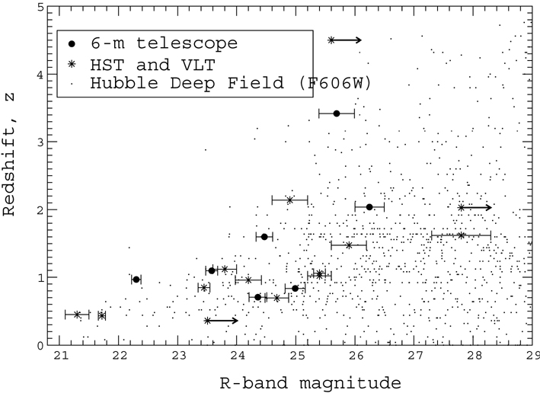

Fig.4. The Hubble diagram for GRB host galaxies with known (before June 2002 [11]) observable stellar magnitudes (or with upper R limits) and spectroscopic red shifts against the background of results of the photometric measurement of z applied to galaxies from the Hubble Deep Field (HDF) by Fernández et al. (1999). Circles denote the GRB host galaxies with the BTA photometry, asterisks are results by other authors (HST, VLT). For the galaxy GRB 991208 the measurement of z = 0.706 and R = 24.35 were made at the BTA. Points show location of HDF galaxies from results of deep observations with the Hubble Space Telescope (HST), i.e. the diagram shows stellar magnitudes in the filter HDF F606W and corresponding photometric red shifts of galaxies from the catalog F606W. The observable R stellar magnitudes of host galaxies are corrected for the Galactic extinction. Effects of observational selection are as follows: the decrease of amount of measured spectroscopic z after z ≈ 1.2; the z values of host galaxies are mainly obtained by spectra of brighter galaxies; the galaxy brightness measurement error increases with stellar magnitude. With regard to these effects, the R distribution of z for GRB host. galaxies well follows the Hubble course for all other “normal” (non-peculiar) galaxies of the deep survey. (In this picture one can see galaxies of large and small luminosities up to dwarfs for identical values of z.)

3. The second stage of optical identification: core-collapse supernovae

Most GRB afterglows should be accompanied by a supernova (SN) as already supported by the GRB 030329 and more recently, GRB 060218 results. In addition, the late-time light curve of several GRBs can be explained by the presence of a SN similar to the peculiar SN 1998bw but at a redshift around 1 [12, 13]. Similarly for GRB 991208, a SN 1998bw-like light curve redshifted to the distance of the GRB as measured spectroscopically fits the observed magnitudes very well [14]. Moreover, our own data on GRB 030329 and the recent results on the SN shock-breakout in GRB 060218 suggest that H-lines should be observable in an early SN/GRB spectrum if taken in the first few hours following the GRB, if the photosphere temperature of the shock becomes sufficiently low and the H density over the photosphere is sufficiently high [15]. Thus, the second stage of optical identification of GRBs and core-collapse SNe (see Fig. 5) started.
On Feb. 18.149, 2006 UT the space observatory Swift detected a peculiar GRB with a powerful component of supernova (SN) emission in spectra and in the light curve of the GRB afterglow [16]. Therefore, this burst is simultaneously classified both as GRB 060218, and as SN2006aj: GRB 060218/SN 2006aj. But since in this case the X-ray emission was prevailing in the GRB spectrum, the GRB is also classified as XRF (X-Ray Flash), and the total event is denoted either as XRF/GRB 060218/SN 2006aj, or as XRF 060218/SN 2006aj. We use the latter notation to emphasize that in the case of SN 2006aj the SN event itself started with observation of a powerful XRF.
XRF/GRB 060218 is one of the nearest GRBs with its redshift z=0.0331. In this respect it can be compared to GRB 030329/SN 2003dh having the redshift z=0.1683 which was also identified with the Type Ic SN. Both events have aroused considerable interest because such coincidences (GRB and SN) happen rarely, only once every two-three years [17], when SN were revealed in GRB starting from the moment of star cores explosion. It can be said that the study of GRBs is a new phase of investigation of core-collapse SNe, but from the very beginning of this remarkable event. That is why in these cases early spectral observations turn out to be very important for understanding of the mechanism of both core-collapse SN explosion itself and GRB source. When such early observations are successful, the 6-meter telescope, with its large accumulating area and eastern location relatively other large European observatories, can play an important role in implementation of the international program of spectroscopic observations (of the monitoring) of quickly-fading optical GRB afterglows.
In BTA spectra of the supernova SN 2006aj, identified with the XRF and γ-ray burst XRF/GRB 060218/SN 2006aj, we detected details interpreted as hydrogen lines, which is a sign of stellar-wind envelope around a massive progenitor star of the γ-ray burst. Results of modeling two early spectra obtained with the BTA in 2.55 and 3.55 days after explosion of the Type Ic supernova SN 2006aj (z=0.0331) are presented. The spectra were modeled in the Sobolev approximation with the SYNOW code [18, 19]. In the spectra of the optical afterglow of the X-ray flash XRF/GRB 060218 we detected spectral features interpreted as 1) the Hα PCyg profile for the velocity 33000 km s⁻¹ – a wide and almost unnoticeable deformation of continuum in the range of ~/= 5600 – 6600 Ǻ (see Fig. 7) for the first epoch (2.55 days) and (2) a part (“remnant”) of the Hα PCyg profile in absorption blueshifted by 24000 km s⁻¹ – a wide spectral feature with a minimum at ~/=6100 Ǻ (see Fig. 8) for the second epoch (3.55 days). Taking into consideration early BTA observations and spectra obtained with other telescopes (ESO Lick, ESO VLT, NOT) before 2006 Feb. 23 UT [20], it can be said that we observe evolution of optical spectra of the Type Ic core-collapse supernova SN 2006aj during transition from the short phase related to the shock breakout to outer layers of the stellar-wind envelope to spectra of the phase of increasing brightness corresponding to radioactive heating. Signs of hydrogen in spectra of the γ-ray burst afterglow were detected for the first time.
The signs of hydrogen in spectra of Type Ib and Ic (Ib-c) SNe are not a new. In particular, the signs of hydrogen and evolution of the blueshofted Hα line were already found with the help of the same SYNOW code [18, 19] in the analysis of a time series of optical spectra for usual core-collapse type Ic and Ib SNe. In this analysis, special attention addressed to traces of hydrogen in observations of especially these stripped-envelope Type Ib-c SNe. Though, by (formal) definition, the Type Ic and Ib supernovae do not have conspicuous lines of hydrogen in its optical spectra. The SNe Ic and Ic usually are modeled in terms of the gravitational collapse of massive and bare carbon-oxygen cores which stripped envelope before collapse, and, apparently, signs of this envelope must be present always in spectra of these SNe as hydrogen lines.
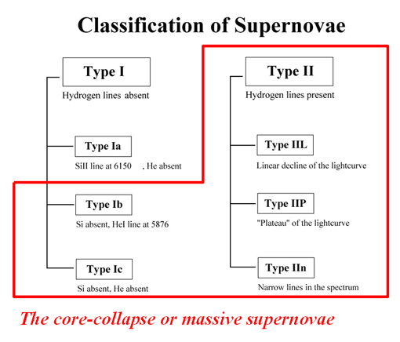
Fig.5. Modern classification of supernovae.

The burst XRF 060218/SN 2006aj was a classical XRF event indeed [16, 21]. The fact that in the case of usual and nearby SNe the explosion does not begin with a GRB is naturally explained by an asymmetric, axial-symmetric or bipolar (with formation of jets) explosion of the core-collapse SNe. Now one of the most popular conceptions (see references in the paper by Soderberg et al. [22]) proceeds from the idea that in the case of flashes of the XRF type an observer is out of the beam in which the most γ-ray radiation is concentrated for one reason or another.
The farther is an observer from the SN explosion axis, the more of X-ray radiation and the less γ-ray quanta are in the spectrum of the flash – GRBs transform to X-ray Rich GRBs (like GRB 030329) and become X-ray Flashes [23]. When observing at an angle close to 90° to the SN explosion axis, no GRB is seen; one observes only an XRF (X-ray Flash) and then a powerful UV flash caused by interaction in the shock and the envelope surrounding the pre-SN as was in the case of SN 1993J.
Thus, if an SN is observed close to the explosion equator (and this situation is the most probable) and if there is a sufficiently dense stellar-wind envelope around a massive collapsing star nucleus, then only the shock breakout effect is to be observed in X-rays and in optical. In that case the contribution of GRB afterglow into a light curve of a “usual” SN can be unnoticeable. One way or another, but it must be much less than for classical GRBs observed close to the SN explosion axis (the least probable situation). In this connection, Filippenko et al. (2006) noted recently that a substantially asymmetric explosion can be a genetic feature of core-collapse SNe of all types, though it is not clear yet if the mechanism generating the GRB is also responsible for the star explosion (see Fig. 6).

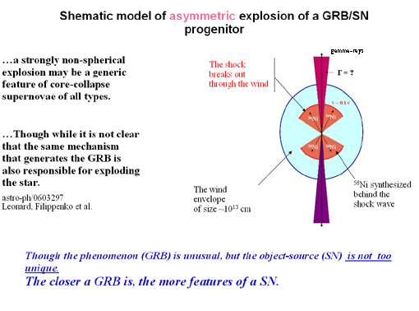
Fig.6. The most popular conception of the relation between long-duration GRBs and core-collapse SNe.

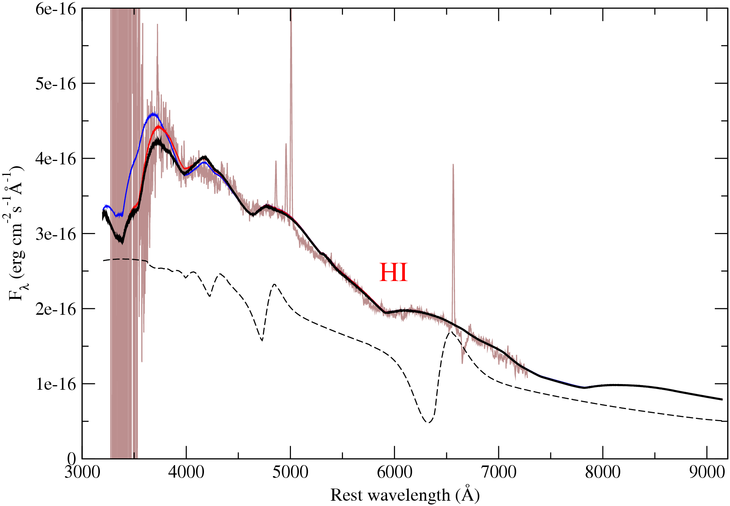

Fig.7. The spectrum of the XRF/GRB060218/SN2006aj afterglow in rest wavelengths (z=0) obtained with BTA in 2.55 days and corrected for galactic extinction. Its fitting for “the undetached case” by synthetic spectra with the velocity of the photosphere (V_{phot}), all elements and their ions equal to 33000 km s⁻¹ is shown by smooth lines differing only in the blue range of the spectrum at λ < 4000 Ǻ, see the text). Main parameters of calculation of the synthetic spectrum represented by the thick black line are given in Table 2. HI denotes the Hα PCyg profile at V_{phot} = 33000 km s⁻¹. The model spectrum for the photosphere velocity 8000 km s⁻¹ is shown for example by the dashed line as an example of the Hα PCyg profile.

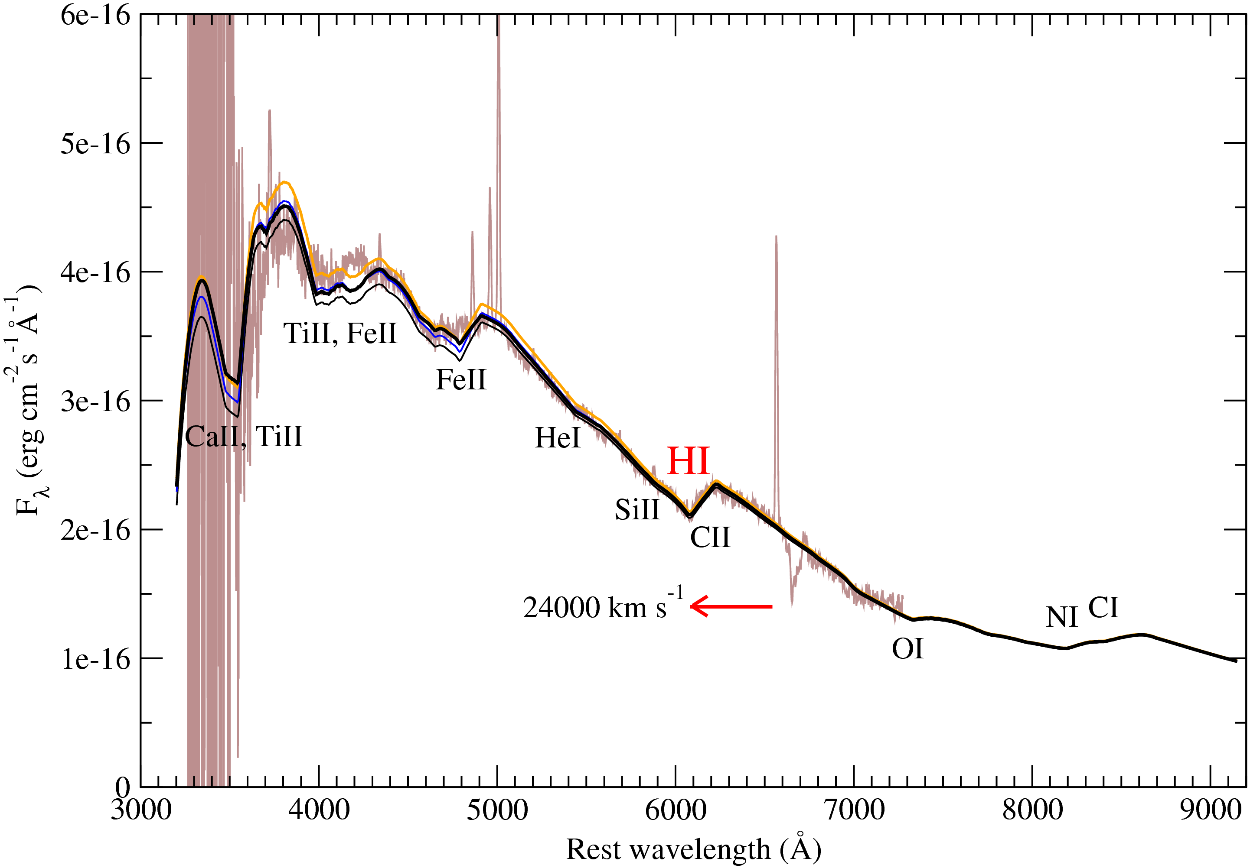
Fig.8. The spectrum of SN2006aj/XRF060218 (rest wavelength at z=0) obtained with BTA in 3.55 days and corrected for galactic extinction. Synthetic spectra are shown by smooth lines. Locations of spectral lines of some ions and blends of their lines are shown in those parts of the spectrum where contribution of this ion into the spectrum is essential for given model parameters. The thick black line is the synthetic spectrum with parameters from Table 3 at which the absorption with minimum about 6100 Ǻ is described by suppressing influence of HI for “the detached case”. This is a strongly blue-shifted part of the Hα PCyg profile at the velocity of expansion of the detached HI layer equal to 24000 km s⁻¹.

We studied the core-collapse Type Ibc SN 2008D which exploded on Jan.9, 2008 and was identified with a bright X-ray transient XRO 080109 discovered by Swift/XRT in the nearby galaxy NGC 2770 (the distance 27 Mpc). On Jan.16 and Feb.6, 2 spectra of this object were taken with BTA (the wavelength range 3700А-7500А). The preliminary processing of data was fulfilled including the subtraction of the host galaxy contribution. Our spectrum was also compared to the spectrum by Gemini-North/GMOS (Soderberg et al., 2008; arXiv:0802.1712) obtained on the same day. Physical conditions in the envelope of this SN were modeled with the parametrized SYNOW code [18, 19].

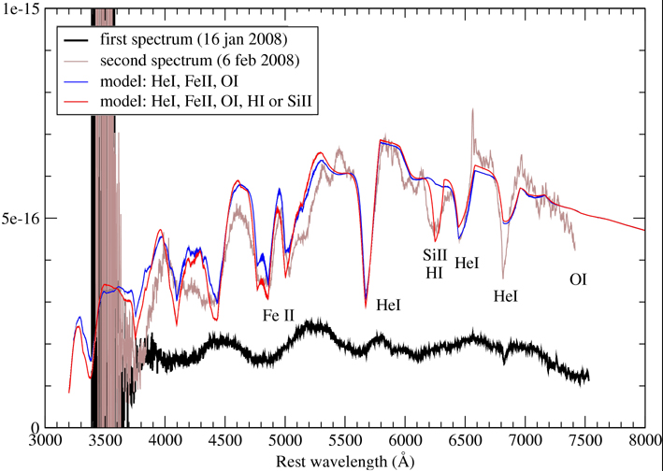

Fig.9. The BTA spectra of SN 2008D obtained on Jan.16 and Feb.6, 2008 in the wavelength range 3700-7500 Ǻ. SN 2008D is a type Ibc core-collapse supernova discovered with the space platform Swift and identified with the bright X-ray transient XRO 090109. it exploded on Jan. 9, 2008 in the galaxy NGC 2770 (the distance 27 Mpc). Main absorption features noticeable in both spectra were interpreted with the help of the parametrized SYNOW code as PCyg profiles of the lines HeI, FeII and, presumably, HI or SiII (the feature at 6200 Ǻ. Velocity of expansion of the SN envelope is noticeably higher on Jan.16 in comparison to Feb.6, which is seen from wide absorptions in the spectrum obtained on Jan.16.

If interpretation of the thermal component in the spectrum of GRB/XRF 060218 as interaction between the SN shock and the wind envelope around the SN 2006aj/XRF 060218 progenitor star will be confirmed by observations of afterglow of other bursts, then it will give a new impulse to development of the theory of GRBs themselves and of the core-collapse SNe.
Though the intermediate redshift GRB/SNe are observed relatively rarely, but they are the most informative events (such as XRF /GRB 060218/SN 2006aj or GRB 030329/SN 2003dh) from the point of view of comprehension of relation between GRBs and SNe. And the key moment of the study of these transient sources may be the search for manifestations of wind envelopes around core-collapse progenitor stars of GRBs both in early spectra and in the photometry of GRB afterglows.

4. The study of host galaxy fields: the most distant galaxies in BVRI GRB fields

For the Practical Cosmology the essential fact was that when studying GRB host galaxies we obtained also information, as a by-product, about all galaxies which were in CCD images of the telescope up to the limit of detection. Thus, the SAO RAS 6-meter telescope was used to obtain deep fields under the program of optical identification of γ-ray bursts. Some of these fields are listed in Table 1 which gives its location in the sky. Thus, thanks to quite a random distribution of GRBs in the sky we have a sample of sufficiently deep fields of size about 4΄×4΄ which can be used for the study the distribution of all galaxies in these fields by the SEDs and red shifts up to 27-28 st. magnitude.

GRB | α₂₀₀₀ | δ₂₀₀₀ | Fileters | Texp, sec
GRB 970508 | 6^{h}53^{m}49^{s}.2 | +79°16΄19˝ | BVRI | 600x7, 500x4, 600x5, 400x5
GRB 971214 | 11^{h}56^{m}25^{s}.2 | +65°11΄57˝.9 | VR | 600x1, 600x1
GRB 980613 | 10^{h}17^{m}57^{s}.64 | +71°27΄26˝.4 | BVR | 700x1, 600x1, 600x3
GRB 980703 | 23^{h}59^{m}06^{s}.67 | +08°35΄07˝.09 | BVRI | 480x1, 320x1, 300x1, 360x1
GRB 990123 | 15^{h}25^{m}30^{s}.34 | +44°45΄59˝.1 | BVRI | 600x1, 600x1, 600x1, 600x1
GRB 991208 | 16^{h}33^{m}53^{s}.51 | +46°27΄21˝.5 | BVRI | 300x6, 300x5, 180x7, 180x2
GRB 000926 | 17^{h}04^{m}09^{s}.62 | +51°47΄11˝.2 | BVRI | 500x5, 300x5, 180x25, 120x15
GRB 021004 | 00^{h}26^{m}54^{s}.68 | +18°55΄41˝.6 | BVRI | 600x6, 450x13, 180x15, 120x14

Table 1. BTA deep fields obtained when observing GRBs in different filters.

As a rule, the processing includes the primary reduction of direct images, selection of faint galaxies in images, photometry in four filters (B,V,R,I), estimation of galaxy angular size and photometric red-shift, the construction of relation between different observed values. In particular, we studied the deep field of size 4.05΄×4.05΄ of the GRB 021004 host galaxy by data of BTA BVRI observation which were obtained under the program of GRB identification.
GRB 021004 was photometrically observed on November, 30 and December, 1, 2002 with the 6-meter SAO RAS telescope. Observational conditions were photometric with the seeing 1.3 arcsec measured as the full width at half maximum (FWHM) of images of stellar-like objects in the field. The area was centered to coordinates of the host galaxy α_{2000.0} = 0^{h}26^{m}54^{s}.4, δ_{2000.0} = +18°53΄44˝.42 which corresponds to galactic latitude b = -43°35΄37˝.1 and longitude l = 114°54΄34˝.3.
The catalog of galaxies detected in the field included 183 objects with the signal/noise ratio higher than 3 in each filter, which corresponds to the following stellar magnitudes: 26.0 (B) during 3600s, 25.5 (V) during 3600s, 25.0 (R) during 2700s, 24.5 (I) during 1800s. Differential and integral counts of detected objects were fulfilled in all 4 filters up to the limit corresponding to S/N > 3 (311 objects): 28.5 (B), 28 (V), 27 (R), 26.5 (I). Fig.10. shows an example of the differential count of galaxies in the V filter. Color diagrams were built for all field galaxies (S/N>3) and stellar-like objects in it: (B-V)/B, (B-V)/V, (V-R)/(B-V), (R-I)/(V-R).
Magnitudes of the GRB021004 host galaxy were determined: B=24.434(±0.132), V=24.006(±0.099), R=24.174(±0.154), I=23.437(±0.170). The photometric red shift turned out to be close to the spectroscopic one: z_{phot} = 2.215 (z_{sp} = 2.329) χ²: 0.003, Probability: 99.980, Type: E, the Seaton (MW) law of internal extinction with the carbon feature at ~ 2200 A.

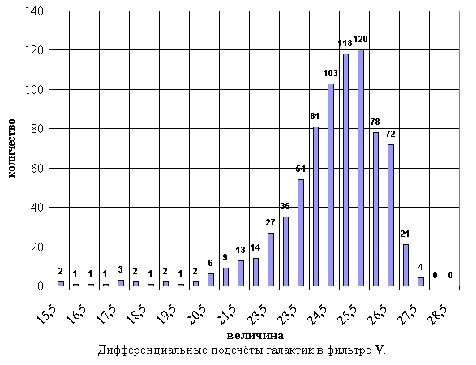
Fig.10. Differential counts of galaxies in the B filter.

Photometric red shifts of field galaxies were determined up to z ~ 3.5. The Seaton (MW) extinction law was used. The histogram of obtained red shifts is shown in Fig.11.
Photometric red shifts of field galaxies were estimated by the method realized in the software package HyperZ [8]. The aim was to estimate red shifts of all extended sources detected in the field of the GRB 021004 host galaxy. Determination of spectroscopic red shifts for hundreds of faint objects in deep fields is a rather difficult and labor-consuming problem demanding large observational time. But for many tasks the estimates of photometric red shifts made from results of multi-color photometry turn out to be quite sufficient. Certainly, the precision of such estimates is about 10%, but frequently this is quite sufficient for statistical study of properties of distant objects. The multi-color photometry may be considered as a spectrum of a very low resolution, which can be used to estimate z. Sometimes, such estimates are preliminary, especially for faint objects, before more complicated observations with a spectrograph. The input data of the package HyperZ are BVR_{c}I_{c} values of extended objects in the field and their errors, extinction in our Galaxy, spectral energy distribution of galaxies of different types, parameters of a cosmological model, and different laws of galactic extinction.
The result shown in Fig.11 can be interesting in connection with the question “Where are the missing gamma-ray burst redshifts?” which is discussed by Coward et al. [24] in view of newest results of the study of the z-distribution of GRB sources obtained with the Swift satellite [25].
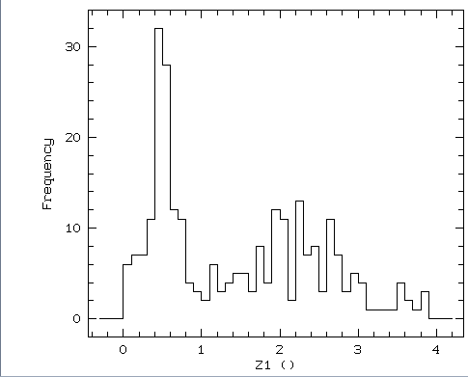

Fig.11. Distribution of galaxies in the field of GRB 021004 by photometric red shifts.

References.

1. Schaefer B.E., et al., 1994, ApJS, 92, 285.
2. Amati L., Frontera F., Tavani M., et al., 2002, A&A, 390, 81
3. Avila-Reese V., et al., 2007, “XII IAU Regional Latinamerican Meeting”, astro-ph/ arXiv:0802.2578v2
4. Kawai N. et al., 2006, Nature, Vol. 440, Iss. 7081, pp. 184-186
5. Costa E. et al., 1997, Nature, 387, 783
6. Djorgovski S.G., Kulkarni S.R., Bloom J.S. et al., 2001, invited review in Proc.”Gamma-Ray Bursts in the Afterglow Era: 2nd Workshop”, eds. N. Masetti et al., ESO Astrophysics Symposia, Berlin: Springer Verlag, p. 218 (asro-ph/0107535)
7. Frail D. A. et al., 2002, ApJ, 565, 829
8. Sokolov V., Fatkhullin T., Castro-Tirado A. et al., 2001, A&A , 372, 438
9. Sokolov V., 2001a, in Proc. “Gamma-Ray Bursts in the Afterglow Era: 2nd Workshop”, eds.Costa E. et al., ESO Astrophysics Symposia, Berlin: Springer Verlag, p. 132 (asro-ph/0102492)
10. Savaglio S., 2006, New Journal of Physics, 8, 195 (astro-ph/0609489)
11. Sokolov V.V., 2002, The Doctoral Thesis in http://www.sao.ru/hq/grb/team/vvs/vvs.html
12. Bloom J., et al. 1999, Nat. 401, 453
13. Castro-Tirado, A. J. and Gorosabel, J. 1999, A&AS 138, 449.
14. Castro-Tirado, A. J., et al. 2001, A&A 370, 398
15. Sokolov V.V., et al., 2008, Astrophys. Bull., Vol. 63, Iss.3, in preparation
16. Campana S., et. al 2006, Nature, 442, 1008
17. Chapman R., Tanvir N.R., Priddey R.S., Levan A.J., 2007, astro-ph/arXiv:0708.2106
18. Branch D., et al. 2001, Supernovae and Gamma-Ray Bursters. Edited by K. Weiler., Lecture Notes in Physics, vol. 598, p.47-75 (astro-ph/0111573)
19. Elmhamdi A. et al. 2006, A&A, 450, 305 (astro-ph/0512572)
20. Mazzali P.A., et al. 2006, Nature, 442, 1018
21. Heise J., in 't Zand J., Kippen R.M., and Woods P.M., 2001, in Proc. of the Int. Workshop (Rome, 17-20 October 2000), astro-ph/0111246
22. Soderberg A. et al., 2005, astro-ph/0502553
23. Sokolov V.V. et al. 2006, Bull. Spec. Astrophyz. Obs., 59, 5
24. Coward D.M. et al., 2007, astro-ph/arXiv:0711.0242, submitted to MNRAS
25. Cincarini G., on behalf of the Swift team, 2006, astro-ph/arXiv:0608414

