Some difficulties for measuring and interpreting the expansion of the universe

© G. Paturel 1,2

1 CRAL, Université Claude-Bernard,
Observatoire de Lyon 69561 Saint-Genis Laval, France
2 Email: patu@obs.univ-lyon1.fr
submitted : 23 march 2008

Abstract: The so-called "expansion of the universe" is conventionally measured by the Hubble constant. We will expose some practical difficulties with both the measure and the interpretation of the Hubble law.
We first discuss briefly the difficulties connected with statistical biases : the Malmquist bias and the completeness bias. Then we discuss the bias of the Cepheid Period-Luminosity relation that affects the calibration of the distance scale. It is shown that the Period-Luminosity-Colour relation can lead to unbiased distances, while the Period-Luminosity relation can be biased. Finally, we analyse the consequences that could come from the extension of the Hubble law to all scales, including the microscopic scale. This could give an interpretation for the "quartz aging" phenomenon. Amazingly, this may suggest a new paradigm in which there is no place for the Hubble law itself.

1. Introduction

The origin of the well known controversy about the value of the Hubble constant is now well explained with the understanding of statistical biases [1,2,3]. The debate seems to be over with the result of the Hubble Space Telescope Key Project on Extragalactic Cepheids (hereafter HSTKP) [4]. However, a new kind of bias has been found, that affects directly the calibration from Cepheids Period Luminosity relation (hereafter, PL). This bias vanishes when the true physical Period Luminosity Color relation (hereafter, PLC) is used instead.
In section 2 of this paper we will give a short way to understand the Malmquist bias and the incompleteness bias. For more detail the reader can refer to the review paper by Teerikorpi [3]. Then, in section 3, we will show that the PL relation still leads to a biased Hubble constant for distant galaxies, while PLC does not. In order to exhibit this new bias, we use an accurate relative distance scale provided by the Hubble law, applied to the very local volume. This unexpected local law, first suggested by Sandage [5], has been confirmed and improved independently by Ekholm et al. [6,7] and Karachentsev et al. [8]. This unexpected tool, rises the question : “on what scale does the cosmic expansion starts ?”. This question will be analyzed in section 4 of this paper. Some possible consequences are discussed in sections 5 and 6.

2. The classical biases

The difficulty for the calculation of the Hubble constant is directly related to the difficulty of measuring astronomical distances. Using logarithmic scale, the distance modulus, μ, is very simply expressed from the apparent magnitude m and the absolute magnitude M.
$\text{μ= m}−M$ (1)
If M is known, the measurement of m leads to the distance modulus, hence to the distance. The problem is thus : “how to guess the value of M for a given galaxy ?”. In 1977, Tully and Fisher have shown [9] that the absolute magnitude of a spiral galaxy is directly related to its rotation velocity Vm, in the form (this is the TF relation) :
$\text{M=a} \text{logVm}+b$ (2)
However, the constancy of a and b, were questioned. Are they real constants ? Do they depend on the morphological type ? Further, the inclination needed to correct Vm introduces an additional uncertainty because it is estimated from a combination of the axis ratio and morphological type. Anyway, the results obtain from the TF relation were still subject to controversy. In 1984, all these difficulties were bypassed by the method of sosie galaxies [10]. The principle is very simple and will facilitate the explanation of the bias.
If one selects galaxies having the same rotation velocity, the same axis ratio and the same morphological type than a calibrating galaxy (e.g., Messier 31 = M31), they should have the same absolute magnitude as M31, whatever the model to correct for inclination and whatever the a and b dependencies. The distance modulus of one such galaxy is simply (from Rel. 1 and 2 applied to M31 and to the studied galaxy):
$$μ=μ_{M\text{31}}+(m−m_{M\text{31}})$$
Unfortunately, the problem is not so simple. At the time of the publication of sosie method, I argued that there is no more Malmquist bias, because, by construction, all sosie galaxies have the same absolute magnitude. Thus, at large distances our sample should not contain intrinsically brighter galaxies. The error was that for a given rotation velocity we have not on single value for the absolute magnitude but a certain distribution of absolute magnitude. The larger the sample the wider the spread of values. Then because any sample is magnitude limited, one cannot observe galaxies beyond a certain magnitude, as shown in Fig. 1. The result is a bias on absolute magnitude, hence on the Hubble value. This is the classical Malmquist bias. Obviously, when different absolute magnitudes are mixed, the problem is more complex, but fundamentally the same.

Fig. 1 The Spaenhauer diagram for sosie galaxies of NGC3031 : absolute magnitude vs. radial velocity (distance). Galaxies with the same rotation valocity have not exactly the same absolute magnitude. The larger the sample, the larger the chance of having a discrepancy. Because of the limiting magnitude (dashed curve) the mean absolute magnitude is the nominal one, but only up to a given limit (vertical solid line). Beyond this limit, the absolute magnitude of the galaxies diminishes. The galaxies are intrinsically brighter and the Hubble constant underestimated.

Another kind of bias exists for galaxies in a cluster. All galaxies being at the same distance, the cut-off in apparent magnitude induces a cut-off in absolute magnitude (this can be seen directly from Rel. 1). This is the incompleteness bias. This bias affects cluster galaxies but also Cepheid stars belonging to a same external galaxy.

3. The Cepheid PL bias

When the HSTKP Cepheid sample is used, the PL relation lead to distances giving an Hubble constant of H≈70 (km/s)/Mpc. However, we had suspected the presence of another bias [11]. To check the presence of the bias, accurate relative distances are needed. For long distance criteria, these relative distances are provided by the classical Hubble law, assuming an arbitrary Hubble constant. For short distances, it seemed that this was not possible, because the Hubble law is not supposed to work. Sandage was the first to demonstrate that it works indeed [5] even for short distances. Later, a verification has been performed independently by Ekholm et al. [6,7] and Karachentsev et al. [8], using the recent distance moduli derived from the HSTKP measurements. These studies confirmed that the Hubble law works at small scale (a few Mpc), provided that the velocities are properly corrected for known proper motions. It is then possible to check for the new bias.
We may suspect a circular argument in using Cepheid distance moduli to check the presence of a bias on themselves. In fact, it is not the case. The Cepheid distance moduli are used only to prove the existence of the Hubble law at small scale. Then, admitting the Hubble law, we use it with an arbitrary value of H.
The suspected bias has been found [12]. Note that the shape of the relation between velocity and distance should start with a small slope and then bend up progressively, when the bias grows. This is exactly what we obtain (Fig. 2a) [13]. How to be sure that the curvature comes from the new bias ? A first test consists in applying the analytical model of the bias [13]. After the correction, the trend of Fig 2a is removed (Fig. 2b).

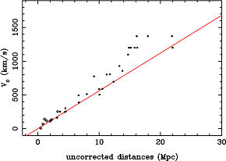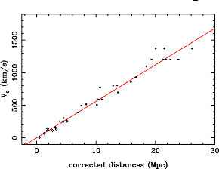

Fig. 2a,b : The curvature observed in the Hubble diagram (Fig. 2a) disappears after correction for the bias (Fig. 2b).

Another test consists to verify that the bias is stronger when old data are used. We showed [13] that the bias appears earlier for ground based observations.

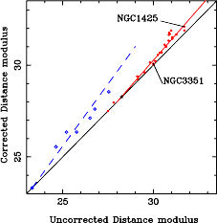

Fig. 3 : The bias appears earlier for ground-based observations (open circles) than for HSTKP ones. The Cepheid population of NGC1425 is more strongly biased than the NGC3351 one.
Using numerical simulations, an additional test (Fig. 4a,b) confirms that the bias is due to an incompleteness of the sample [13]. When a limit on apparent magnitudes is used (Fig. 4b) the calculated Hubble constant behaves exactly as real data from HSTKP (Fig. 4c) [14].

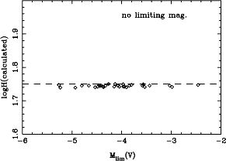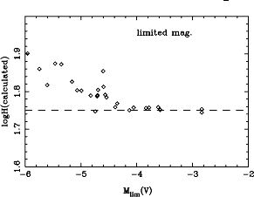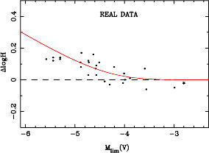

Fig. 4a,b,c : Using a known Hubble constant, an artificial sample of galaxies simulates the use of the PL relation. The input Hubble constant is retrieved when no cut-off in magnitude is used (Fig. 4a). When a cut-off is applied, the Hubble cosntant is distorted (Fig. 4b), exactly as real data (Fig. 4c).

Finally, an ultimate test has been made [15] using the Cepheid PLC relation. Indeed, The true physical relation is a PLC that can be written as :$M=α\text{log}P+β C+γ$, where P is the period of the Cepheid and C its intrinsic color index (difference between two apparent magnitudes at two different wavelengths, e.g. V-I). α, β and γ are constants.

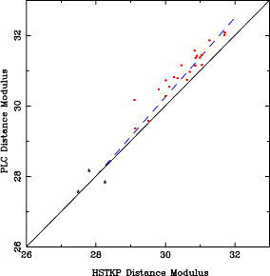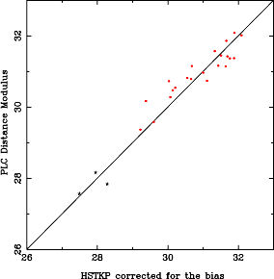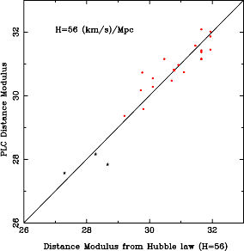

Fig. 4a,b,c : The PLC is a true physical relation for which no bias is expected. In Fig4a, it is visible that the PLC does not lead to distance moduli compatible with the HSTKP moduli derived from the statistical PL relation. The agreement is retrived when HSTKP moduli are corrected for the bias (Fig. 4b). The PLC distance moduli are in agreement with those derived from a local Hubble law (Fig. 4c).

It is impossible to calculate the intrinsic color index, because it is derived from the unknown total extinction. Thus, it is implicitly admitted that all the samples have the same mean color index. So, the relation becomes a statistical PL relation, the color term entering in the γ constant. But, the luminosity depends on the color index. Hence, if there is a selection effect in magnitude, particularly at large distances, a bias will appear, because the mean color index will change, inducing a change in γ.
The extinction has two origins : 1) the extinction, a_{G}, inside our own Galaxy 2) the extinction, a_{h}, in the host galaxy. For our application we corrected for a_{G} from a map describing the galactic extinction. Then a_{h} is assumed to be constant, on the mean. This solution is also a simplification, like the simplification used in the PL relation consisting in assuming that the mean color is constant for any Cepheid sample. But this new simplification does not introduce a bias ; it just increases the dispersion of the diagram.

4. Discussion about the Hubble law

Here, the Hubble law has been used as a tool to provide us with accurate relative distances. This was possible because the Hubble law has been proved to work at a small scale (within a few Mpc) with an amazingly small dispersion (σ ≈ 40 km/s). As noted by different authors [16, 17], the Hubble law is not expected at such small distance because the matter is not uniformly distributed. So, the present observation of the local Hubble law inevitably leads to the question : "on what scale does the cosmic expansion starts ?". In fact, since 1992, I have been asking this question to different physicists and astronomers. I got all kinds of answer, sometimes, very affirmative in a sense or in the opposit. So, we have to search for our own answer, without a priori.
The most acceptable answer comes, to my point of view, from Landau & Lifchitz [18, p.456]. They say :" The conclusion that the bodies expands when a(t) [the scale factor] grows, can, of course, works only under the condition that the energy of their mutual interaction is small in comparison with the kinetics energy of their expansion...". Indeed, in the general demonstration of the Hubble law, there is no condition to fix a limit to the application of the law. This means, that the expansion has no practical influence at small scale because it is hidden by other interactions. If, through a Gedankenexperiment (thought experiment), one removes all superimposed interactions, the Hubble law will remain alone. This is similar with the Galilei Gedankenexperiment that consists in removing all causes of damping or friction to prove the inertia of a moving body. If one accepts this idea, the Hubble law becomes a general law, almost independent on the distribution of baryonic matter. As a general law, It must work at all scales, including the microscopic one. Now, let us imagine that the Hubble law works at all scale, from microscopic to our cosmic horizon. What would be the consequences ?
If I measure the length of my desk using a rule, I shall not find any expansion, because the rule expands itself by the same factor. This can be shown easily by integrating the Hubble law. However, I can measure the time interval required by the light to travel from one side of my desk to the other side. I shall observe that this time interval grows with time, providing that the velocity of light, c, is constant and that my clock is monotonic with the ideal time.
Is the expansion mesurable at small scale ? Some measurements within the solar system tends to confort the possible existence of a local expansion. But these measurements will always be suspect, because they cannot be controlled, as those made in a laboratory. But, measurements in laboratory seems out of reach. Using a Hubble constant of 60 (km/s)/Mpc, one calculates that a one-meter stick would expands by 0,006 μm per century. I try to devise an experiment to measure this expansion by measuring the time interval required by the light to perform many back and forth paths along a given length L. In practice, this means that the light travel constitutes a clock (based on L and c.). This clock is compared with an atomic clock. In fact, such experiment can be done, more simply, by comparing a quartz oscillator with an atomic clock (the quartz frequency depends on its thickness, equivalent to L).

5. A possible explanation for "quartz aging" phenomenon

When I started to think about local expansion, I imagined, as explained above, that a comparison of a quartz oscillator shoud show a secular drift with the time of an atomic clock (I was confident that an atomic clock gave an ideal time). I searched a book about quartz oscillators and found that all quartz actually show an unexplained drift with time. This is the "quartz aging" phenomenon, considered as a simple degradation of characteristics of the quartz. J.R Vig [19] made a model where the quartz-aging is written as :
$\frac{Δν}{ν}=−A\text{.}\text{Ln}(B Δ t+1)$.
Because B is very small, this relation can be simplified as :
$\frac{1}{ν}\frac{Δν}{Δt}=−A\text{.}B$
On the other hand, the fundamental frequency of a quartz is inversely proportional to the thickness of the quartz. If the thickness is affected by the local expansion, one predicts :
$\frac{1}{ν}\frac{Δν}{ Δt}=−H$,
where H is the Hubble constant. This means that the aging effect can actually be represented by a law compatible with the local Hubble law. The old measure of the drift by Vig [19], A.B≈10⁻¹² per day, (i.e., 10⁻¹⁷ s⁻¹), corresponds to an Hubble constant six times too high. But, owing the numerous perturbing effects (contamination of the quartz and temperature effect), the measurement was very uncertain.

Recently, Bize et al. [20] compared a cryogenic saphire oscillator to a hydrogen maser, whose frequency was also compared to cesium and rubidium atomic fountain clocks. A "natural frequency drift" has been measured. Its value, 1.7 × 10⁻¹⁸ s ⁻¹, corresponds to an Hubble constant H=52 (km/s)/Mpc. If my interpretation is correct, this could be a nice confirmation of the existence of the local expansion and a new interpretation of the unknown quartz aging phenomenon. Incidentally, this measure support a small Hubble value, as expected from the first three sections. If my interpretation is wrong, please, forgive me and jump to the end of the paper.

6. Can we imagine a new paradigm ?

Let us return to the Gedankenexperiment seen in section 4 and consider a physicists, who trusts the uniformity of his atomic clock. He measures the length of his desk and observes an increasing time interval for the light to travel from one side to the other. What would be his natural conclusion ? He will probably say : "either there is an expansion, unobservable from mechanical means, whatever the precision of my rule, or the velocity of light diminishes with time, so that the time needed by the light is growing". An acceptable (and probably equivalent) conclusion would be, there is a secular variation of the velocity of light. The consequences would be numerous considering the large number of phenomenons involving c.
Note that, the quartz oscillator could be replaced by a many back and forth paths along a, given length. The test would be more significant.

7. Conclusions

When one takes into account the classical statistical biases, the Hubble constant is about 60-70 (km/s)/Mpc. When the Period luminosity bias is taken into account for the calibration of the distances with nearby galaxies, the Hubble constant is reduced to about 50-60 (km/s)/Mpc.
The evidence for the validity of the Hubble law at small scale (a few Mpc) suggests to consider it at a still smaller scale, down to a microscopic scale. This seems to be confirmed by the yet unexplained quartz aging phenomenon.
If the Hubble law is a general law working at all scales, we may consider an alternative paradigm were the secular variation of the light velocity could replace the general expansion.
Acknowledgment. This paper would not have been possible without the research work done with Pekka Teerikorpi and Yuri Baryshev, and without the numerous stimulating exchanges we had together.

References

1. Teerikorpi, P., 1975, A&A 45, 117
2. Teerikorpi, P., 1987, A&A 173, 39
3. Teerikorpi, P., 1997, ARA&A 35, 101
4. Freedman W.L., Madore, B., Gibson, B.K., et al. 2001, ApJ, 553, 47.
5. Sandage, A, 1986, ApJ 307, 1
6. Ekholm, T., Lanoix, P., Teerikorpi, P., et al., 1999, A&A 351, 827
7. Ekholm, T., Baryshev, Yu., Teerikorpi, P., et al., 2001, A&A 368, L17
8. Karachentsev, I.D., Makarov, D.A., 2001, Astrofiz. 44, 5
9. Tully, B., Fisher, R., 1977, A&A 54, 661
10. Paturel, G., 1984, ApJ 282,382
11. Paturel, G., Lanoix, P., Garnier, R., et al., 1997, i n Proceedings of the ESA symposium, Hipparcos Venice'97, eds., Perryman M.A.C., Bernacca, P.L.
12. Teerikorpi, P., Paturel, G., 2002, A&A 381, L37
13. Paturel, G., Teerikorpi, P., 2005, A&A 443, 883
14. Paturel, G., Teerikorpi, P., 2004, A&A 431, L31
15. Paturel, G., Teerikorpi, P., 2006, A&A 452, 423
16. Dicke, R.H., Peebles, P.J.E., 1974, Phys. Rev. Lett. 12, 435
17. Baryshev, Yu.,V., Chernin, A.D., Teerikorpi, P., 2001, A&A 378, 729
18. Landau L., Lifchitz, E., 1969, in "Theory of Fields", Ed. Mir, Third Edition
19. Vig, J.R., 1991, Proceeding of the 45th Annual Symposium on Frequency Control., pp77-101
20. Bize, S., Wolf, P., Abgrall, M., et al., 2004, in "Cold Atoms Clocks, Precision Oscillators and Fundamental Tests, Lect. Notes Phys. 648, 189

We have no means to verify that an experimental time is an ideal time. We can only assume that our best atomic clocks give an ideal time. Note that, a non uniformity of my time cannot cancel the effect.

