What Happened if Dirac, Sciama and Dicke had Talked to Each Other
About Cosmology ?

© A. Unzicker

Pestalozzi-Gymnasium München, Germany
Email: alexander.unzicker@lrz.uni-muenchen.de

Abstract: The inspiring contributions to cosmology originating from the above named researchers seem abandoned today. Surprisingly, their basic ideas can be realized by slight modifications of each proposal. We study Dirac’s article on the large number hypothesis (1938), Sciama’s proposal of realizing Mach’s principle (1953), and Dicke’s scalar theory of gravitation with a variable speed of light (1957). Dicke’s tentative theory can be formulated in a way which is compatible with Sciama’s hypothesis on the gravitational constant G. Additionally, such a cosmological model satisfies Dirac’s large number hypothesis (LNH) without entailing a visible time dependence of G which never has been verified, though originally predicted by Dirac. While Dicke’s proposal in first approximation agrees with the classical tests of GR, the cosmological redshift arises from a shortening of measuring rods rather than an expansion of space. The speed of light turns out to be the increase of the horizon R. A related discussion is given in arxiv:0708.3518.

1 Introduction

In 1968, Dirac made the follwing provoking statement [1]:
‘It is usually assumed that the laws of nature have always been the same as they are now. There is no justification for this. The laws may be changing, and in particular, quantities which are considered to be constants of nature may be varying with cosmological time. Such variations would completely upset the model makers.’
Usually few attention is given to this warning, probably because Dirac’s earlier prediction on a change of the gravitational constant G [2] seems to be ruled out. Moreover, general relativity has undergone an impressive series of confirmations, and Friedmann-Lemaitre cosmology has won all battles so far. This success and the lack of alternatives however bears the danger of interpreting new data assuming a model we still should not forget to test. A review of the observational evidence for standard cosmology and its problems is given elsewhere [3]. The enthusiasm about new data of the past decades brushed aside the interest in old unresolved problems and it is a somehow unfortunate development that Dirac’s criticism has not been considered any more by theoreticians. In particular, the idea of time as an invisible river that runs without relation to the universe (‘time is what happens when nothing else does’) may be just wrong [4]. A redefinition of time by means of parameters which govern the evolution of the universe should have profound consequences, though observational evidence may be minute. It should be clear that dealing with any alternative approach to cosmology requires much patience, and a reinterpretation of all new data cannot be done immediately. A closer look to those old ideas is still fascinating: Dirac’s large number hypothesis, which consists of two independent, struggling coincidences is one of the most mysterious, unexplained phenomena in cosmology. Sciama’s efforts to link the value of G to the mass distribution of the universe are accompanied by profound insights and for the first time realized Mach’s principle concretely. The major part of the present proposal is due to Dicke [5], though that idea is much less known than the later developed scalar-tensor-theory. We shall first have a compressed look at the mentioned papers and then investigate the impact on gravitation and cosmology.

Dirac’s Large Number Hypothesis

Strictly speaking, Dirac’s article [2], relating three large dimensionless numbers occurring in physics, expresses three different coincidences we shall name Dirac 0, I, and II. Eddington had already noticed the number
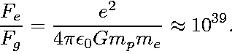 (1)
Dirac then observed that the age of the universe is about the same multiple of the time light needs to pass the proton radius, or equivalently

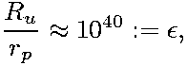 (2)
and postulated epoch-dependent forces. Then, he noted the total number of baryons being

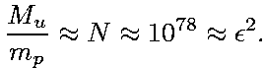 (3)
As a consequence, for the gravitational constant, the relation
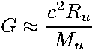 (4)
must hold, a coincidence that was previously noted by Eddington and much earlier (though lacking data, not in an explicit way) suggested by Ernst Mach, who insisted that the gravitational interaction must be related to the presence of all masses in the universe [6]. I shall call the coincidences (1+2) Dirac I and (2+3) Dirac II, while (4) should be named Dirac 0, to emphasize that Dirac’s considerations go much further: (4) could be realized either with a different radius of elementary particles (not satisfying Dirac I) or with another number of baryons of different weight (and being in conflict with Dirac II). While Dirac I had a great influence on physics with a huge amount of experimental tests (see [7] for an overview of the Ġ≠0 search) contesting the appreciation of the idea, Dirac II remained completely out of any theoretical approach so far. While Dirac I would be fairly compatible with standard FL cosmology, Dirac II is in explicit conflict with it. To be concrete, FL cosmology assumes for the epoch ε=10²⁵ (BBN, creation of light elements) a horizon containing 10⁶⁴ baryons, while in the epoch ε=10⁵⁰ still 10⁷⁸ baryons should be seen. Dirac argued that ‘Such a coincidence we may presume is due to some deep connection in nature between cosmology and atomic theory.’ ([2], p. 201). According to the predominant opinion among cosmologists however N~ε² is just a coincidence invented by nature to fool today’s physicists.
Dirac was aware that a cosmological theory of this type could require a change of time scales and considered evolution of the horizon R~τ^{1/3}. Since time measurements necessarily involve frequencies of atomic transitions and therefore the speed of light, it is strange that he maintained the postulate c=1. This omission led him to the inviting but somewhat premature claim that the gravitational constant G had to vary inversely with the epoch. The (negative) outcome of the Ġ≠0 search [7] has prevented theorists from taking that deep principles too serious, without however having challenged the prediction as such from a theoretical point of view.

Sciama’s implementation of Mach’s principle

Contrarily to Dirac, Sciama [8] focussed on the question how to realize Mach’ principle in a quantitative form, having noticed that in Newton’s theory the value of G is an arbitrary element (p. 39 below). From considerations we skip here he derived a dependence of the gravitational constant

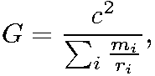 (5)
whereby the sum is taken over all particles and denoting the distance to particle i. Sciama commented the apparent constancy of G:
‘... then, local phenomena are strongly coupled to the universe as a whole, but owing to the small effect of local irregularities this coupling is practically constant over the distances and times available to observation. Because of this constancy, local phenomena appear to be isolated from the rest of the universe...’
Sciama further considered the gravitational potential (eq. 6 there)
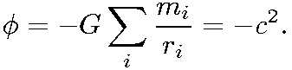 (6)
Astonishingly however he did not consider a spatial variation of c, though it seems a reasonable consequence to relate c² to the gravitational potential. As we shall see below, a variable speed of light in combination with (5) leads to a differential equation that satisfies Dirac’s second hypothesis. Since Sciama considered the coincidence (5) as approximate, we shall be able to modify it by a numerical factor.

Dicke’s ‘electromagnetic’ theory of gravitation

It was Robert Dicke [5] who first thought of combining the dependence (5) with a variable speed of light, apparently having been unaware of Sciama’s previous efforts. Dicke’s proposal belongs to the ‘conservative’ VSL theories that widely agree with general relativity (GR) in the sense that a variable c in a flat background metric generates a curved space. While recent VSL theories had to suffer a couple of objections, these do not apply to the present ‘bimetric’ type, since the notion of VSL is implicitly present in GR (see [9], ref. 70, with numerous excerpts of GR textbooks). Dicke introduced therefore a variable index of refraction ([5], eq. 5)
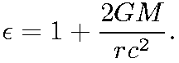 (7)
While the second term on the r.h.s. is related to the gravitational potential of the sun, Dicke raise the speculation on the first term having ‘its origin in the remainder of the matter in the universe’. In the following I will describe briefly how Dicke’s tentative theory may provide a formulation of spacetime geometry equivalent to GR and compatible with the classical tests.

2 Flat-space-representation of general relativity

It is a known feature of GR that in a gravitational field clocks run slower and a shortening of measuring rods occurs with respect to clocks and rods outside the field. Defining c with respect to the latter scales, one can equivalently say that c is lowered in the gravitational field ([9], ref. 70 with numerous textbook excerpts). Expressing Dicke’s index of refraction in (eq. 7) as and taking into account the smallness of δc, with δc²= 2 c δc we may write
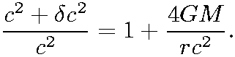 (8)
Slightly modifying Sciama’s proposal (5) we use , leading to
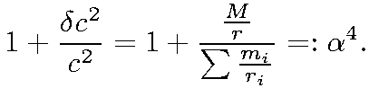 (9)
whereby denotes the distance to particle i. Since δ indicates the difference of values far from and nearby the sun, we compare the l.h.s. and r.h.s in (9) with$\frac{M}{r}=δ\sum{\frac{m_{i}}{r_{i}}}$.After integration and cancelling of the arising logarithms, this leads to a spatiotemporal dependency of the speed of light

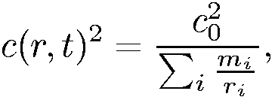 (10)
whereby the sum is taken over all particles i and denoting again the (time-dependent) distance to particle i. In the following, we will use in first approximation
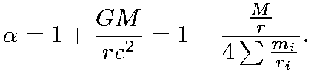 (11)

2.1 Classical tests of GR

Since c= f λ, it turns out that the change of c must be equally distributed to f and λ. We shall denote the quantities outside the gravitational field as c, λ, f and the lower quantities in the field as c*; λ*; f *. Hence, in a gravitational field, clocks run slower by the relative amount
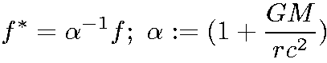 (12)
and wavelengths λ shorten by the same factor α: λ*= α⁻¹ λ, c*= α⁻² c, in a weak-field approximation.

Clock delay and gravitational redshift

The first-order general relativistic clock delay is described by f~α⁻¹, since the slower rate at which clocks run in a gravitational field can be measured directly. The gravitational redsift can be interpreted as follows: consider a photon travelling away from the gravitational field of a star. Starting at f *; λ*; c*, while travelling it keeps its (lowered) frequency f *. Outside the gravitational field where c= α² c* is higher by the double amount, the photon has to adjust its λ, and raise it with respect to the value λ at departure. Since the adjustment α² to c overcompensates the originally lower λ*= α⁻¹ λ, we detect the photon as gravitationally redshifted with α² λ*= αλ.

Radar echo delay and light deflection

The speed of light changes c~α⁻² in the gravitational field, while during photon propagation, again f=const. holds. Accordingly, the wavelength must shorten λ~α⁻² while bypassing the star. There, the photon’s λ appears even shorter by α⁻¹ with respect to local length scales. This is an equivalent, though uncommon interpretation of the Shapiro time delay. (cfr. [11], p. 111). A lower c in the vicinity of masses creates light deflection just as if one observes the bending of light rays towards the thicker optical medium. Quantitatively, light deflection is equivalent to the radar echo delay. The final result for the total deflection yields ([5], eqn. 5).
Independently from describing GR by such a VSL theory, in a given spacetime point there is only one reasonable c, from whatever moving system one tries to measure. This, but not more is the content of SR, which is not affected by expressing GR by a variable c.

Change of measuring rods

Time and length measurements naturally affect accelerations (a~α⁻³), and surprisingly, masses, too. Photon and rest masses, hf and mc² have to behave in the same manner, and since f~α⁻¹, c²~α⁻⁴, m~α³ must hold. This is in agreement with Newton’s second law according to which masses have to be proportional to inverse accelerations. Due to lower acceleration scales, masses appear more inert. An overview on the relative change of various quantities inside the gravitational field (cfr. [5], p. 366 and [12]) is given in Table 1 below. α denotes a factor of :
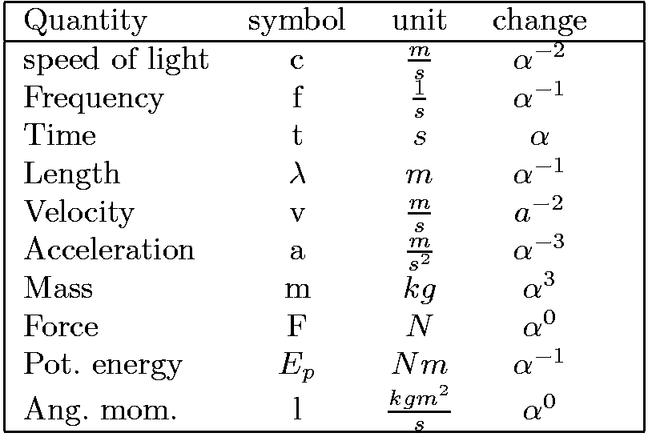

Table 1: Relative change of quantities inside the gravitational field.

Advance of the perihelion of Mercury

In the Kepler problem, the Lagrangian is given by

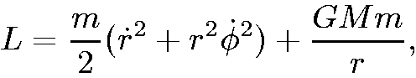 (13)
which after introducing the angular momentum transforms to

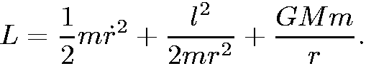 (14)
Now we have to consider the relative change of the quantities as given above. m~α³ however refers to a test particle at rest. The kinetic energy causes an additional, special relativistic mass increase proportional to α (), thus in eq.(14), m~α⁴ holds, while r~α⁻¹ and l=const. Hence, the middle term changes as α⁻² in total, which means that it is effectively multiplied by a factor
. The arising represents the well-known correction which leads to the secular shift

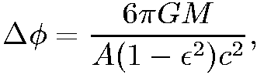 (15)
A being the semimajor axis and ε the eccentricity of the orbit.

2.2 Newton’s law from a variable c

Once time and length measurement effects of GR are described by a spatial variation of c, all gravitational phenomena should be encompassed by the same framework. However, c~α⁻² requires (eqns. 7, 8) in first approximation

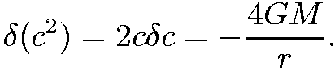 (16)
This leads to a Newtonian gravitational potential of the form
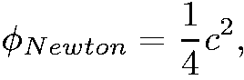 (17)
which differs by a factor 4 from Sciama’s potential. Sciama’s proposal was however always considered as approximate by the author ([8], p. 38 below). Since (10)
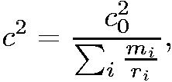 (18)
for the acceleration of a test mass

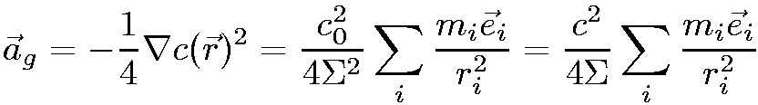 (19)
follows, yielding the inverse-square law. Thus c₀ does not appear any more and the Newtonian force is perceived in the local, dynamic units. The ‘gravitational constant’ is then given by the quantity

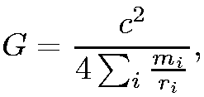 (20)
in accordance with [8]. From (20) and the assumption of an homogeneous universe, elementary integration over a spherical volume yields $\sum{\frac{m_{i}}{r_{i}}}$ ≈$\frac{3m_{u}}{2r_{u}}$, and therefore
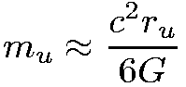 (21)
holds, which is in approximate agreement with the amount of baryonic matter.

3 Dirac-Sciama-Dicke (DSD) cosmology

3.1 Units and Measurement

In the following, we assume an absolute, Euclidean space and an absolute, undistorted time. The time t and the distances r expressed in this absolute units however are mathematical parameters not directly observable. All time and distance measurements instead are performed in relative, dynamical units defined by the actual frequencies f(t) and λ(t) of atomic or nuclear transitions. These perceived or relative quantities measured by means of f(t) and λ(t) shall be called t' and r'. In that absolute space, all matter is assumed to be at rest having a uniform density ρ (particles per absolute volume). In the next subsection we shall consider an evolution of the horizon R(t) (absolute distance) with the assumption $\overset{˙}{R}$(t) = c(t) starting at R(t=0)=0 everywhere in Euclidean space. To obtain (arbitrarily chosen) time and length scales for the absolute units, we define λ₀=λ(t₀)>0 by the condition . Equivalently, we may say the horizon R(t₀)=λ₀ contains just one particle. $\overset{˙}{R}$(t₀) = c(t₀)= c₀ is then the speed of light at t=t₀ in absolute units and we may define the frequency f(t₀)= f₀ by the identity λ₀f₀=c₀.

3.2 Temporal evolution

We start again from spatiotemporal dependency of the speed of light eqn. (10)

(22)
whereby the sum is taken over all particles i and denoting the distance to particle i, measured in absolute units. The expansion rate c(t) depends therefore on the number of visible particles and will decrease while the horizon increases. I also shall use the approximation

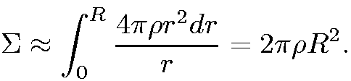 (23)
Keeping in mind that$\overset{˙}{ρ}$ =0, after inserting $\overset{˙}{R}$(t) =c(t), (10) transforms to

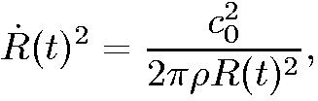 (24)
which after taking the square root, reduces to the simple form

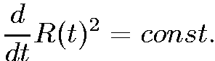 (25)
with the solution

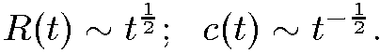 (26)
This evolution is the central difference to FL cosmology with $\frac{d}{\text{dt}}$R(t) = c =const.

3.3 Change of measuring rods

Since the locally observed speed of light c'=λ'f' is a constant, the agreement with the classical tests of GR requires λ~$t^{−\frac{1}{4}}$ and f~$t^{−\frac{1}{4}}$, that means both wavelengths and frequencies of atomic transitions become smaller during the evolution of the universe. The intervals τ we actually use to measure time change according to τ= $t^{\frac{1}{4}}$. Since for the relative, measured time t' the condition holds ( by definition), the relative time t´= $\frac{t}{τ}$shows a dependence t´= ~$t^{\frac{3}{4}}$ (mind that constancy, τ~ t⁰ would lead to the usual t´~ t¹). The measuring value of the perceived epoch is t‘ =10³⁹ now, therefore the ‘true’ epoch, in absolute units, must be t =10⁵² at present.

Dimensionful units and change of further quantities.

The change of time and length scales has further consequences. Firstly, all measurements of velocities and accelerations will be affected. This is already clear for those arising in atoms, otherwise the scale-defining decline of wavelengths and frequencies could not happen. Thinking in absolute units, the same particles, undergoing smaller accelerations, have an apparent inertial mass which accordingly increases. Developing further this principle of measurement with dynamical scales, almost all dimensionful physical units turn out to have a time evolution, thus we may imagine the dependency directly ‘attached’ to a unit like m or s. This eases to find the consistent trend but also elucidates why the change of physical quantities may be hidden at a first glance in conventional physics. A list of the respective change of physical quantities for the static case has already been given by [5], p. 366. A corresponding overview is given below in Table 2. All quantities at t₀ are normalized to 1.

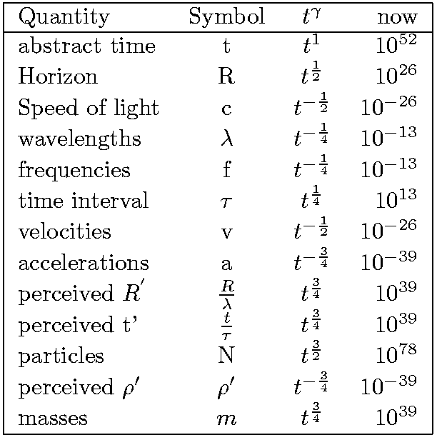
Table 2. Temporal evolution of measuring scales.

3.4 Observational consequences

Cosmological redshift
As Dicke ([5], p. 374) points out, in the context of a VSL light propagation the following properties hold: ∇c with approximately ċ=0 affects λ, while f remains unchanged. Vice versa, when ∇c vanishes, ċ will change f and leave λ constant. Therefore, assuming an isotropic DSD universe while analyzing the large-scale evolution, a propagating photon will change its frequency only, while λ is kept fixed. Consider now a photon emitted at t₁ with c(t₁) = λ( t₁) f(t₁), in brief c₁ = λ₁ f₁. It is detected later at t₂ when other photons (*) of the same atomic transition obey λ₂*f₂*=c₂* with

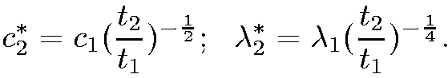 (27)
Since the arriving photon still has and c₂=c₂*, it will appear redshifted by the factor

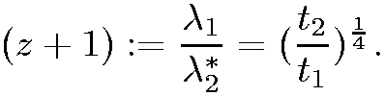 (28)
Its frequency decreased by$\frac{f_{2}}{f_{1}}$= (z+1)⁻² with respect to emission, but is lower only by $\frac{f_{2}}{f_{2}^{}}$=(z+1)⁻¹ with respect to other photons (*) generated at t₂.

Dirac’s second hypothesis on the total number of particles

Since we have assumed an Euclidean space with constant density ρ in which the horizon increases according to R(t) ~ $t^{\frac{1}{2}}$ (eq. 26), for the total number of visible particles

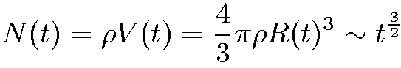 (29)
holds. Taking into account that the perceived time shows the dependency t‘ ~$t^{\frac{3}{4}}$, Dirac’s second hypothesis

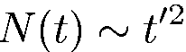 (30)
follows. Of course, the same result is obtained considering the shortening of length scales λ ~ $t^{−\frac{1}{4}}$ causing the perceived horizon to be at the relative distance of R´=$\frac{R}{λ}$~$t^{\frac{3}{4}}$. Then for the number of particles

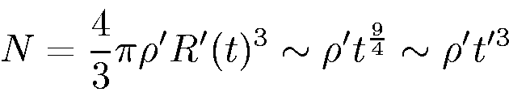 (31)
holds, which coincides with (29) because ρ´ ~ $t^{\frac{3}{4}}$ ~ t´⁻¹ , which is an equivalent form of Dirac’s second observation.

The apparent constancy of the gravitational constant G

There is strong observational evidence [7] against a temporal variation of G. In the DSD evolution developed above however, Dirac’s postulate of a variation of G turns out to be premature. First we have to ask what observational evidence supports Ġ≈0. Exemplarily, we consider the absence of increasing radii in the Earth-moon and the Sun-Mars orbit [7], since these are the most simple ones to discuss. In the DSD picture, frequencies and wavelengths of atomic transitions contract according to f ~ λ ~$t^{−\frac{1}{4}}$. Hence, in the classical limit of orbiting electrons, Bohr’s radius has to decline like r_{b} ~λ ~$t^{−\frac{1}{4}}$ and the respective centripetal acceleration according to a_{z} ~ $t^{−\frac{3}{4}}$. On the other hand, the gravitational acceleration is proportional to . Since all gradients are taken with respect to the dynamic units λ~ $t^{−\frac{1}{4}}$, they appear bigger by the factor $t^{\frac{1}{4}}$, while c ~ $t^{−\frac{1}{2}}$. Therefore, the gravitational acceleration a_{g} ~ $t^{−\frac{3}{4}}$ has precisely the dependence required for a decrease of the radius r ~ $t^{−\frac{1}{4}}$ in a sun-planet orbit. This contraction synchronous with length scales results in an apparent absence of any change in distance; two-body systems, the ‘planetary clocks’, run slower and contract their orbits in the same manner as the atomic clocks do. This result is in agreement with Kepler’s 2nd law, since the angular momentum L with m~ $t^{\frac{3}{4}}$, v ~ $t^{−\frac{1}{2}}$ and r ~ $t^{−\frac{1}{4}}$ yields a time-invariant quantity even in absolute Euclidean units. From other considerations there are good reasons to assume Planck’s constant h, whose units correspond to L, to be unchanged in time. Contrarily to the speed of light, the factor F_{e}/F_{g} will yield different measuring values dependent on the epoch, and therefore the measuring value of G, too. The experimental bounds of absolute G determinations by far do not exclude such a possibility. The paradox of a changing G without a visible Ġ is a result of the assumption of a time measured unchanged units, a picture which cannot be uphold in DSD cosmology.

4 Discussion

Dirac’s hypotheses and agreement with GR phenomenology

The most convincing property of DSD cosmology seems the agreement with Dirac’s large number hypothesises. In particular, also the second one is obtained while explaining the apparent Ġ≈0, which has been considered as an argument against Dirac’s first hypothesis so far. Mach’s principle is fully encompassed while the cosmological redshift becomes an intrinsic necessity in DSD cosmology. A critical point to be evaluated further will be the agreement of the underlying tentative gravity model with GR from a theoretical and experimental point of view. For the latter, as far as the classical tests are concerned, DSD cosmology does not seem to predict any differences to GR. However, general covariance can hardly be achieved since a minute variation of the gravitational constant is suggested. If ever, a consistent formulation must be obtained along the flat-space formulations of GR, the bimetric theories. Though there is a long history (e.g. [13, 14, 12]), the representations in terms of a spatially varying speed of light (e.g. [15, 16, 9]) have to gain yet broad acceptance. In general, there is a wide-ranging observational agreement with conventional cosmology due to the dynamics of physical units, whose relations to each other change so slowly that observational differences, if any, remain minute. Energy conservation is no longer a valuable condition for the evolution of the universe. Taking a general perspective, this is not heavily surprising, because energy is a concept introduced to describe the time-independency of physical laws. While this is true for the snapshot of the universe we are observing, the clumping of matter suggests that the universe is anything but stationary. Though the differential equation $\frac{d}{\text{dt}}$R²=const. seems to be a simple principle, a general formulation, possibly by means of a Lagrangian, has still to be given.

The flatness and horizon problem

Flatness is closely related to the observation of the approximate coincidence (4). As it is evident from (5), the apparent G must have an according value in the same order of magnitude. In Friedman-Lemaitre cosmology, gravity acts as a contracting force which slows down the Hubble expansion. It is precisely that slowdown that causes new masses to drop into the horizon and raises the question how masses, without having causal contact, could show a highly uniform behavior like the CMB emission. Contrarily, in DSD cosmology, since all matter is initially at rest, masses attract due to gravitational interaction, but this does not affect the apparent redshift. Consequently, the problem of slowing down the ‘expansion’ does not even arise.

Cosmic Microwave Background

According to common cosmology, the CMB is a signal from the recombination period at z≈1100, commonly assumed to be 380000 years after the big bang. Assuming an nonuniform evolving time like in DSD cosmology, corresponds, since λ ~ $t^{−\frac{1}{4}}$, to an epoch of t=3⋅10⁴², while at present t=10⁵³ holds. Measured in units of the ‘local’ time, that epoch corresponds to t‘ =10³¹, i.e. about one year. This is a dramatic difference and must carefully be compared to the observations. As far as the amplitude of CMB fluctuations is concerned, one expects much tinier fluctuations in DSD cosmology since there is much more time left for the fluctuations to evolve to galaxies. One should keep in mind that before the COBE data had analyzed, much greater fluctuations were expected, a riddle which was resolved in the following by postulating dark matter.

Big Bang
Though we were not able to discuss the details shortly after t=0, some substantial differences to FL cosmology should be noted. The absolute scale λ₀ was defined above by the condition of a single particle being contained in the horizon. If one assumes this particle to be a baryon, its rest energy corresponds to the zero energy E₀ of a particle closed in a quantum well of the size of the horizon: E₀=$\frac{h}{t_{0}}=\frac{\text{hc}}{λ_{0}}$= m_{p}c². In this case, the evolutionary equation in absolute units writes as $\frac{d}{\text{dt}}$R² = h/m_{p}. In general, a density equal to the density of nuclear matter seems to require much less extrapolation of physical laws than the densities that arise in FL cosmology shortly after the big bang.

5 Outlook
The present proposal based on the ideas of Dirac, Sciama and Dicke is a first framework for a cosmology based on a tentative alternative gravity model. Regarding the quantity of observations in agreement with a theoretical framework, the DSD proposal is unable to compete with standard FL cosmology with its currently accepted ΛCDM model. DSD cosmology may only gain importance if one is disposed to raise doubts to (1) the validity of the standard model with its considerable extrapolation of the laws of nature and an increasing number of free parameters (2) the suggestion of the standard model that Mach’s principle and Dirac’s enigmatic hypotheses being just numerical coincidences (3) the conviction of the constants of nature being fixed but arbitrary numbers; this last condition seems the most entrenched one and the idea that we are observers living inside a prison of dynamic measuring instruments, which in first approximation cause a blindness for the perception of change, is certainly unfamiliar.

References

[1] P. A. M. Dirac. Methods in Theoretical Physics, page 128. Cambridge University Press, 1990.
[2] P. A. M. Dirac. A new basis for cosmology. Proc. Roy. Soc. London, A 165:199–208, 1938.
[3] A. Unzicker. Why do we Still Believe in Newton’s Law ? Facts, Myths and Methods in Gravitational Physics. gr-qc/0702009.
[4] J. Barbour. The End of Time. Oxford University Press, 2000.
[5] R. H. Dicke. Gravitation without a principle of equivalence. Review of Modern Physics, 29(3):363–376, 1957.
[6] E. Mach. Die Mechanik in ihrer Entwicklung - historisch-kritisch dargestellt. 1897.
[7] J.-P. Uzan. The fundamental constants and their variation. hep-ph/0205340. Reviews of modern physics, 75:403–455, 2003.
[8] D. W. Sciama. On the origin of inertia. Monthly Notices of the Royal Astronomical Society, 113:34–42, 1953.
[9] J. Broekaert. A spatially-VSL gravity model with 1-PN limit of GRT. ArXiv: gr-qc/0405015, May 2004.
[10] A. Unzicker. A Look at the Abandoned Contributions to Cosmology of Dirac, Sciama and Dicke. ArXiv: 0708.3518, 2007.
[11] C. Will. Was Einstein Right ? Basic Books, New York, 1986.
[12] H. Dehnen, H. Hönl, and K. Westpfahl. Annalen der Physik, Folge 7, 461:370–406, 1960.
[13] H. A. Wilson. An electromagnetic theory of gravitation. Physical Review, 17:54–59, 1921.
[14] N. Rosen. General relativity and flat space. I.+II. Physical Review, 57:147–153, 1940.
[15] H. Puthoff. Polarizable-vacuum (PV) representation of general relativity. Found.Phys., 32:927–943, 2002; arXiv: gr–qc/9909037.
[16] M. Arminjon. Scalar gravity with preferred frame: asymptotic post-Newtonian scheme and the weak equivalence principle. ArXiv: gr-qc/0409092, September 2004.
[17] Y. Baryshev. Conceptual Problems of the Standard Cosmological Model. In E. J. Lerner and J. B. Almeida, editors, First Crisis in Cosmology Conference, volume 822 of American Institute of Physics Conference Series, pages 23–25, April 2006, astro-ph/0509800.

This argument is not changed by the variety of elementary particles discovered in the meantime, since it involves orders of magnitude only.
eq. (1) and (5a) with a change of notation.
Astonishingly, Dicke derived a total number of particles proportional to ε^{3/2}, in contrast to Dirac II, which seems to be due to an errorneous treatment of time in eq. (95), see [10].
Sciama explicitly ([8], p. 38 below) allowed such a factor.
The time derivative refers to the absolute time.
c'=299792458m/s is used for the SI definition.
To avoid fractional exponents, we shall approximate by .
which is equal to the de-Broglie wavelength of the orbiting electron divided by 2π.
Conceptual problems of this kind are addressed in [17].

