Gravitational Thermodynamics, The Cosmological Constant And Quantum Gravity
© Fateen A. Assaleh
Al-Quds Institute for Studies of Knowledge Genesis,
Jerusalem
Abstract. By using the functional integral approach with a new proposal of the boundary conditions which stated as “thermal equilibrium itself is the boundary condition of the universe”; The calculations of the gravitational microcanonical partition function within a prototype model of semiclassical gravity produce An Old Bohr-Sommerfeld quantization condition for the gravitational configurations, reveal the existence of a quantum gravitational curvature constant , and prove false the concept of entropy of any Euclidean solution of Einstein equations. As a result a new gravitational Schrödinger’s equation was formulated with a time term and satisfies the classical constraint of canonical gravity. It is shown that the right hand side of Einstein’s Equation is precisely the eigenvalues of their left hand side Hamiltonian. The solutions of this new gravitational Schrödinger’s equation bypasses the singularity theorems by making the gravitational wave function goes to zero when the scale goes to zero. Those singularity theorems actually reflect the limited validity of general relativity in describing the global quantum space-time structure. Nature, when described by Quantum Gravity proper, forbids those singularities.
Keywords: Gravity, quantum, thermodynamics, fundamental.

1. Gravitational Thermodynamics and the Cosmological Constant

An Introduction
The functional integral approach, as developed for Gravitational Thermodynamics, with a new proposal for the boundary condition stated as Thermal equilibrium itself is the boundary condition of the Universe, shall be the starting point in a prototype model of semiclassical gravity. When the microcanonical gravitational partition function, with this boundary condition, is calculated semiclassically, the immediate important products were the following:
- An old Bohr-Sommerfeld quantization condition
- A quantum curvature cosmological constant
- A proof that the concept of intrinsic entropy of any Euclidian solution of Einstein’s equations is false
- A DeSitter space entropy equals zero
- Oscillations appear in the density of states at the tail of the partition function
- These oscillations and the Bohr-Sommerfeld quantization condition are shown to have the same physical origin
To obtain such huge amount of physical information from the calculation of a microcanonical partition function is reasonable if one recognizes that these calculations are in principle equivalent to the calculation of the resolvent of a Hamiltonian, in which all physical information are contained. In section 2, we shall formulate, according to the findings of section 1, a new Schrödinger’s gravitational equation with an explicit time term where this time term shall reproduce the right hand side of Einstein equations. In this equation the quantum curvature cosmological constant captures the formal roles hitherto taken by Planck’s constant in quantum theory. This equation satisfies the classical constraints of canonical gravity; and it has the two limiting cases of classical gravity and of quantum field theory in curved space. At the end we shall show that time is neither a classical nor a semiclassical concept but is a quantum mechanical concept.

A Prototype Model
Our starting point is a simplified prototype model described by the action:
For an equilibrium microcanonical ensemble; the entropy is given by:
The renormalized matter free energy of conformal coupled scalar field in Einstein space is well known and is given, for example, by . Ignoring here the correction terms, working with conformal Euclidian time and assuming total energy equals zero to obtain:
To calculate the last integral semiclassically, one stationarizes over the integration’s variables:
Stationarizing over the scale factor gives Einstein’s equation:
where. From equation (1.4) the periodicity is obtained:
Stationarizing over the boundaries, one obtains the equality of the momentums at the end points of the action.
Recalling that the fields are periodic; one concludes that the trajectories are periodic. Thus one is left with:
Stationary phase approximation over beta, gives the microcanonical constraint. Here one is implicitly assuming that. In existing literature this is considered as a generalized thermodynamic equilibrium and it is implicitly assumed (see reference 1), thus one obtains:
From this microcanonical constraint one obtains the self consistent equation:
This equation gives the boundaries which satisfy the equality of the two periodicities of matter and of gravity. Thus, the number of states becomes a summation over the collection of all incomplete bounces satisfying Einstein’s equation (1.4) and constrained by the generalized thermodynamic equilibrium; it is written as:
where s are the classical actions of the incomplete bounces and the prefactors are the quadratic fluctuation integrals around the stationary trajectories. Ignoring for the main while the dependence of on, then the summation can be written as follows:

Solutions Of The Self-Consistent Equation (1.9):
Before pursuing further in evaluating the sum (1.11), one must know the boundaries which are supplied by the self-consistent equations
where
in order to evaluate the actions in the exponents.
The solutions are represented by figure 1 for a fixed value of, and have the following common properties:
- characterizes these partitions
- The partition terminate at the top of the barrier
- A minimum boundary at a fixed value of beta where Newton’s constant satisfies the relation:
- The partition represents a collection of 4-geometries where De-Sitter’s 4-bounce is a limiting geometry corresponding to:
`
- is a monotonic parameter along the boundaries :

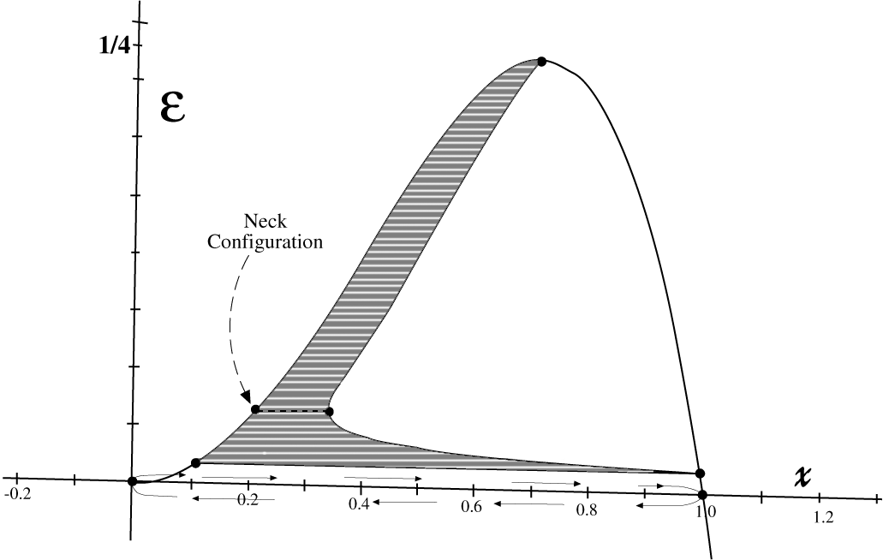

Figure 1. The shadowed area represents the collection of all incomplete bounces, shows the bounce of maximum contribution to the summation of equation (1.11). The complete bounce between zero and one is the Hawking-Gibbons bounce for DeSitter space.

Evaluating The Sum In Equation (1.11):
- By knowing the explicit function , then the actions in the summation can be done.
- The actions are found to be:

- The action are proportional to the boundaries in the major parts of the partition as in figure 2
- Oscillations appear at the tails of the partition
- Two branches
- The dominant semiclassical contribution comes from the bounce of minimum boundary (the neck configuration in figures 1and or 2) while De-Sitter’s bounce has no well defined semiclassical contribution, because of the oscillatory behavior of the actions in the limit.
- Due to the linear property of the actions with respect to the boundaries, and by a careful inclusion of the contributions of the prefactors, one obtains the Bohr-Sommerfeld quantization condition:
Had one begun work with real time one would obtain
Thus the calculations predict the following:
- By dimensional analysis of the exponentiated actions in equation (1.16), one is compelled to postulate the existence of a quantum curvature cosmological constant
- The gravitational action is quantized by a curvature constant

Note that the commonly used formal notation of the gravitational momentum actually is not adequate, because it is more notifying the velocity rather than the momentum, however, when one makes the replacement where defines the average matter density in the 3-volume under consideration, one gets:
- The entropy of any single Euclidian gravitational bounce is Zero; in particular , and this is because each bounce is found to be contributing 1 to the number of states, namely, because the entropy can now be written as
Conclusion: If these calculations are right then the concept of intrinsic gravitational entropy is to be reconsidered. And one might expect that DeSitter space is much more a quantum gravitational entity than a classical gravitational entity.

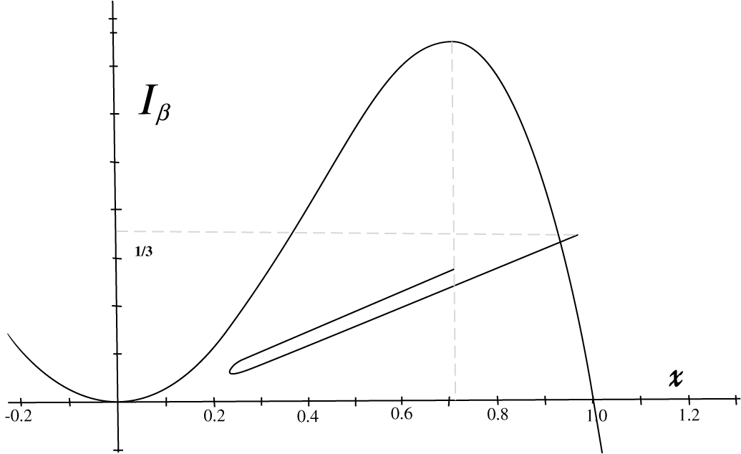
Figure 2. Illustration of the general features of the gravitational actions (not exact graph), in units of [] versus the dimensionless scale.

2. The Cosmological Constant and quantum Gravity Theory
Based on the previous results, in this section we shall build a new Schrödinger’s gravitational equation, a radical modification of Wheeler-DeWitt equation, which has a time term at its right hand side and satisfies the canonical classical constraint of General Relativity. In this equation the cosmological constant shall take the role taken by Planck’s constant in conventional quantum theories. As a result, time is shown to be a quantum mechanical concept.
- By acknowledging the quantization of the gravitational action according to:
- One needs to build a gravitational “action” of dimensionality of curvature, we shall illustrate it with the following example; consider the geometry of closed 3-sphere:
- Conventionally, the gravitational action for this geometry is written as:
- By using which means that Newton’s constant takes part in the dynamics, then the total action of matter and gravity is written as:
- Then the total Hamiltonian is:
- Quantization is followed by replacing:
, ,
- Then one obtains the Hamiltonian operator:
- Using to obtain:
To see how this equation works, its basic properties and the physical interpretations, one needs first to look for its semiclassical solutions to see whether they make sense or not.

Gravitational W.K.B. Approximation
- The Schrödinger’s gravitational equation has the following general formal appearance:
- The wave function is given by:
- To see the interpretation and operation of each term, let us expand the action in power series of its quantum constant:
- To zero order in Λ , one obtains the Einstein-Hamilton-Jacobi equation for the action where now a time term does appear at this order:
- The wave function in the zero order approximation is:
- The zero order approximation of the wave function conform two properties;
  - Non-existence of singularity, because the gravitational wave function goes to zero when the scale goes to zero (bypassing the classical Singularity Theorems),
  - Finiteness of the geometry, because the gravitational wave function goes to zero when the scale goes to infinity.
Projecting these two properties on the Universe one predicts that irrespective of its energy density, the Universe is neither Singular nor Infinite.
Moving to the first order approximation, one finds the result:
Hence, the wave function can be written as:
Examining the second order approximation; the result is:
Because of separability; the solutions of the last equation are:
So the solutions for and are obtained and the wave function up to the second order is determined:
The last equality is a consequence of the gravitational continuity equation (see below).

Matter And Time In Quantum Gravity
Now, one can look at the role of matter in gravity within the new tools developed above. looking at the equation satisfied by , it is seen that it does satisfy an equation which is similar to the classical H-J equation, thus identifying the quantities and with the temporal and the spatial parts of the matter action respectively, then the two quantities and should correspond to the matter energy and to the spatial part of the matter energy-momentum tensor respectively, to write:
With this correspondence one writes:
Thus it is shown that imposing the classical constraint on the gravitational wave function is equivalent to vanishing of the matter Hamiltonian.
- The familiar Classical Einstein Equation, however, appears as a semiclassical zero order equation:
Here it is crucial to address the history of conceiving Einstein’s Equations as purely classical equations, when they should have been conceived as purely quantum equations in which the matter represents the eigenfrequencies of the left hand side gravitational Hamiltonian. From equation (2.23) it is clear that the coupling constant G between the gravitational variables $x$ and the matter variables, say$y$, is determined by the Universal mass ( it is still consistent with the replacement we made earlier). The determination of Newton’s Gravitational “fundamental constant” by the universal distribution of matter and by, is a full Mach-Berkeley incorporation of the theory. The common understanding established during the previous century, that quantum gravitational effects are important only at energies close to the so called Planck’s energies, is misleading. The origin of this understanding resides in supposing G as fundamental. The relaxation of this supposition shows that the gravitational effects are here and around wherever you look, namely, the very meaning of our large and small scale structures is quantum gravitational. Thence the main features of quantum gravity as proposed here are as follows: The matter is a gravitational eigenvalues and the back-reaction of matter on gravity is the formation of the gravitational amplitude by the matter; the way how matter follows gravity is parameterized by time.
Moving from the zero order to the first order approximation in, one finds the following gravitational continuity equation:
From this continuity equation the following useful result is available
The matter action satisfies an equation which describes the relation between the gravitational amplitude and the temporal component of the gravitational wave function; or one can interprets it as describing the state of free falling of matter in gravity:
Hamilton-Jacobi equation for the matter fields does not capture a status at the level nor at but at the level:
Thus the “classical” time is neither a classical nor a semi-classical concept. Time is shown to be a quantum mechanical concept. The familiar Schrödinger’s Equation for the matter in curved space is easily obtained from the quantum Hamilton-Jacobi equation (2.27) through the familiar procedure of - quantization to eventually obtain:
Hence this theory has the two major theories, quantum theory and Einstein’s gravity theory as two limiting cases.
Conclusion: The origin of time is hidden inside the quantum gravitational domain.

References

R. Brout, G. Horwitz, and D. Weil, Phys. Lett. B 192, 318 (1987); S.W. Hawking, “The Path-integral Approach to Quantum Gravity,” in General Relativity, An Einstein Centenary Survey, edited by S.W. Hawking and W. Israel, Cambridge: Cambridge University Press, 1979, pp. 746-789.
J. S. Dowker and G. Kennedy, J. Phys. A: Math. Gen. 11, 5 (1978).
M. C. Gutzwiller, J. Math. Phys. 8, 1979 (1967); Giorgio Parisi , Statistical Field Theory, Frontiers In Physics Series (Volume No. 66), Redwood City: Addison-Wesley Publishing Company Inc., 1988, p. 267.

