Towards the Origin Theory of Sb galaxies containing Ring Structure

© S.N.Nuritdinov 1,2,3

1 Federal University, Karachi, Pakistan;
2 Astronomy Inst. of Uzbek Acad.Sci. )
3 Email: snurit2006@yahoo.com

Abstract. According to our statistics of the observational data on ring galaxies the ring structure more often is observed in SB-galaxies. In connection with it we have made an instability analysis of two modes – the ring and the bar modes of perturbations on the background of non-linearly radially oscillating disc model developed earlier by the author. The corresponding non-stationary analogues of the dispersion equations are obtained. The criterion of formation of SB-galaxies with ring structure on the background of non-stationary model is found: the total initial kinetic energy of the disc should be not more than 5.2 percent of initial potential energy. The nature of instability is connected with the radial motions instability mechanism. The comparative analysis of instability growth rates for two above-mentioned oscillation modes is given.

1. Introduction

According to the observations many galaxies contain the various ring structures. Mainly they are spiral galaxies at that one can meet also the purely ring galaxies without the spiral arms and the barred rings. Though our work has only theoretical nature and is connected with analysis of oscillation modes for the concrete disc model it is useful at the first to note some results of observations in this field.
De Vaucouleurs [ 1 ] was probably the first who paid attention to the necessity of taking into account ring-like galaxies in the Hubble’s tuning fork scheme. Vorontsov-Velyaminov [ 2 ] has revealed the pure ring galaxies using the POSS and also suggested to consider the ring structures in general as separated sequence which lays in parallel to the normal and barred galaxies in the Hubble’s tuning fork scheme. Later the number of lists and catalogues of ring-like galaxies were combined. Among them we would note the first lists, for example, the list of 143 galaxies with a ring structure [ 3 ] , and also the list of about 300 galaxies of the Northern Hemisphere [ 4 ] and their corresponding classification. According to the [4] the most observable sample are the SB-galaxies with a ring structure. Necessary to note also the catalogue of 3623 ring galaxies [ 5 ] of the Southern Hemisphere. A statistics shows that the SB-galaxies with a ring structure are observed more often in comparison to other their types over here too.
Talking again about the theoretical investigations in the field of ring-like galaxies at all, it is sufficient to note, that although many interesting works have been made which somehow approach or have direct relation to these objects, however in almost all these works the equilibrium and stationary models are considered in initial state. In particular, this is a reason why we should not to stop on them, since in initial state we later take evidently nonlinear non-stationary self-gravitating model. The last is a non-stationary generalization [ 6,7 ] of the known equilibrium model of Bisnovaty-Kogan and Zel’dovich [ 8 ]. We would note that we do not pretend on constructing the theory of origin of SB-galaxies with a ring structure. Understanding, that it is impossible to explain the different ring galaxies SB by means of only one mechanism and single theory, we are studying the problems of gravitational instability of two main oscillation modes here – ring and bar modes superimposed onto the radiallly oscillating self-gravitating disc. The comparison of corresponding results of dependences between the instability growth rates, the initial virial ratio and a rotation parameter obtained by us has been made.

2. The initial model

As it is known, non-stationary Boltzman’s equation could not be analytically solved immediately because of existence of non-linear term in it. On the other hand, not every solution of this equation allows the theoretical analysis of its instability. That is why it has a sense to generalize known equilibrium solutions taking into account that or another characteristic type of a global non-stationarity, if it could be made in analytical form. And one of the main kinds of non-stationarity at the early stages of evolution are primarily a global radial motions of the system in whole. Namely such generalization of the model of Bisnovaty-Kogan - Zel’dovich has been made by the author of this work, and the following phase density of this non-stationary model was obtained [7]
$Ψ\left(r, v_{r}, v_{}, t\right)=\frac{σ_{0}}{\text{2πП}\sqrt{1−Ω^{2}}}{\left[\frac{1−Ω^{2}}{П^{2}}\left(1−\frac{r^{2}}{П^{2}}\right)−{\left(v_{r}−v_{а}\right)}^{2}−{\left(v_{}−v_{b}\right)}^{2}\right]}^{−\text{1/2}}⋅χ\left(R−r\right)$ (1)
where the function $П\left(t\right)$ has a sense of a tension coefficient of the system and
$П\left(t\right)=\frac{1+λ\text{cos}ψ}{1−λ^{2}}$ , $t=\frac{ψ+λ\text{sin}ψ}{{\left(1−λ^{2}\right)}^{3/2}}$ , (2)
$ψ$ is an auxiliary variable , the value $Ω$ is non-dimensional parameter characterizing the degree of disc’s solid-body rotation $0 ≤ Ω ≤ 1$, and parameter $λ=1−{\left(\frac{2T}{\left|U\right|}\right)}_{0}$is exactly expressed through the value of virial ratio at the time moment t=0, i.e., at $λ=0$ we have an equilibrium disc of the authors of the paper [8]. In the non-stationary model (1) $0 ≤ λ ≤ 1$, v_{r} and v⊥ are the radial and tangential components of velocity of the “particle” with coordinate $\vec{r}\left(x,y\right),$ module of which is simply expressed with corresponding equilibrium coordinate $r_{0}$ in the form $r=Π\left(t\right) ⋅r_{0}$. At last, in (1)
$v_{а}=−λ\sqrt{1−λ^{2}}\frac{r\text{sin}ψ}{П^{2}},$ $v_{b}=\frac{Ωr}{П^{2}}$ (3)
in which connection the known normalization $π^{2}{Gσ}_{0}=2R_{0}$ is adopted, where the radius of equilibrium disc $R_{0}$ always taken equal to 1. We would note also that nonlinear non-stationary model (1) has the surface density
$σ\left(\vec{r}; t\right)=\frac{σ_{0}}{П^{2}}\sqrt{1−\frac{r^{2}}{R^{2}}}$ , $R(t)=R_{0}Π(t)$ (4)
and performs the strict radial oscillations with a period
$P\left(λ\right)=\frac{2π}{{\left(1−λ^{2}\right)}^{3/2}}$ (5)
It is easy to calculate the potential energy of non-stationary disc $U$ and the kinetic energy of its rotation $T_{\text{rot}}$

$U=−\frac{3π{\text{GM}}^{2}}{\text{10} Π(t)}$, $T_{\text{rot}}=\frac{MΩ^{2}}{5 Π^{2}(t)}$ (6)
Hereof we find the expression for the Ostriker-Peebles parameter
$\frac{T_{\text{rot}}}{\left|U\right|}=\frac{Ω^{2}\left(1−λ^{2}\right)}{2 \left(1+λ\text{cos}ψ\right)}$ (7)
As is obvious the Ostriker-Peebles stability criterion [9] is not working in this case and it is necessary to deduce a non-stationary analogue of the dispersion equation (NADE).

3. NADE’s bar-modes

Since the bar-mode is belonging to a sectorial perturbation type, we at first in [ 10 ] deduced the NADE for them in the common case. Herewith we impose a small disturbance onto the nonlinear non-stationary model (1) and deduce the equation for the particle shift in the perturbed state
$Λδ\vec{r}=Π^{3}(ψ)\frac{∂(δФ)}{∂\vec{r}}$ (8)
where the operator $Λ=(1+λ\text{cos}ψ)\frac{d^{2}}{{\text{dψ}}^{2}}+λ\text{sin}ψ\frac{d}{\text{dψ}}+1$, δФ is a potential perturbation. As a deflection of the particle in the perturbed state at the current moment of time depends on condition of the field in the previous moments of time $ψ_{1}∈\left[−∞, ψ\right]$ and our aim is to search of instability, one could suppose that at $ψ_{1}=−∞$, $δx=δy=0$. In the current moment of time $ψ$ in every point there are particles with the different velocities, therefore for the calculation of the density perturbation or deformation of the perturbed system border it is required a transion to the centroid deviation $(\overline{δx}, \overline{δy})$, averaging (8) upon the velocity space. So we find
$\overline{δ\vec{r}}=\int_{−∞}^{ψ}{Π^{3}(ψ_{1})S(ψ,ψ_{1})\overline{\left[\frac{∂(δФ)}{∂\vec{r}}\right]}{\text{dψ}}_{1}}$ (9)
where S($ψ$,$ψ_{1}$) in an analogue of the Green’s function.
The sectorial modes are belonging to the perturbation class which develop only in the disc plane (x, y) and do not depend on z. Taking into consideration the nature of investigated model, by the analogy with the theory of stationary model stability we describe the sector disturbances as
$δФ=A(ψ)(x+\text{iy})^{m}$ (10)
where $A(ψ)$is a unknown function of time, m is a azimuth wave number. So we have found the following NADE in the form of a system of differential equations [ 10]:
${ΛL}_{τ}(ψ)=\frac{2\left(2m−1\right) \text{!!}}{\left(2m\right) \text{!!}}{\left(λ+\text{cos}ψ\right)}^{m−1−τ}{\left(\text{sin}ψ\right)}^{τ}B\left(ψ\right)$ (11)
$B\left(ψ\right)=\sum_{τ=0}^{m−1}{ \frac{m!{\left(\text{cos}ψ+λ−iΩ\sqrt{1−λ^{2}}\text{sin}ψ\right)}^{m−1−τ}}{τ!\left(m−1−τ\right)!{\left(1+λ\text{cos}ψ\right)}^{2m−2}}} Q^{τ}⋅L_{τ}\left(ψ\right)$ (12)
where $Q=\left(1−λ^{2}\right) \text{sinψ}+iΩ\sqrt{1−λ^{2}}\left(\text{cosψ}+λ\right)$.
We have made the analysis of stability in case of bar-mode m = 2 at arbitrary$λ$. Then NADE (11) would have an appearance as
${ΛL}_{τ}(ψ)=\frac{3{\left(λ+\text{cosψ}\right)}^{1−τ}{\left(\text{sinψ}\right)}^{τ}}{2(1+\text{λcosψ})^{2}}B\left(ψ\right) , τ=0; 1$ (14)
where $B\left(ψ\right)=(\text{cos}ψ+λ−iΩ\sqrt{1−λ^{2}}\text{sin}ψ) L_{0}\left(ψ\right)+ Q⋅L_{1}\left(ψ\right)$
If we divide the function L_{τ} into the real and imaginary parts due to the existence of the terms with iΩ, then we will get the system of differential equations of the 8-th order.
For the non-rotating model , when Ω = 0, the system of equations (14) might be transformed to the one equation [10]
$(1+λ\text{cos}ψ)\frac{d^{2}B}{{\text{dψ}}^{2}}+3λ\text{sin}ψ\frac{\text{dB}}{\text{dψ}}+\left(\frac{5}{2}−2λ\text{cos}ψ\right)=0$ (15)
Using the method of determination of the critical state, presented by us in [14], from (15) we find the necessary critical values λ and initial virial ratio
$λ^{}=\sqrt{\frac{5}{8} }≃0\text{.}\text{7906} , {\left(\frac{2T}{\left|U\right|}\right)}_{0}=1−\sqrt{\frac{5}{8}}≃0\text{.}\text{2094}$ (16)

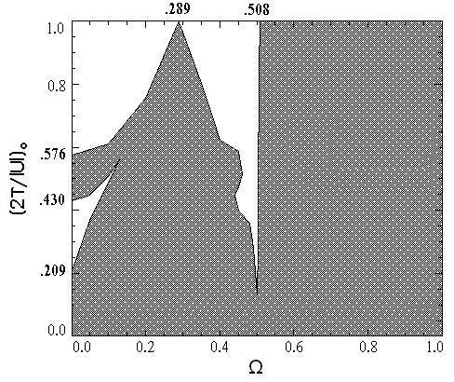
Fig. 1. The critical relation of the initial virial ratio on the model rotation degree for the bar-like mode of oscillation. The instability region is dashed.

At arbitrary Ω ≠ 0 we solve (14) numerically by means of periodical solutions stability method and find a relation of critical value of the initial virial ratio on the model rotation degree Ω (Fig.1). As it could be seen from the figure, in the region 0.209 < (2T/|U|)₀ < 0.430, 0 ≤ Ω < 0.12 there is an island of stability. The model rotation always plays destabilizing role, besides the interval 0.289< Ω < 0.49. The marginal curve goes up to value (2T/|U|)₀ = 1 at two values of Ω, namely Ω₁ = 0.289 and Ω₂ = 0.507. Тhe point Ω = Ω₁, λ = 0 is a stable one in the frame of linear approximation and forms the likeness of the bifurcation point on abscissa axis. At Ω > Ω₂ = 0.507 the linear and nonlinear oscillations are fully unstable.

4. NADE for the (4;0) mode.

Let us consider separately the concrete mode of oscillation N = 4; m = 0, the instability of which could led to the formation of the purely ring-like structure on the background of non-stationary model (1).
So, let
$δΦ=A_{\text{40}}(ψ){\left(x^{2}+y^{2}\right)}^{2}$ (17)
Тhen the centroid deviation in the disturbed system , according (10), defined in the following appearance
$\overline{δ\vec{r}}=4\int_{−∞}^{ψ}{Π^{3}\left(ψ_{1}\right) S\left(ψ,ψ_{1}\right)A_{\text{40}}\left(ψ_{1}\right)\overline{ {\vec{r}}_{1}\left(x_{1}^{2}+y_{1}^{2}\right)} {\text{dψ}}_{1}}$ (18)
Substituting this and (4) into the formula for the disturbed density
$\text{δσ}=−\frac{∂(σ\overline{δx})}{∂x}−\frac{∂(σ\overline{δy})}{∂y}$ (19)
we find
$\text{δσ}=\frac{\text{20}r^{4}σ_{0}}{Π^{2}\left(ψ\right)}\int_{−∞}^{ψ}{Π^{3}(ψ_{1})S(ψ,ψ_{1})A_{\text{40}}(ψ_{1}) }H(ψ,ψ_{1}){\text{dψ}}_{1}$ (20)

Introducing definition
$K_{τ}\left(ψ\right)=\int_{−∞}^{ψ}{{\left(1+{\text{λcosψ}}_{1}\right)}^{3}S(ψ,ψ_{1})A_{\text{40}}\left(ψ_{1}\right){\left(λ+{\text{cosψ}}_{1}\right)}^{3−τ}{\left({\text{sinψ}}_{1}\right)}^{τ}}{\text{dψ}}_{1}, τ=\overline{0−3}$ (21)
And taking into account the expression for H one could turn again, as in part II, to the differential form of NADE [10]
${ΛK}_{τ}\left(ψ\right)=\frac{\text{45}}{8}A^{}\left(ψ\right){\left(λ+\text{cosψ}\right)}^{3−τ}{\text{sin}}^{τ}ψ$ (22)

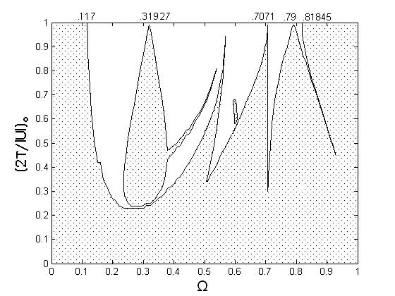
Fig. 2. The relation of the initial virial ratio on the rotation degree for the ring mode

NADE (22) is the system of differential equations of the 8-th order and could not be solved analytically. It was investigated by us numerically by means of periodical solutions stability method. So, we have plotted The critical relation of the initial virial ratio on the model rotation parameter (Fig.2). As it is seen from the Fig. 2, in the region Ω ≤ 0.117 the ring-like mode of perturbation is unstable for the random value of the virial ratio. Then the rotation in the region 0.117 < Ω < 0.3 plays the stabilizing role. In the vicinity of Ω ≈ 0.3, (2Т/|U|)₀ > 0.25 there is a имеется the elongated island of instability with additional narrow bifurcation. At Ω > 0.5 the regions of stability and instability are alternate, if (2Т/|U|)₀ > 0.3. At last , in the range Ω > 0.818 the model (1) is instable regarding the ring-like disturbances at the random value of the initial virial ratio. In the state (2Т/|U|)₀ =1 the critical values Ω =0.117 and 0.818 are well-known from the linear theory of instability, and in the points Ω =0.31927, 0.7071 and 0.79 the instability exists only in the frame of nonlinear model (1).

5. Discussion of results

If we compare the marginal relations in Figs. 1 and 2 for two oscillation modes considered by us above, than one could see that at (2Т/|U|)₀ < 0.2, the both oscillation modes are instable independently of rotation parameter value Ω, at that for both modes this instability has , in the main, non-periodic character. Above this region there is a oscillation-resonance instability, which is indicated by the complexly-linked roots of the characteristic equation, composed from the solutions of NADE in the point $ψ=2π$ by means of the periodical motions stability method. The both modes of oscillations are also instable at the random value of the initial virial ratio, if Ω > 0.82. In the vicinity of (2Т/|U|)₀ ≈1 there is an interval rotation parameter value 0.176 < Ω < 0.507, where the both oscillation modes are stable simultaneously. In the other cases it is difficult to resolve the common for the modes considered due to the complex picture of the marginal relations obtained. It is very important also the comparison of the instability increments for the bar-like and ring-like oscillation modes. In every case we calculated the corresponding values of the growth rates.
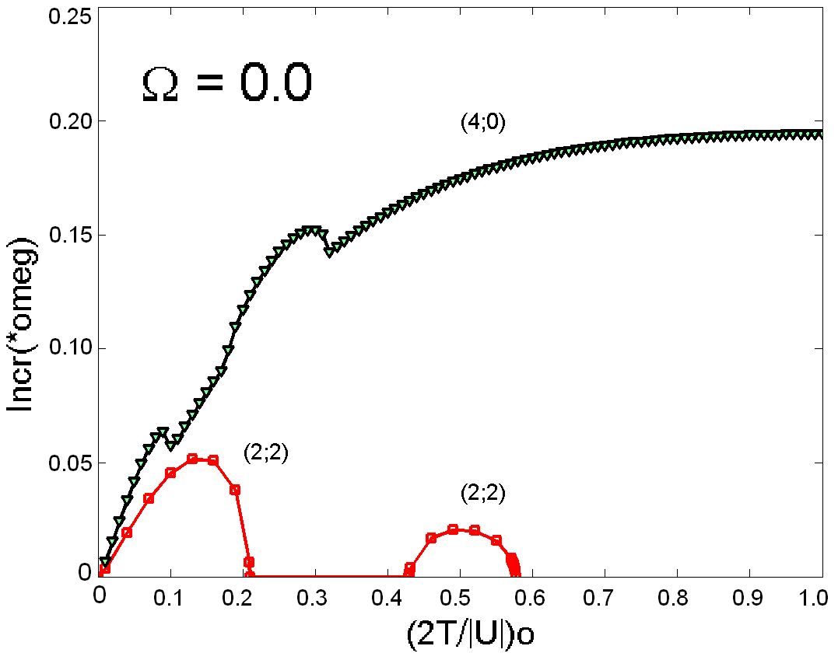 | 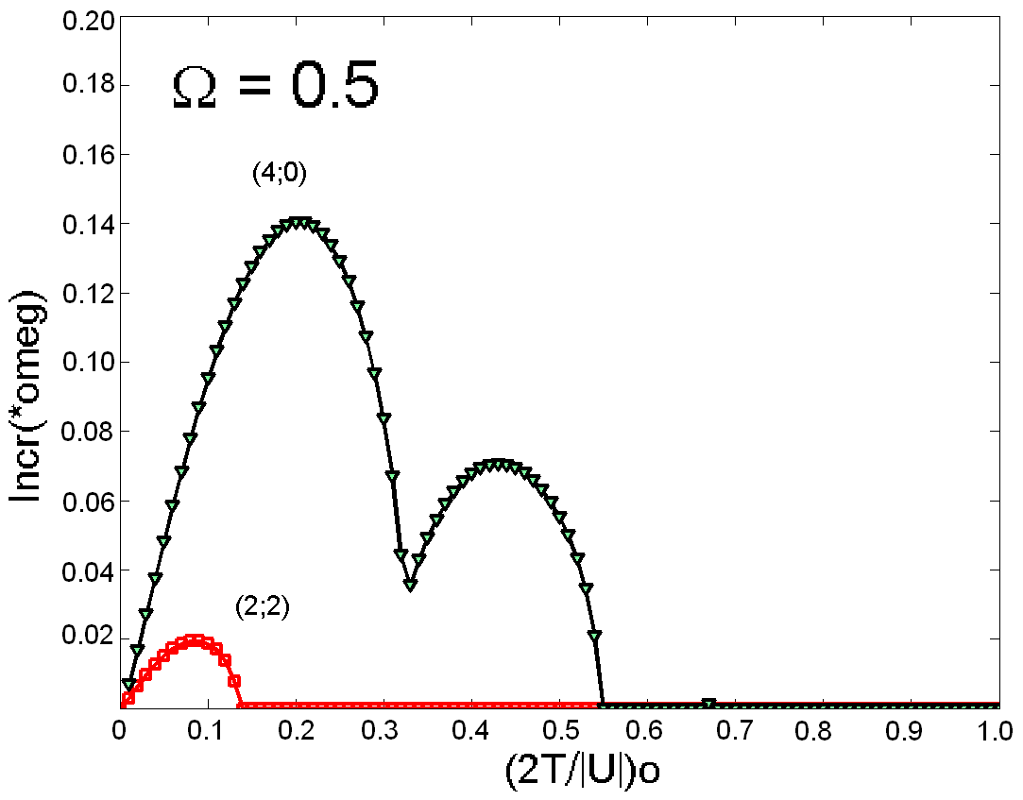 | 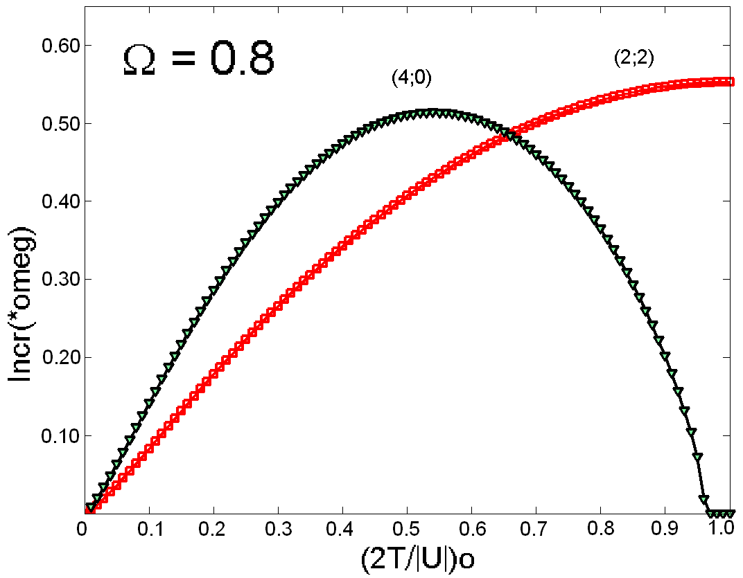
Fig. 3.The comparison of the instability increments of the bar-like and ring-like modes for the various model rotation parameter value.

In the Fig. 3 the relations of increments of the modes (2;2) and (4;0) on initial virial ratio for the various values of Ω. The calculations show that for the arbitrary value of the initial virial ratio Inc(4;0) > Inc(2;2) in the regions Ω < 0.15, 0.45 < Ω < 0.55 and Ω > 0.96. In the regions of the oscillating instability, when (2Т/|U|)₀ > 0.2, there is an opposite inequality Inc(2;2) > Inc(4;0), if 0.2 < Ω < 1. In the region of instability of the radial motions, when (2Т/|U|)₀ < 0.2 always Inc(4;0) > Inc(2;2) independently of the values of Ω.
The increment of the non-periodic instability is clearly higher than the oscillating instability. For the bar-mode the condition (2Т/|U|)₀ < 0.2 ia a criterion of non-periodic instability. However for the non-periodic instability of the ring-mode one needs the more strong condition (2Т/|U|)₀ < 0.10, because in the interval 0.11 < (2Т/|U|)₀ < 0.20 the instability of given mode has an oscillating character.
Though the parent nonstationar model (1) is sufficiently simple, but nevertheless the results obtained by us one could consider as a preliminary « sonde » applying to the early stages of evolution of separated non-collision systems, which are not only the stellar systems, but also the states of the pure dark matter. Our results have some relations to the theory of origin of SB -galaxies, containing the ring-like structure, because their diversity impossible to explain in the frame of one or two mechanisms.

6. Conclusions

Let’s note the main results we obtained in this work.
- The non-stationary analogues of the dispersion equations for the two modes of oscillations – the ring and the bar modes of perturbations on the background of radial oscillating model of self-gravity disc are obtained.
- The corresponding critical relations of the initial virial ratio on the rotation parameter are found for these two modes of oscillations.
3. The following criterion for the formation of SB-galaxies with the ring structure on the early non-stationary stage of their evolution is found: the initial total kinetic energy of the self-gravity disc should be not more than 5,2 percent of initial potential energy. Herewith the nature of instability is connected with the mechanism of radial motions instability, which has aperiodic character for the bar only in the region of small values of rotation Ω < 0.1, and for the ring structure the result and character of instability do not depend on the values of Ω.
The corresponding relations of instability growth rates on the values of an initial virial ratio and of rotation parameter Ω are calculated. The comparative analysis is given for the instability growth rates of two above-mentioned oscillation modes. In most cases the ring instability growth rate is larger than for bar-like one. In particular, for the arbitrary value of (2Т/|U|)₀ the growth rate of ring mode is always larger in the regions Ω < 0.05, 0.45 < Ω < 0.55 and Ω > 0.96. When (2Т/|U|)₀ > 0.2 the growth rate of bar-mode is larger than that of ring-mode, if 0.2 < Ω < 1.

References

1. de Vaucouleurs, G.//Ap.J., 1958, 127, 487
2. Vorontsov-Vel’yaminov B.A.// Astron.Zh., 1960, v.37, 381 - 386
3. Kostyuk I.P.//Soobscheniya SAO AN, 1975, 13, p.45-62; 1979, 26, 33-50
4. Nuritdinov S.N., Usarova М. //Problems of the physics and the dynamics of stellar systems, Тashkent., 1989, 49
5. Buta R. // Astrophys. J.Suppl.Ser., 1995, V.96, № 1, p.39-116
6. Nuritdinov S.N.//Dynamika gravitiruyushih system i methods analyticheskoy nebesnoy mehaniki, Alma-Ata:Nauka, 1987, с. 65 – 67
7. Nuritdinov S.N. //Astronomicheskiy Tsirkular Russ.Acad.Sci., 1992, № 1553, с. 9–10
8. Bisnovaty-Kogan G.S., Zel’dovich Ya.B. // Astrophizika, 1970, T.6, с. 387-393
9. Ostriker J.P., Peebles P.J.E.//Ap.J., 1973, v.186, 467.
10. Nuritdinov S.N., Mirtadjieva K.T., Mariam Sultana // Astrophysics, 2008 ( in press ).

