Microlensing events in gravitationally lensed quasar Q2237+0305:
stars or dark matter?

© A.A. Minakov¹, R.E. Schild², V.G. Vakulik^{1, 3}, G.V. Smirnov³, V.S. Tsvetkova¹

¹Institute of Radio Astronomy of Nat.Ac.Sci. of Ukraine, Krasnoznamennaya 4, 61002 Kharkov, Ukraine
²Center for Astrophysics, 60 Garden Street, Cambridge, MA 02138, U.S.A.
³Institute of Astronomy of Kharkov National University, Sumskaya 35, 61022 Kharkov, Ukraine
Email: minakov@ri.kharkov.ua , rschild@cfa.harvard.edu, vakulik@astron.kharkov.ua, gleb.smirnov@gmail.com, tsvetkova@astron.kharkov.ua

Abstract: Some principal results obtained during two decades of observations of Q2237+0305 are presented. Typical approaches used to interpret the light curves of gravitationally lensed quasars (GLQs) are discussed, their advantages and weak points are analyzed. Simulation and statistical analysis of the Q2237+0305 light curves were fulfilled using the data taken in the V filter by the OGLE monitoring program during 1997–2000, and in the R and I filters at the Maidanak Observatory (Central Asia) for the same time period. The estimates of the source dimensions and characteristic microlens masses were obtained. Probability distributions for the brightness variations of the Q2237+0305 components built from the observations of 1986–2006 in the R filter are analyzed. Some problems inherent in interpreting the high magnification events in Q2237+0305 as a result of microlensing by the stars populating the lensing galaxy are discussed.

1. Introduction

It became clear almost three quarters of a century ago that, to explain the velocity dispersion in galaxy clusters [1], it is necessary either to assume a more slow decrease of gravity at large spatial scales as compared to the Newton law, or to admit that an unknown hidden mass exists in the Universe, which escapes observations so far. This has lead to a concept of “dark matter”, which interacts with the usual matter only gravitationally, and as an alternative, to development of the so called modified theories of gravity [2,3], which are presently supported by, e.g., [4]. Baryonic dark matter, such as dust and invisible objects has been searched for initially. However, recent cosmological models exploring a hypothesis of the accelerated expansion of the Universe, have lead to the idea that a contribution of the baryonic matter is as small as about 5%, and that the Universe consists mostly of hypothetic particles of cold dark matter (CDM, about 23%) and of dark energy contributing about 70%.
At present, the most promising method of discovering dark matter and direct estimation of its contribution into a total cosmological density is seen in the use of a phenomenon of gravitational lensing at various spatial scales of the Universe. Three types of gravitational lensing are distinguished, which differ in their potentials to solve the dark matter problem: galactic lensing, strong lensing and weak lensing.
Till recent times, a great bulk of the world’s observational resources was dedicated to studies of galactic microlensing initiated by B.Paczyński [5] within the framework of the known MACHO (Massive Astrophysical Compact Halo Objects) project. Paczyński proposed to use the events of gravitational microlensing of stars in the nearby galaxies by compact bodies of our Galaxy. These events reveal themselves in brightness changes of stars caused by the mutual motion of a star, a microlens and an observer. Though a probability of such events is very low (for example, it equals 10⁻⁶ events per year for the Large Magellan Cloud, LMC), – one can expect detection of several microlensing events during a year when observing several millions of stars in the LMC with the use of panoramic detectors. A contribution of compact bodies with masses of into a total mass of the dark halo of the Galaxy derived from duration and frequency of such events has been estimated to be less than 10%.
In contrast to the case of galactic lensing, which provides information only about compact objects in the halo of our Galaxy, brightness variations of macroimages in gravitationally lensed quasars caused by microlensing by objects of a lensing galaxy contain information both about the stellar component of the surface density of the lensing galaxy matter, and about smoothly distributed matter, with a possibility to separate these two components. Recent studies [6, 7] suggest that the fraction of mass in smooth matter noticeably exceeds that in stars for most of lensing galaxies. It is well known that analysis of microlensing light curves of Q2237+0305 gives mostly small masses of microlenses [8, 9]. The light curves of Q0957+561 can also be explained assuming the effect of very small masses, which are present along with the stellar ones [10].
The most comprehensive information about statistical characteristics of light curves of macroimages of quasars can be obtained from the analysis of probability density distributions of their amplifications produced by microlensing. There are a number of works, where such distributions were built from simulations of microlensing events for some objects for various relative contributions of a lensing galaxy mass contained in stars and in smoothly distributed matter, for example [11]. There are no works, however, where simulated probability distributions of microlensing magnification would be compared to those obtained from the observed light curves. This is caused by several reasons. One reason is that the available light curves are poorly sampled as a rule, with inevitable gaps caused by weather conditions and periods of the object invisibility. To make the observational data suitable for statistical analysis, a method to correctly interpolate them should be found. Another problem to be solved for the subsequent statistical analysis of microlensing light curves is a necessity to exclude a constituent caused by the quasar intrinsic brightness variations. And finally, the last but not the least, it should be remembered that the observed light curves are encoded by the source quasar: its size and surface brightness distribution is a clue to correctly interpret the light curves of macroimages.
Using one of the most frequently observed gravitationally lensed quasar Q2237+0305 as an example, we tried to direct the way to solution of these problems, and made an attempt to obtain preliminary estimates of magnification probability distribution from the available light curves of the Q2237+0305 components.

2. Estimation of the source quasar dimensions

As was indicated above, knowledge of the source quasar structure and dimensions is badly needed to adequately interpret the observed light curves of gravitationally lensed quasars. On the other hand, light curves of microlensing events provide the most important initial information to determine the effective size of the source quasar. To do this, one has to use a prior physically validated information concerning the spatial structure of quasars.
The mechanism of accretion onto the massive black hole is presently believed to provide the most efficient power supply in AGNs (quasars), and effectively all researchers uses various accretion disk models when interpreting microlensing events in gravitationally lensed quasars, (see e.g., most recent publications [12,13]. However, with the accretion disc being generally accepted as a central engine in quasars, the difficulties in explaining the observed polarization and spectral properties of quasar radiation and their variety still remain, [14,15], as well as the amplitudes of the long-term microlensed light curves and color effects in microlensing [10,16].
The above considerations suggest that the existence of extended structures in quasars should be expected, and there is observational evidence for these structures in the Q2237+0305 quasar, such as mid-infrared and radio observations [17,18], observations in the broad emission lines [19]. Recently, it has been shown that the accretion disk alone fails to reproduce in simulations the microlensing brightness variations observed in the optical continuum in Q0957+561 [10] and in Q2237+0305 [9].
The first attempts to interpret microlensing light curves of Q2237 aimed at determining the source quasar dimensions and estimation of characteristic mass of microlenses were based upon the analysis of individual microlensing events interpreted as a simple crossing of a caustic fold by the source. With such a simple approach, a fundamental conundrum was immediately encountered: microlensing simulations produced sub-stellar mass estimates and cosmologically unwarranted large transverse velocities, and large microlensing amplitudes.
A statistical approach seems to be more promising, wherein the quasar's size estimates are obtained through the analysis of the lensed light curves as a whole, and much less specific assumptions on the microlensing event peculiarities are needed. There are several attempts to apply statistical analysis to the existing light curves of Q2237, such as, for example, structure function analysis by Lewis and Irwin [20], or analysis of the distribution of light curve derivatives [21].
A version of statistical approach, which can be referred to as the method of statistical trials, has been recently developed by Kochanek [22]. In our recent work, [9], we analyze the Q2237 microlensing light curves using a two-component model of the quasar's structure, and apply a statistical approach which is in general similar to that of Kochanek [22]. A two-component model of a quasar spatial structure consisting of a compact central source and an extended outer structure was proposed. Though surface brightness of such outer structure must be much less than that of the central source in optical wavelengths, microlensing light curves of these complicated source structure may noticeably differ from those for a simple compact source structure represented by a uniform disk or accretion disk alone.
Our basic approach is to accept the existence of inner and outer structural elements as detailed above, and to derive from parameter fitting only the size of the inner luminous feature, and the fraction of the total UV-optical energy from the extended outer feature as compared to the luminosity originating in the compact central feature. The structural elements of this two-component quasar model were shown to satisfactorily explain the observed microlensing brightness curves.
To characterize similarity of the simulated and observed light curves, statistics for each image component was chosen:
(1)
where is the observed light curve of the -th component, and is one of the simulated light curves, produced from a source trajectory at the magnification map. The magnification map was calculated for the source model described by a set of parameters , which could be varied. The quantity characterizes the errors of the observed light curve measurements.
The probability that, for a given set of parameters , a simulated light curve will be close enough to the observed light curve, – that is, the value of will happen to be less than some boundary value , – such a probability will be:
(2)
where is a number of successful trials, and is a total number of trials. The boundary value was adopted for calculations.
For better comparison, we adopted, following Kochanek [22], a probable projected cosmological transverse source velocity of to determine a linear size of the compact central source of . This size was estimated by Kochanek [22] to be for the accretion disc model and for the same transverse velocity, (, where is the excepted value of the Hubble constant). For the relative size of the source of ( is the mean Einstein radius of a microlens), the estimate for the average microlens mass is .

3. Approximation of microlensing light curves with the use of the sampling theorem

The attempts to represent light curves by the low-frequency splines provide good results, but unfortunately, such an approximation does not contain any physical meaning. Meanwhile, the frequency characteristics of light curves can be shown to depend on the effective size of the source, which plays a role of a smoothing factor, and the spectra of light curves are known to be rapidly decreasing functions. Based on this fact, an attempt was made to find the algorithm of light curves approximation, which would take into account their expected statistical characteristics, and, if possible, would allow a relevant smoothing of the experimental data and their interpolation to the time intervals, when the objects cannot be observed.
To approximate a light curve, let us use an expression well known in optics, radio engineering and theory of information as the sampling theorem, supposing that the function that has a monotonely decreasing spectrum can be represented with some accuracy by a function with a bounded spectrum:
, (3)
where the function is specified as , and are samples of taken at a net with a step , which is determined by the boundary frequency of the function spectrum: . This expression means a possibility to accurately reconstruct the signals with bounded spectra from the series of their samples taken at a raster with the step called the Nyquist interval.
Unfortunately, discrete measurements of light curves do not represent a set of even samples. However, if a number of initial measurements at the time interval under consideration is much larger than the assumed number of samples needed to represent the function at this interval according to (3), then the values at the sampling points can be obtained using redundancy of the information contained in the light curves.
Using a prior information about the source size and surface brightness distribution and about the relative velocity of the source, we may estimate the expected width of the approximating function spectrum and, correspondingly, the value of the Nyquist interval. The values ofin the sampling points can be determined from the condition of minimum of a functional:
, (4)
where are the initial data, are the values of function determined by (3) at the proper time moments , and N is a number of measurements used in the light curve . The least square minimization of the functional results in solving a system of linear equations for K unknown values .
Since the approximating function is a somewhat smoothed estimate of the actual light curve , the largest differences can be shown to exist near extrema of function , while their values will be in general proportional to the second derivative of . Therefore, a noticeable correlation between the deviations of experimental points from the approximating function and the values of its second derivatives in these points may be an indication that the interval should be shorten.
It should be noted that the presence of boundaries in experimental data is a separate problem, but we can not discuss it here because of the limited space for this publication.
Thus, the approach presented above permits not only to obtain smooth and physically justified approximation of the light curve, but also to estimate a characteristic size of a lensed source.

4. Estimation and accounting for the quasar intrinsic brightness variations

Quasars are known to be variable objects, and their luminosities may change noticeably on time-scales of several years, months, and even days. If a variable source is macrolensed, the intrinsic brightness variations will be observed in each lensed image with some time delays. This is just the fact that allows the Hubble constant to be determined from measurement of the time delays. In the analysis of microlensing, however, variability of the source is an interfering factor, which needs to be taken into account.
In the Q2237+0305 system, because of an extreme proximity of the lensing galaxy, (z = 0.04), and because of the almost symmetric locations of the macroimages with respect to the lens galaxy center, the expected time delays do not exceed a day, (e.g. [23, 24] ). This is why the intrinsic brightness variations of the source would reveal themselves as almost synchronous variations of brightnesses of all the four lensed images. This was observed in 2003 [25], when the microlensing activity was substantially subdued for all four image components.
Therefore, the variance of the sum of the light curves and of the Q2237+0305 components, for example, A and B, can be represented in the following way:
, (5)
where, are variances of the light curves of the components, , are errors of brightness measurements, and is a variance of the source brightness. Respectively, the variance of difference of the corresponding light curves does not contain a variance of the source brightness
(6)

Table 1. Mean-square deviations of sums and differences of light curves for pairs of Q2237 components

 | σ_{A+B} | σ_{A+C} | σ_{A+D} | σ_{B+C} | σ_{B+D} | σ_{C+D}
V (OGLE) | 0.421 | 0.468 | 0.348 | 0.436 | 0.416 | 0.413
R (Maidanak) | 0.369 | 0.333 | 0.241 | 0.406 | 0.381 | 0.305

 | σ_{A–B} | σ_{A–C} | σ_{A–D} | σ_{B–C} | σ_{B–D} | σ_{C–D}
V (OGLE) | 0.377 | 0.234 | 0.192 | 0.430 | 0.294 | 0.208
R (Maidanak) | 0.347 | 0.211 | 0.123 | 0.381 | 0.287 | 0.183
Thus, comparing variances of the light curves sum and difference for a pair of components, one can obtain a statistical estimate for the variance of the source quasar brightness changes. For Q2237+0305, six sums and six differences of light curves can be composed for 4 image components. In Table 1, the mean-square deviations of sums σ_{A+B} and differences σ_{A–B} for pairs of components are presented, which were calculated from the light curves taken in 1997–2006 in the V filter in the framework of the OGLE project [26], and at the Maidanak Observatory in the R filter. The estimates of the mean-square deviations of the light curves sums are systematically larger than those of the light curves differences for both filters, that suggests noticeable variations of the source brightness. The estimate of σ_{S} averaged over all pairs of components turned out to be σ_{S} = 0.14 ^{m} ± 0.04 ^{m} for the V filter data, and σ_{S} = 0.11 ^{m} ± 0.05 ^{m} for filter R data. Thus, in Q2237+0305, the amplitude of the source brightness variations, especially during the last 7–8 years, is comparable to the amplitudes of the brightness changes, which are due to microlensing events, and therefore, variations of the source brightness may distort the results of statistical analysis noticeably.
Generally, separation of the intrinsic brightness variations of the source from the light curves containing microlensing events is a poorly defined and intricate task. The first approximation for the source light curve was calculated as the weighted average of the four light curves, where the weight for the n-th component was estimated for every time moment to be proportional to the value
(7)

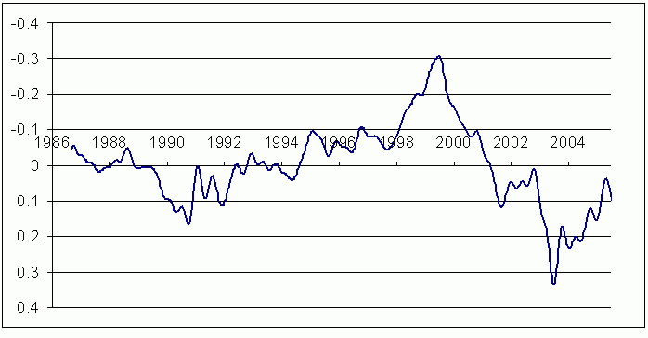
Fig.1. Estimate of the quasar intrinsic brightness variations in Q2237+0305.

It is easily understood from (7) that if a microlensing event was observed for a particular component at a particular time moment, a derivative of its light curve will noticeably differ from the average derivative, and thus the corresponding values will enter with the minimal weight into the estimate of the average light curve of the source quasar.
In Fig. 1, the quasar Q2237+0305 intrinsic brightness variations curve is presented, which was obtained with the use of all available observations in the R band during the time period from 1986 to 2006 [16, 27, 28, 29, 30]. The full range of brightness changes corresponding to a “slow” component of variations is about 0.6 ^{m} at this time period.

5. Magnification probability distributions from the Q2237+0305 light curves in filter R; preliminary results

As was noted in section 1, a method of estimation of the dark matter content in lensing galaxies of quadruply lensed quasars suggests building of histograms representing magnification probability distributions caused by microlensing events, and the subsequent comparison with those obtained from simulations for various contributions of smoothly distributed matter with respect to the matter contained in stars.
To build the histograms of microlensing brightness variations of the Q2237+0305 components, we used all available photometry data obtained in the V filter during 20 years [16, 27, 28, 29, 30]. After removing of the source variations from the light curves of components, and approximation with the use of the sampling theorem as was described above, the smooth microlensing light curves were obtained. The observed data points (symbols) and the corresponding approximating curves calculated with the Nyquist interval of are shown in Fig. 2. The RMS errors of such approximation are for components A, B, C and D, respectively, which are comparable with the photometry errors.

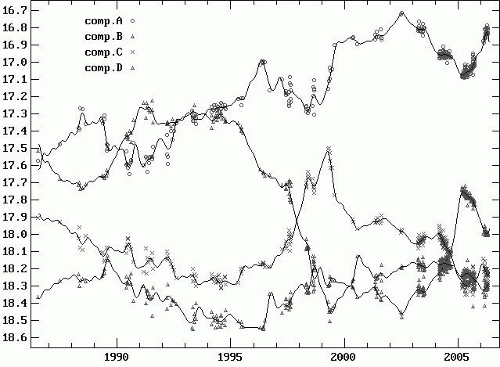

Fig.2. Light curves of the Q2237+0305 components in the R filter with the quasar brightness variations subtracted (symbols). Results of their approximation with the use of the sampling theorem are shown with smooth curves (the Nyquist interval is 0.23 yr).

Supposing 3300 km/s for the value of the transverse velocity at the source plane, the estimate of the effective size of the source compact feature was obtained to equal. Histograms of magnification probability distributions for the A and C components presented in Fig. 3 were built with a step . Since, according to most of the macrolens models for Q2237+0305 (e.g. Kochanek [22] ), the expected microlensing parameters for pairs of opposite components (A and B, C and D) are very similar, the joint histograms for these pairs were built as well.

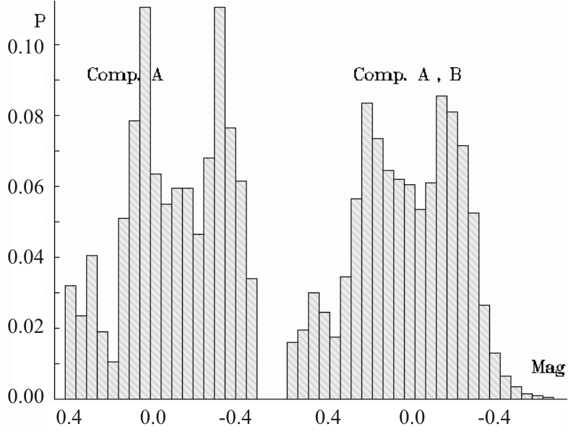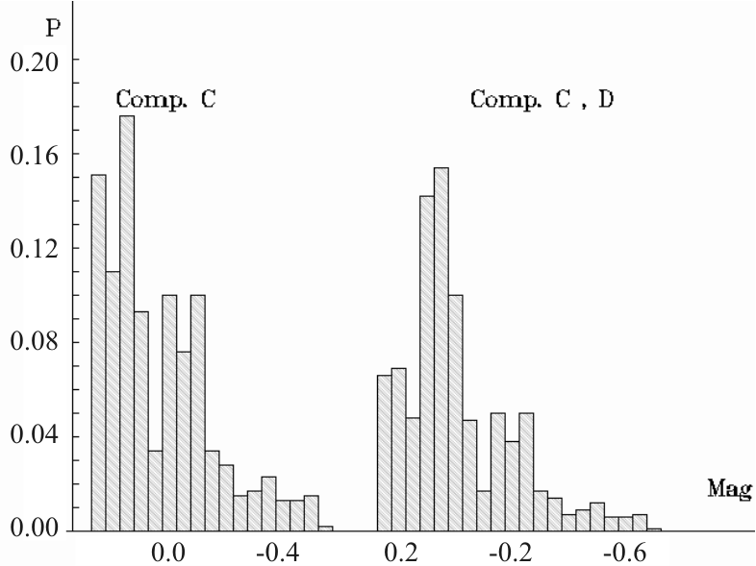

Fig.3. Histograms of magnification probability distributions for components A and B (to the left) and C and D (to the right) of the quadruple system Q2237+0305 built from all available photometry data in the R spectral band.

First of all, a significant difference of histograms for pairs A – B and C – D should be noted, that is a consequence of different parities of these images: A and B correspond to the minima of the Fermat surface, while C and D are the so called “saddle” images. Schechter and Wambsganss [31] were the first to notice this fact. The microlensing parameters и are also different for these pairs, and besides, different contributions of the lensing galaxy matter contained in stars and that one represented by a smoothly distributed matter can be naturally expected for these pairs because of different distances to the galaxy center. The histogram for the A – B pair is noticeably wider than for C – D and has a clear bimodal character. A high probability of deamplifications (positive values at the horizontal axis) should also be noted for the C and D components, much higher than for the A – B pair, which is consistent with the simulations by Schechter & Wambsganss [31]. The further investigations suggest simulations of microlensing events for various relative contributions of stellar component and smoothly distributed matter, with the subsequent comparison with the histograms obtained from the data of observations.
The results presented here are of a preliminary character, but nevertheless, it can be argued already that the method of determining dark matter contribution based on the analysis of statistics of microlensing brightness variations in quadruply lensed quasars are very promising. Our future work will be dedicated to development of such approach.
The authors from Ukraine are thankful to the Ukrainan grant “Cosmomicrophysics” which has made this investigation possible.

References

1. Zwicky F. // Helvetica Physica Acta. 6, 110 (1933).
2. Milgrom M. // ApJ.270, 365 (1983).
3. Bekenstein J., Milgrom M. // ApJ. 286, 7 (1984).
4. Brownstein J.R., Moffat J.W. // MNRAS 382, 29 (2007).
5. Paczynski B. // ApJ. 304, 1 (1986).
6. Schechter P., Wambsganss J. // ApJ. 580, 685 (2002).
7. Dalal N., Kochanek C.S. // ApJ. 572, 25 (2002).
8. Gil-Merino R.; Lewis G.F. // A&A. 437, L15 (2005).
9. Vakulik V.G., Schild R.E., Smirnov G.V., et al. // MNRAS. 382, 819 (2007).
10. Schild R., Vakulik V. // Astron. J. 126, 689 (2003).
11. Schechter P., Wambsganss J. // IAUS Proc. No.220, 103 (2004).
12. Yonehara A. // ApJ, 548, L127(2001)
13. Gil-Merino R., Gonzalez-Cadelo J., Goicoechea L.J., et al. // MNRAS. 371, 1478 (2006).
14. Ferland G.J.; Rees M.J. // ApJ. 332, 141 (1988).
15. Laor A., Netzer.H. // MNRAS. 238, 897 (1989).
16. Vakulik V.G., Schild R.E., Dudinov V.N., et al. // A&A. 420, 447 (2004).
17. Agol E., Jones B., Blaes O. // ApJ. 545, 657 (2000).
18. Falco E.E., Lehar J., Perley R.A., et al. // ApJ. 112, 897 (1996).
19. Lewis G.F., Irwin, M.J., Hewett, P.C. et al. // MNRAS. 295, 573 (1998).
20. Lewis G.F., Irwin, M.J.// MNRAS. 283, 225 (1996).
21. Wyithe J.S.B., Webster R.L., Turner, E.L. // MNRAS. 318, 1120 (2000).
22. Kochanek C.S. // Ap J. 605, 58 (2004).
23. Wambsganss J., Paczynski B. // AJ. 108, 1156 (1994).
24. Schmidt R.W., Webster R.L., Lewis G.F. // MNRAS. 295, 488 (1998).
25. Vakulik V.G., Schild R.E., Dudinov V.N., et al. // A&A. 447, 905 (2006).
26. Udalski A., Szymanski M. K., Kubiak M. et al. // 2007. arXiv: astro-ph/0701300
27. Corrigan R.T., Irwin M.J., Arnaud J., et al. // AJ. 102, 34 (1991).
28. Ostensen R., Refsdal S., Stabell R, et al. // A&A. 309, 59 (1996).
29. Burud I., Stabell R., Magain P. et al. // A&A. 339, 701 (1998).
30. Vakulik V.G., Dudinov V.N., Zheleznyak A.P., et al. // Astron. Nachr. 318, 73 (1997).
31. Schechter P., Wambsganss J. // ApJ. 580, 685 (2002).

