To a question on possible mesh large-scale structure of the universe

© G.V. Zhizhin^{1,2}

¹North-West State Correspondent Technical University, St.-Petersburg, Russia
²Email: gv@nwpi.ru

Abstract: On the basis of the analysis of photos of the universe received for program Sloan Digital Sky Survey (SDSS), and their comparison to results of researches of possible variants of filling of space the regular, semi regular, equiangular and not equiangular polyhedrons adjoining to each other on the whole sides, the assumption about mesh large-scale to structure of the universe expresses. It is established, that this mesh structure the truncated octahedron with the average maximal size 40 Mpc can be elementary cell. Sides of an elementary cell represent super congestions of galaxies (J.B.Zel'dovicha's "pancakes"). The equations for extending mesh model of the universe are received. It is shown, that the mesh model of the universe will qualitatively be coordinated to known models Einstein –de Sitter’s and Friedman - Lemaitre’s, with that difference, that the mesh model of the universe contains the parameters describing mesh large-scale structure varied in time of the universe.

- Introduction
As is known the determining role in evolutionary development of the universe is played with the space scale factor $R(t)$, which has been introduced for the first time in consideration by A.A.Friedman in 1922. The base modern cosmology makes opening at the end of 20-th century of large-scale structure of the universe consisting of super congestions, each of which contains on one hundred, thousand and to one million galaxies. For the first time the theory of large-scale structure of the universe long before it’s opening was created by J.B. Zel'dovich. Experimental astrophysical supervision has confirmed J.B.Zel'dovich's prediction that super congestions under the form and a spatial configuration are similar to huge pancakes. Mysterious phenomenon is existence between super congestions of dark emptiness which understanding represents the important problem modern cosmology.

2. A hypothesis about mesh large-scale structure of the universe

In the given work on the basis of the analysis of photos of the universe received under program Sloan Digital Sky Survey (SDSS), the assumption that the large-scale structure of the universe represents a spatial network expresses, sides of many-sided which elementary cell and are super congestions of galaxies (J.B.Zel'dovich's "pancakes"). The question on filling space by polyhedrons, adjoining to each other on the whole sides, interests people from the Ancient World. Last years interest to these questions again has increased in connection with researches super molecular structures of substances and nanotechnology. By regular, semi regular, equiangular and not equiangular polyhedrons and their combinations under condition of adjoin polyhedrons to each other by the whole sides all possible ways of filling of space are classified [1,2]. One of these ways of filling of space is filling space by the truncated octahedron (fig.1a, b).
In a nature this way of filling of space is distributed. Still in 1932 [3] it was noticed, that cells biological a fabric look like the truncated octahedron and can fill in space indefinitely. Prominent feature of such filling (and only it) is contact on edges of identical length at once three polyhedrons. It means, that in any section of such filling next in a vicinity of each common top internal area of three polyhedrons will be located. If to address to a photo of the universe (fig. 2) on it dark areas divided by three light partitions, which are starting with some point (top) are clearly visible. And such tops are almost in regular intervals distributed on all plane of a photo. Approximately 70 % of all photographed area of the universe can be divided into 23 formations, each of which consists of three dark areas. Using the scale specified in a photo, it is possible to define the characteristic size of an elementary cell of large-scale structure of the universe as the truncated octahedron. The average size of dark areas in a photo changes from 20 up to 40 Мpc.

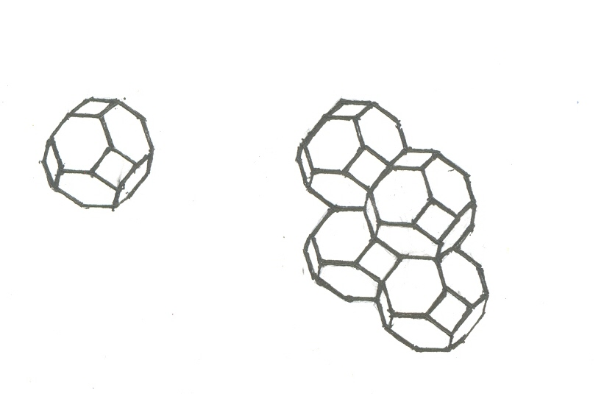
- b)

Fig. 1. Filling of space by the truncated octahedrons
а) The truncated octahedron, b) a fragment of filling of space the truncated octahedrons

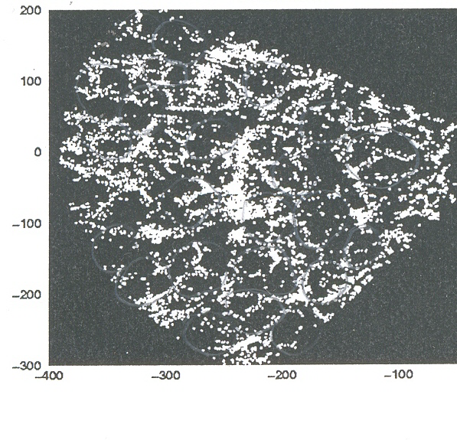
Fig.2. The fist release of the SLOAN galaxy survey shows galaxy structures up to hundreds of Mpc

It, apparently, is connected by that the plane of a photo can dissect an elementary cell in its different places with the different area of section. For an estimation of the characteristic size of an elementary cell obviously it is necessary to take the maximal size of dark area. Thus, the characteristic size of an elementary cell of large-scale structure of the universe makes now 40 Мpc. It is logical to assume, that during expansion of the universe the characteristic size of an elementary cell of large-scale structure of the universe changes. Thus the geometrical form of a cell can be kept, being increased at a rate of in a similar way as uniformity and isotropic results expansions of the universe in uniform increase of the size of super congestions, which represent sides of an elementary cell.

- The equations of extending mesh model of the universe

For a conclusion of the equation describing change of the space scale factor$R(t)$ in mesh model of the universe, we shall consider the spherical area containing n spherical environments. Each of spherical environments (modeling as a first approximation truncated octahedron sphere) isotropic extends as well as all spherical area including environments, with speed $u$. We count, that the weight is distributed on an environment with uniform density $d$, and inside an environment (as against homogeneous models of the universe) weights are not present. Kinetic energy of a mass unit of spherical area is $1/2u^{2}$. The volume of spherical area (remembering that environments model the truncated octahedron) is equal to the sum of volumes of environments $V={\text{nv}}_{m},v_{m}=4/3{πr}_{m^{3}}$, and $r_{m}$ - radius of an environment. Besides, $V=4/3{πr}_{b^{3}}$, where $r_{b}$ - radius of spherical area, i.e. $r_{b}=r_{m}n^{1/3}$. As sides of environments are common for two elementary cells the weight of spherical area is $M={{\text{nM}}_{m}}/2$and $M_{m}=4π{\text{dr}}_{m^{2}}$ - weight of an environment. Potential energy of a mass unit of spherical area is equal ${\text{GM}}/{r_{b}}$, where $G$ - a gravitational constant. We determine a constant of curvature, identical in all space and not dependent on time - ${−1}/2{\text{kr}}_{{m0}^{2}}$, where $r_{m0}$ - radius of an environment at some moment of time. Taking into account the law of conservation of energy, we receive

$1/2u^{2}−{\text{GM}}/{r_{b}}={−1}/2{\text{kr}}_{{m0}^{2}}\text{.}$ (1)

Using relation Hubble required isotropy, where $H=\frac{\text{dR}(t)}{R(t)\text{dt}}$, expressing weight of spherical area and its radius through weight and radius of an environment, taking into account, that ${\text{dr}}_{m^{2}}=d_{0}r_{{m0}^{2}}$, where $d_{0}$ - density of weight in an environment at the chosen moment of time, and $r_{m}=R(t)r_{m0}$, we receive from (1) after transformations the differential equation for the space scale factor $R(t)$

$H^{2}−{\text{Gd}}_{0}4π/(R^{3}r_{m0})={−k}/(n^{2/3}R^{2})\text{.}$ (2)

The result, consisting that the equation (2) for the space scale factor $R(t)$ of mesh model of the universe to within factors coincides with Friedman equation for the homogeneous extending universe is surprising. From here follows, that the mesh model of the extending universe qualitatively does not contradict the accepted known models of extending universe Einstein –de Sitter’s and Friedman - Lemaitre’s and to basic laws of expansion at various values of curvature of space. Difference is, that the equations of the mesh-extending universe include the parameters describing elementary cells of large-scale structure of the universe, allowing quantitatively defining influence of these parameters on process of expansion of the universe.

4. The conclusion

The assumption that the large-scale structure of the universe represents a spatial network along which space bodies are grouped, will be coordinated to visual supervision of the universe, with modern theories about evolution of the universe, with known regulations about opportunities of filling of space geometrical elements and with the general representations about step-type behavior of a matter. Further more detailed quantitative analysis of this assumption and consequences following from it are of interest.

References

1. Жижин Г.В.// Жизнь и безопасность, 2005, № 1-2, с. 551.
2. Жижин Г.В. Архитектура. Строительство. Экология. С.-Петербург: Изд. Вернера Регена, 2006, с.215.
3. Lewis F.T. //Proc. Amer. Acad. of Arts and Sci. 1923, v..LVIII, p.537.

