Nearby quasars in SDSS

© P.Heinämäki ^{1,3}, P.Nurmi ¹, E.Tago ², E.Saar ², J.Liivamägi ², E.Tempel ², M.Einasto ², J.Einasto ², H.Lietzen¹, L.Takalo¹

1 Tuorla Observatory, University of Turku, Finland
²Tartu Observatory, Estonia
3Email: pekheina@utu.fi

Abstract: Recent spectroscopic galaxy redshift surveys are reaching the scales where the closest quasars can already be seen. This allows us to study quasar environments both locally and globally and to provide new constraints on quasar evolution models. Specifically, we study the spatial distribution of galaxies around nearby quasars, based on the Sloan Digital Sky Survey - Fifth Data Release (SDSS DR5). We use two different approaches to study the quasar environments -- comparing number densities of galaxies around quasars and galaxies, and using the global luminosity density field of the SDSS.
Our preliminary results show that the local density of neighbour galaxies around quasars is a function of galaxy luminosity and the scale. Quasars are located in relatively low-density regions among the SDSS galaxies.

1. Introduction

The unified scheme proposes a common physical background for different types of AGN phenomena, suggesting orientation-based classification (depending on line-of-sight to the AGN). Observational results can be mostly explained by this standard AGN unified scheme [1]. From this point of view it is interesting that recent observations of the environmental dependence of the nuclear activity show quite dissimilar results depending on the type of AGN [2]. These results have led also to different evolutionary models for the AGN phenomena [3]. For example, observations based on SDSS suggest that the fraction of galaxies with an AGN does not depend of their environment, and that there is no AGN-density relation for the early- and late-type galaxies [3], leading to the evolutionary model where the AGN population is primarily tracing only the bulge component of galaxies. On the contrary, more recent SDSS observations show that AGN are more common in voids, among moderately luminous and massive galaxies [4]. Moreover, AGNs with high emission [O III] line luminosities seem to be more common in low-density regions than in high-density ones [5]. Analysis of the SDSS survey and the galaxy environment around quasars suggest that within ~ 0.1-0.5 Mpc quasars are located in higher density environments than the L* galaxies [2]. These observations support a model where the local density excess contributes to triggering of quasar activity through mergers and other interactions.
Despite somewhat contradictory results, the densities of the local and global environments seem to have an important role for the AGN and quasar activity. This is probably not surprising, as it is well known that the environmental density affects the properties of galaxies (the so-called morphology-density relation [6]). Luminous, non-star-forming early-type galaxies populate denser regions than late-type, star-forming galaxies. It is an interesting question if the physical mechanism behind the AGN abundance and the enhanced fraction of star-forming galaxies in low-density regions is the same [5].

The SDSS spectroscopic galaxy survey allows us for the first time to study quasars and spectroscopically selected galaxies together in the same volume.
We report here our preliminary results on the galaxy distribution around nearby quasars and describe how quasars are embedded in the global luminosity density field.

2. Galaxies around Quasars

In this analysis we use a sample of galaxies and quasars with spectroscopic redshifts from the Sloan Digital Sky Survey Fifth Data Release (SDSS-DR5, [7]). The SDSS-DR5 main galaxy sample contains 674749 galaxies with spectroscopic redshifts of accuracy of 30 km/s rms. The final data set used here, the Tago group catalogue [8], contains overall 387063 carefully selected galaxies and 50362 groups of galaxies (see [8] for more detail). From the main galaxy sample of the Tago catalogue we extracted four volume limited subsamples with the following magnitude limits: M_{gal} <-21, M_{gal}<-21.5, M_{gal} <-22, and M_{gal}<-22.5 (Petrosian r-magnitudes). The samples contain 106378, 37181, 7790, and 985 galaxies, respectively. In terms of co-moving distance the condition M_{gal}<-21 restricts the sample range between 200 Mpc/h and 500 Mpc/h (for the concordance cosmological model).
The SDSS-DR5 quasar sample [9] consists of objects that are brighter than M_{i}=22.0 and whose spectra contain at least one broad emission line. The whole quasar sample contains 77429 quasars. For the present study we included all quasars between 0.078<z<0.172, which satisfy the target selection flag BEST that refers to the results obtained using the latest photometric software on the highest quality data. As most quasars are far away, our final catalog of nearby quasars contains only 174 quasars. The redshift interval considered here corresponds to the time interval of ~ 7.75*10⁸ years that covers well the assumed quasar lifetime of ~ 10⁷ years [10]. Thus our nearby quasar sample, although a small one, should represent quasars of all ages (if they are formed constantly in time).
In our analysis we study the real spatial density of galaxies around quasars using different scales. The histogram in Fig. 1 shows the mean spatial number density of galaxies brighter than M_{gal}<-21 and M_{gal} <-21.5 as a function of distance from the nearby quasars. The solid line shows the mean number density of galaxies around galaxies in each volume-limited sample. Unfortunately, due to the small number of the quasars, at the radii < 4 Mpc the Poissonian errors are large and we must conclude that the distributions in Fig. 1 do not show considerable differences in the near environs between quasars and galaxies. Nevertheless, Fig. 1 hints that the overdensity around quasars seems to increase with the galaxy luminosity limit.

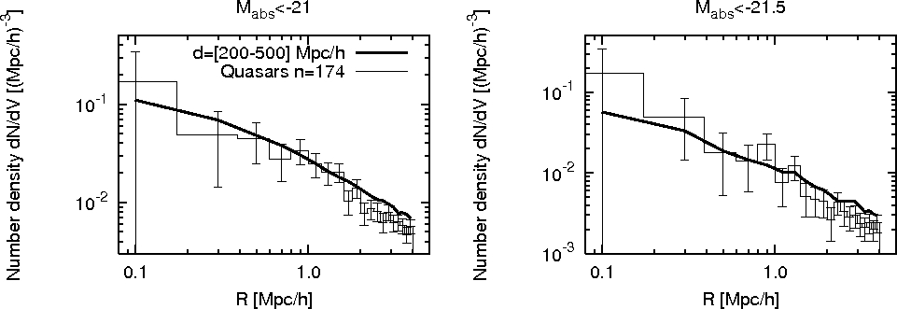

Fig. 1 The spatial density of galaxies at radii r< 4 Mpc/h (in 0.2 Mpc/h bins) around quasars and galaxies for two different galaxy luminosity limits.

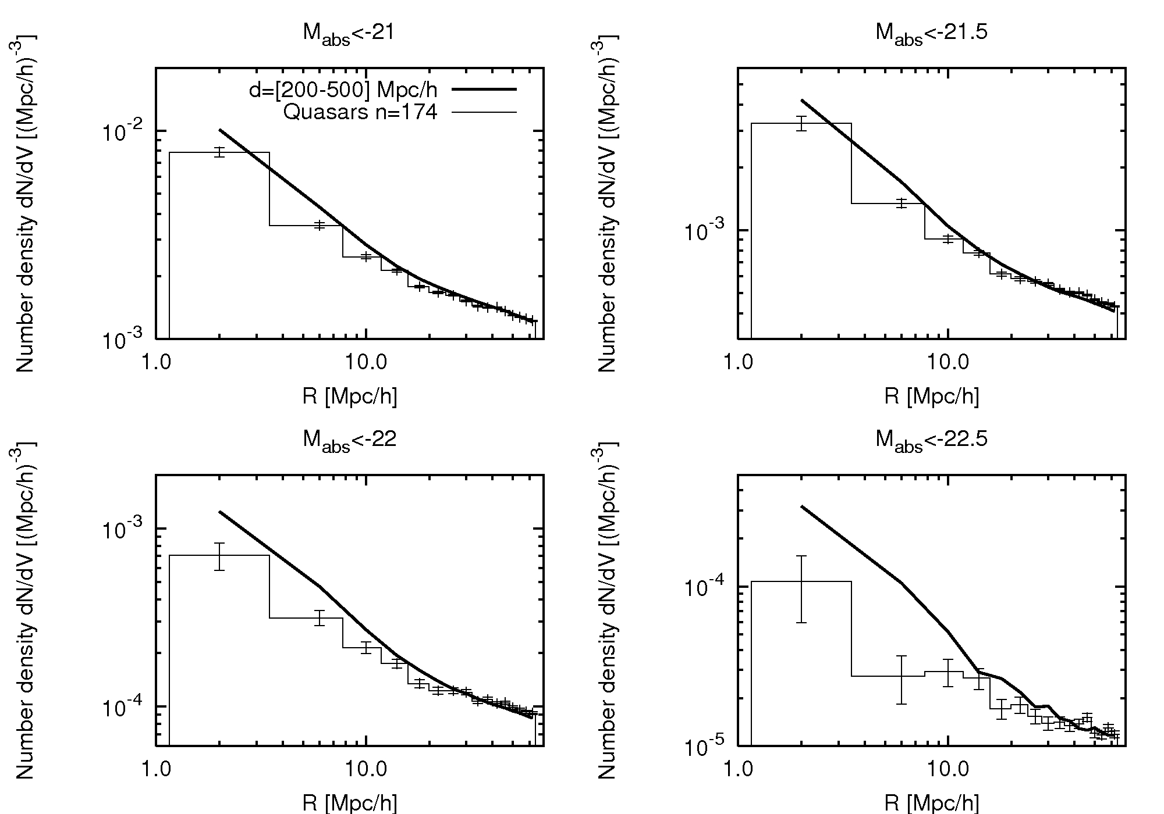

Fig. 2 The spatial density of galaxies at radii r < 60 (in 4 Mpc/h bins) around quasars (histogram) and galaxies (solid line) for four different galaxy luminosity limits.

In Fig. 2 we show the spatial density of galaxies around quasars in large-scale environments from 1.5 Mpc up to 60 Mpc. For galaxies four different volume limited samples are used. The Figure shows that quasars (histograms) are located in less dense regions than galaxies (the solid line) on average. When the galaxy luminosity limit increases from M_{gal}<-21 to M_{gal}<-22.5, the quasars environments become less dense of galaxies, until the mean density of the sample is reached.
Figures 1 and 2 show that the density enhancement of galaxies around quasars is a function of galaxy luminosity and scale. At small scales, r<1.5 Mpc, about a galaxy cluster size, no significant environmental effect, nor overdensity or underdensity around quasars was found. At larger scales, r>1.5 Mpc, quasars clearly avoid galaxies, especially brighter ones. The 'galaxy zone of avoidance' around quasars extends up to 10 -- 20 Mpc. We shall study these scales below with another method.

3. Luminosity density

In this section we briefly describe the density field method, as applied to the current topic. The luminosity density field has been extensively applied for large-scale structure studies for the Las Campanas redshift survey, the Two-degree Field survey and the SDSS [11][12] [13]. Analysis of these surveys has shown that morphological properties of galaxies depend on their large-scale cosmological environment. The properties of galaxies in rich and poor superclusters and in the field are different. The local (at group and cluster scales) environment and the global (supercluster) environment both influence galaxy morphologies and their star formation activity [14]. Galaxy clusters in a high-density environment are about 5 times more luminous than in a low-density environment [15]. Studies of the properties of dark matter halos in environments of different densities agree with observational findings of environmental effects for groups and clusters of galaxies [16]. The density field method allows us to study nearby quasars around different kinds of structures: filaments, sheets, voids, clusters and superclusters. Each of such structures has a characteristic density level within the overall large-scale structure that helps us to distinguish them from each other; it is difficult to do using any other method.
In this procedure we use all SDSS DR5 survey galaxies from the Tago catalogue of groups and isolated galaxies [8]. We assume that every galaxy is a visible member of a density enhancement (group or cluster).
We also position group and cluster galaxies at the mean group-cluster distance, to correct for the effect of the dynamical velocities. We correct the galaxy luminosities for the observational magnitude limited samples by a weighting factor that accounts for the group galaxies outside the visibility window [11]: L_{tot}=L_{obs}W_{L}, where L_{obs} is the luminosity of an observed galaxy and W_{L} is the ratio of the expected total luminosity to the expected luminosity in the visibility window L∈[L₁, L₂].
Next a Cartesian grid is defined in the survey volume and the luminosity density field on the grid is calculated (using the B3-spline kernel function). This gives us the total luminosity density field of the survey where different density levels represent different characteristic structures. It is interesting to see how quasars are located relative to these structures. The total luminosity in some subvolume can be calculated summing over all the grid vertices it contains (the luminosity units are 1.0*10¹⁰/(D³) [L_{sun} / (Mpc/h)³], where D is the grid cell size in Mpc/h). Using an appropriate mass-to-luminosity ratio one can translate luminosities to masses. For the present illustration we chose the cell size of 2 Mpc/h for the Cartesian grid. The radius of the B3 smoothing kernel was 16 Mpc/h. This means that the effective smoothing radius (the kernel radius for which the density value differs considerably from zero) is 8 Mpc/h. The smoothing length determines the characteristic scale of the objects under study. For example, the 1 Mpc/h smoothing scale is comparable to the characteristic scale of clusters and groups of galaxies, while the kernel size used here characterizes supercluster scales [11].
Figs. 3, 4, and 5 show the projected luminosity density field of the SDDS DR5 (northern region), divided into three different density threshold levels 3.6, 5.1 and 6.6 times the mean density. The highest threshold density reveals the most luminous centers of the superclusters (Fig.3). While the density threshold level decreases in the outer regions of superclusters, filaments and sheets and other low-density regions are seen (Figs. 4 and 5). The dots in figures represent quasars. As we see, quasars seem to avoid superclusters. Superclusters are galaxy systems that occupy regions in the density field above the threshold density 4.6 (in units of mean density) [13]. The mean density value around quasars in the SDSS-DR5 sample is about 2 times mean luminosity density. This suggests that quasars are located in low-density areas and not in cores of superclusters. We are preparing a quantitative analysis of this topic.
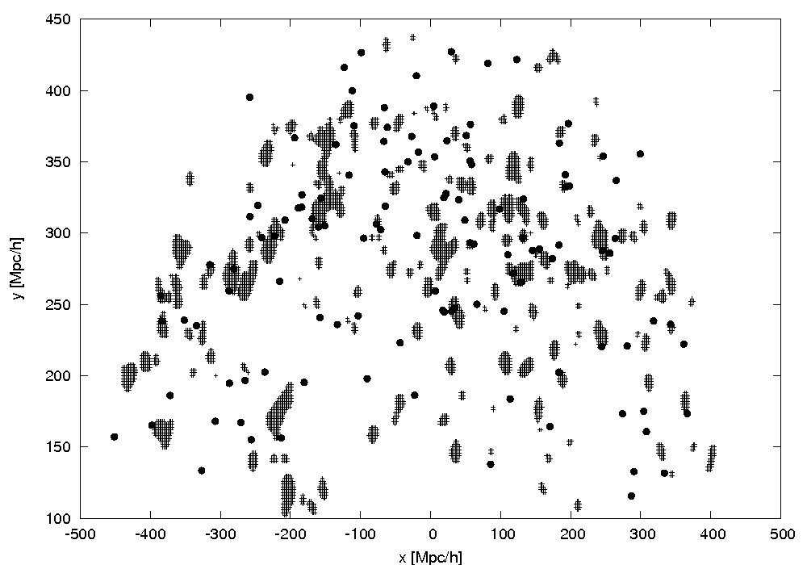Fig.3

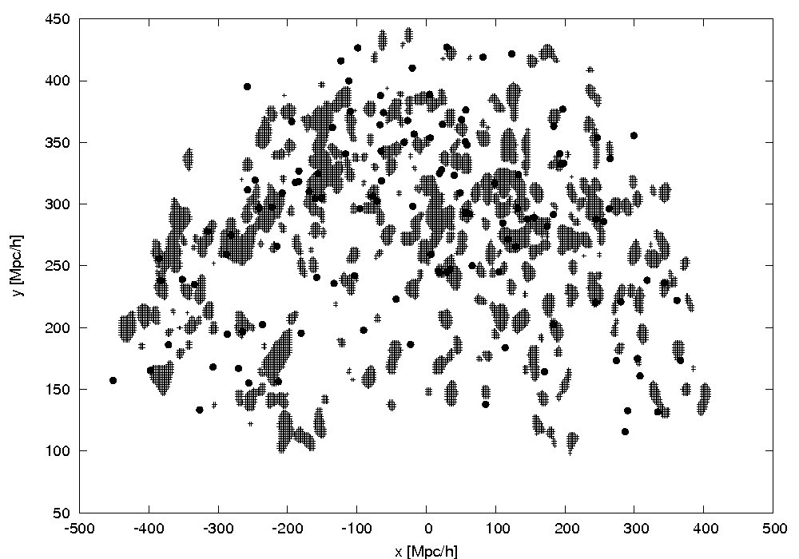
Fig.4

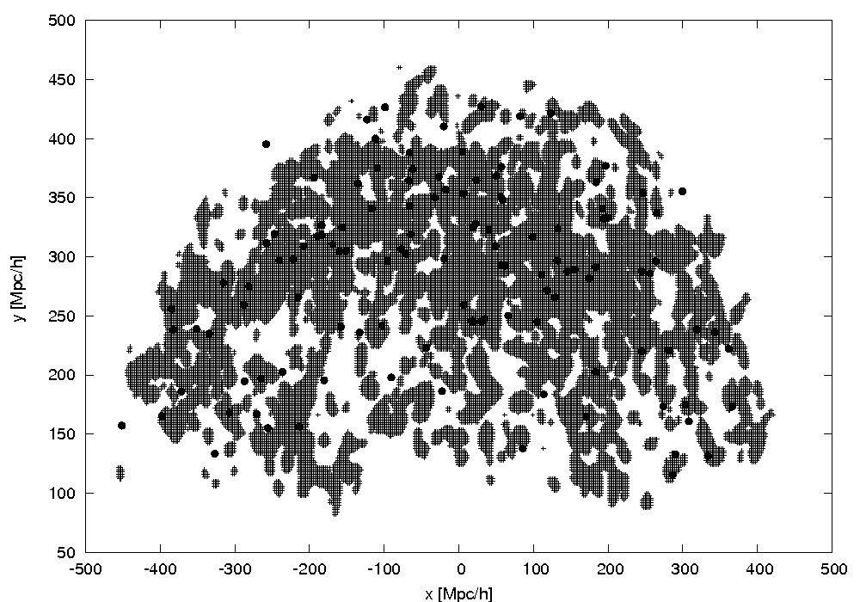
Fig.5
4. Conclusions

We report our preliminary results on the spatial distribution of nearby quasars in the SDSS DR5 galaxy redshift survey. Although the SDSS DR5 galaxy redshift survey hardly reaches the distances of typical quasars, it allows for the first time to study quasars and galaxies together.
We used two different methods to study quasar environs: finding the spatial density of galaxies in volume limited samples around quasars for different scales, and checking how quasars are located within the global density field.
Our results suggest that at small scales, about galaxy cluster sizes, there seems to be no detectable density effect around quasars. At larger scales, r> 1.5 Mpc/h, quasars clearly avoid bright galaxies, if compared to environments of galaxies of the same luminosity. This tendency increases with galaxy luminosity.
This can be interpreted so that quasars avoid regions where luminous galaxies are situated - high-density regions.
Our preliminary study of the luminosity density field also suggests that quasars avoid dense environments of the large-scale density field (superclusters). As we see, quasars seem to avoid superclusters. This is in accordance with our results in sect.2 where we showed that the space density of QSOs is a function of the luminosity of galaxies – most luminous galaxies are located in core regions of rich superclusters [14].
There are several studies that show that galaxy formation must be suppressed in underdense regions in the universe [17]. Presumably, the accretion process for the SMBH in a galaxy center also differs among distinct environs [4]. If nearby quasars are really located in low density environs, the triggering mechanism may have been suppressed until recently. Since then it may have been finally activated long time after the main quasar population has shut down.

References

1. Garcet O., Gandhi P., Gosset E. et al., A&A, 474, 473, (2007)
2. Serber W., Bahcall N., Menard B., Richards G., ApJ, 643, 68, (2006)
3. Miller C. J., Nichol R. C., Comez P. L. et al., ApJ, 597, 142, (2003)
4. Constantin A., Hoyle F., Vogeley M., ApJ, 673, 715, (2008)
5. Kauffmann G., White S.D.M., Heckman T., M. et al., MNRAS, 353, 713, (2004)
6. Dressler, A., ApJ, 236, 351, (1980)
7. Adelman-McCarthy J. K. et al., (The SDSS Collaboration, DR5), ApJS, 172, 634, (2007)
8. Tago E., Einasto J., Saar E. et al., A&A, 479, 927, (2008)
9. Schneider, D., Hall P., Richards G. et al. AJ, 134, 102, (2007)
10. Hopkins P. F., Hernquist P. M., Martini P., Cox T. J., ApJ, 625, L71, (2005)
11. Einasto J., Hutsi G., Einasto M. et al., A&A, 405, 425, (2003)
12. Einasto J., Einasto M., Hutsi G. et al. A&A, 410, 425, (2003)
13. Einasto J., Einasto, M., Tago E. et al. A&A, 462, 811, (2007)
14. Einasto M., Einasto J., Tago E. et al. A&A, 464, 815, (2007)
15. Einasto J., Tago, E., Einasto M. et al. A&A, 439, 45, (2005)
16. Einasto M., Suhhonenko, I., Heinämäki, P. et al., A&A, 436, 17, (2005)
17. Benda-Beckmann A., Muller V. MNRAS, 348, 1189, (2008)

