Velocity Field in the Local Volume

© D.I. Makarov 1,2,3

1 Special Astrophysical Observatory of RAS, Nizhnij Arkhyz, Russia
2 invited researcher, Observatoire de Lyon, Lyon, France
3 Email: dim@sao.ru

Abstract: The Local Volume (10 Mpc) is deep inside the cosmic cell of matter uniformity, the galaxies in the local region are highly clumped. However, the Hubble flow starts just outside the bound of Local Group ~1 Mpc and their random motions are surprisingly small. The masses of the Local Group, M81, Cen A was estimated by its influence on expansion of Local Volume. This method estimates the mass of group on scale about 1 Mpc and is independent from estimations by virial theorem. The residual flows shows strong anisotropy which is connected to the Local Supercluster plane, but main direction significantly differs from direction to the center of the Virgo cluster. The velocity dispersion of field galaxies is less than 43 km s⁻¹.

1. Introduction.

The “Local Volume” is our very tight extragalactic neighborhood out to ~10 Mpc and includes galaxies with velocities ≤550 km s⁻¹. This distance limited sample of galaxies gathers about 550 object [1,2]. Most of them (about 85%) are dwarf galaxies with M_{B}>-17. The distribution of galaxies in Local Volume is far away from homogeneity. The galaxies concentrate to the Supergalactic plane and form the groups and filaments which are easy to see on Figures 1 and 2. In our neighborhood there are three most prominent groups of galaxies. It is Local Group, Cen A and M81 groups. Despite of the fact that the galaxies in Local Universe are highly clumped as was stressed in many publications [3,4,5] the Hubble flow starts just outside the bound of the Local Group (~1 Mpc) and their random motions are surprisingly small.
Before 2000 year, the precise Cepheid distances were known only for members of Local Group and for small sample of giant galaxies. Most of Local Volume galaxies had rough distance estimates from luminosity of brightest stars, the Tully-Fisher relation, or their membership in the known nearby groups. Enormous progress in accurate distance measurements for nearby galaxies has been attained based on the luminosity of the tip of red giant branch (TRGB). This method [6] has a precision comparable to the Cepheid method [7,8] but requeres much less observing time. The high angular resolution of Hubble Space Telescope is a critical for this purpose. The 95% of the TRGB distances have been obtained with HST during last 5 years [9].
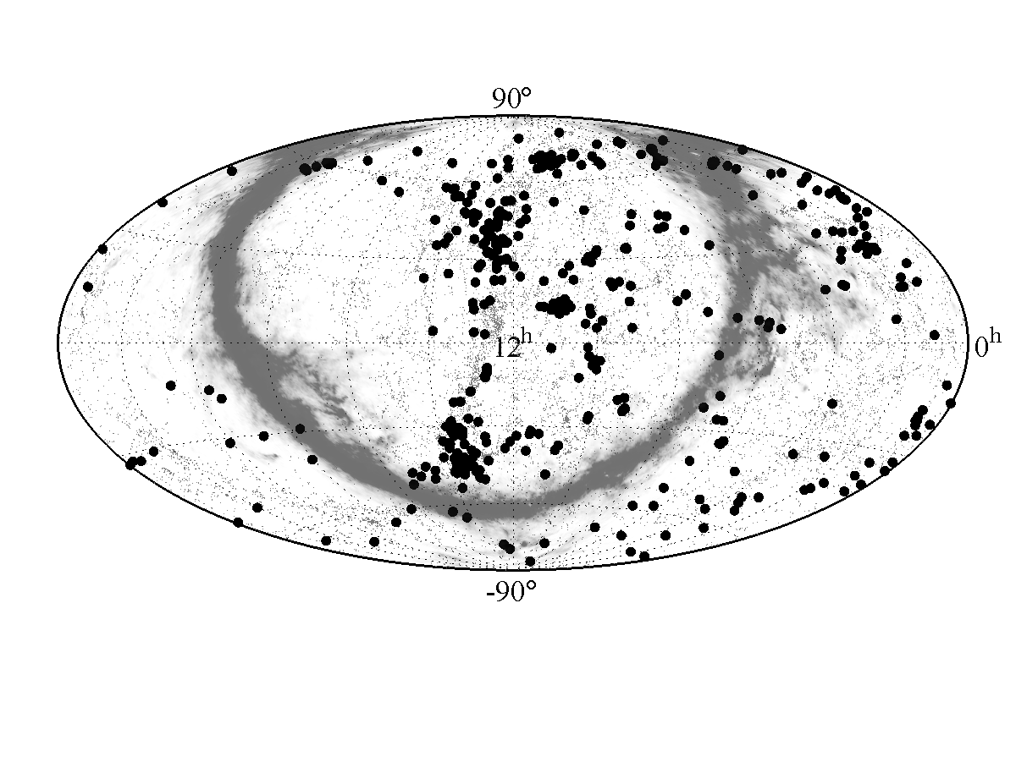Figure 1: All sky map of the nearby galaxies. The galaxies within 10 Mpc are shown by black filled circles. The small gray dots show distribution of galaxies in the Local Supercluster. The gray area shows the Zone of Avoidance.
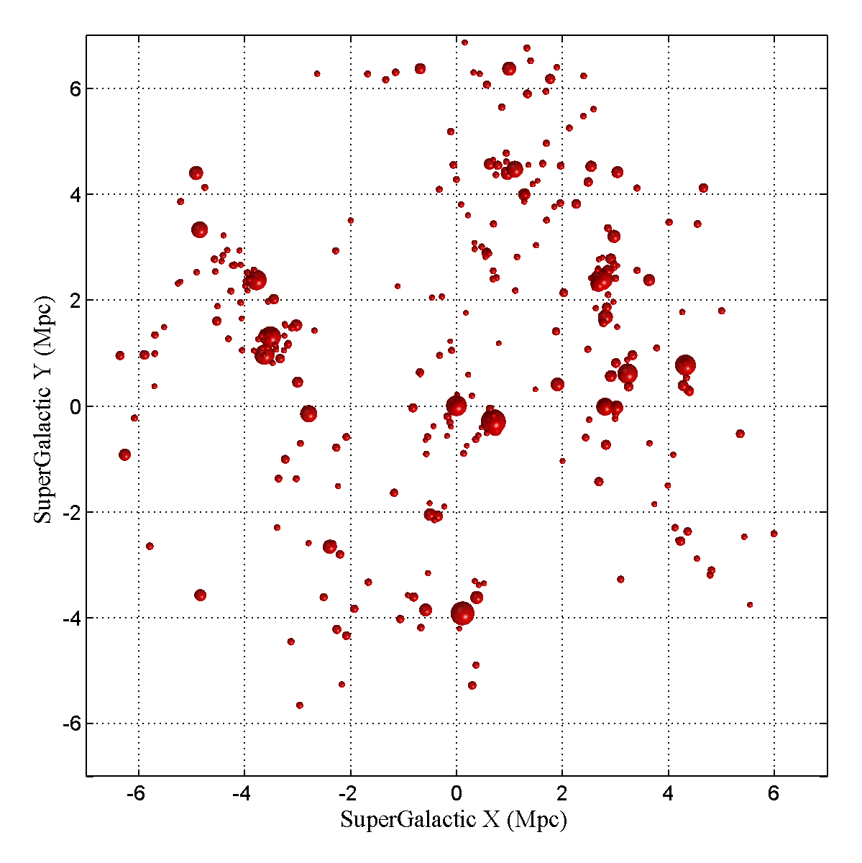 | 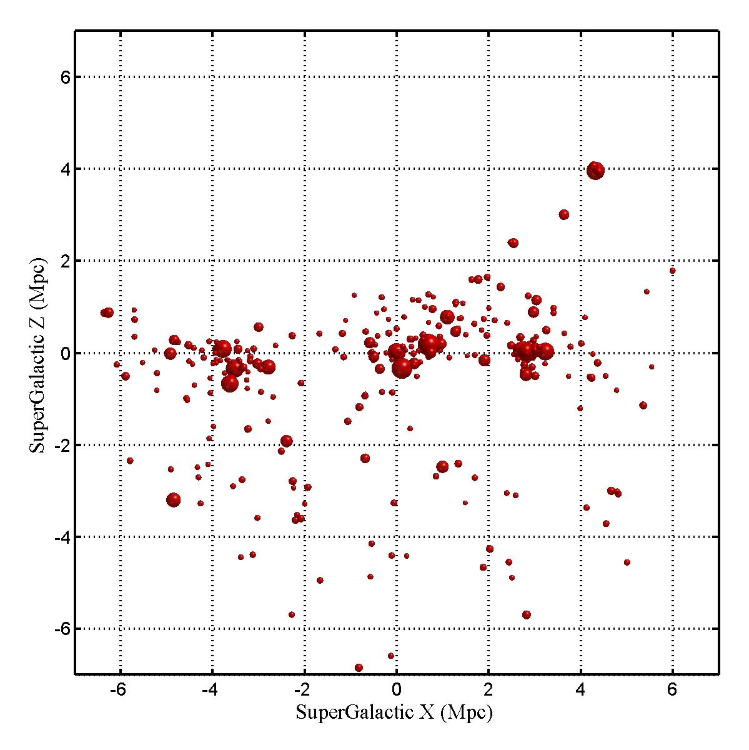
Figure 2: Distribution of the Local Volume galaxies in «face-on» (left) and «edge-on» (right) projections of the supergalactic plane.

2. Velocity field

The pure observational radial velocity – distance relation for nearby galaxies with accurate distances is shown in Figure 3. The big scatter of galaxies within 1 Mpc corresponds to virial motions of satellites of Milky Way and Andromeda galaxy. The members of Cen A and M 81 groups are shown with open circles and open squares respectively. Accidentally, the average distance to these groups are very similar (3.8 and 3.7 Mpc, respectively). The largest deviations from the Hubble regression are seen to be related to the virial motions of galaxies in these groups. The radial velocity dispersion of M 81 group is 91 km s⁻¹, for Cen A group this value equal 105 km s⁻¹ [10]. One can see the “s-wave” feature at distance of these two dominant groups: nearer galaxies have positive peculiar velocity while more distant objects have negative one. This pattern is the signature of infall toward massive attractors. This picture shows that expansion of the field galaxies is quite cold and an increase of dispersion on large distances can be explained by an rise of errors with distance.
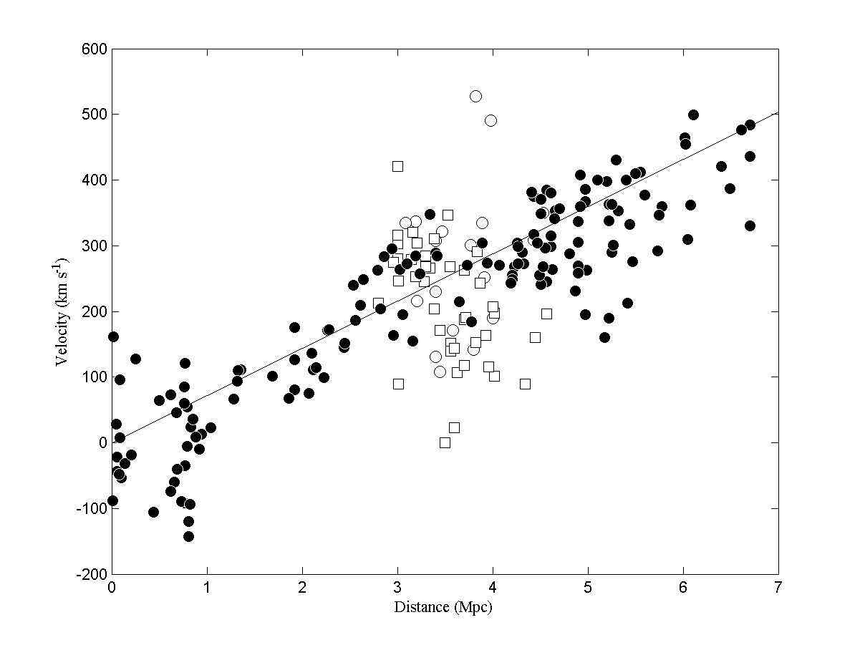Figure 3: Hubble diagram for nearby galaxies. The members of Cen A group are marked by open circles. The M 81 group are shown by open squares. The line corresponds to H=72 kn s⁻¹ Mpc⁻¹.
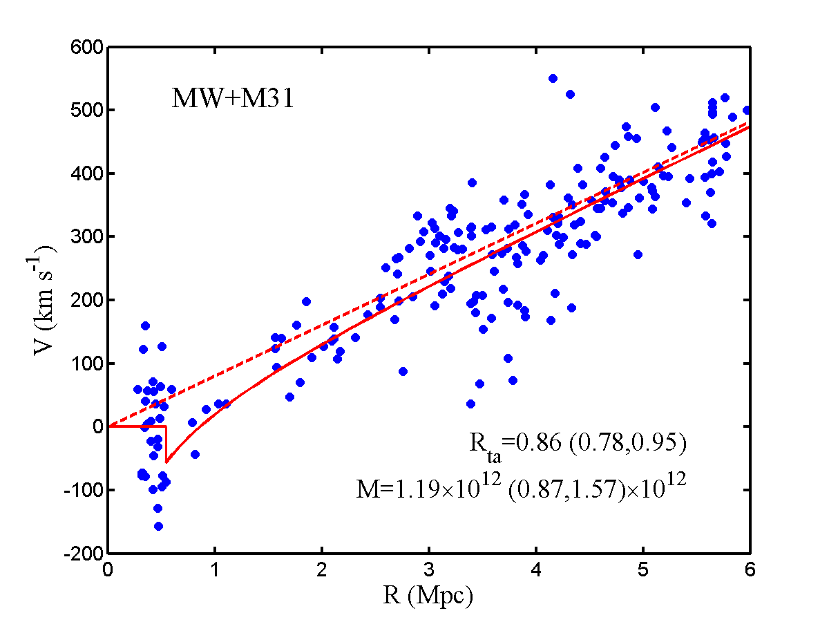 | 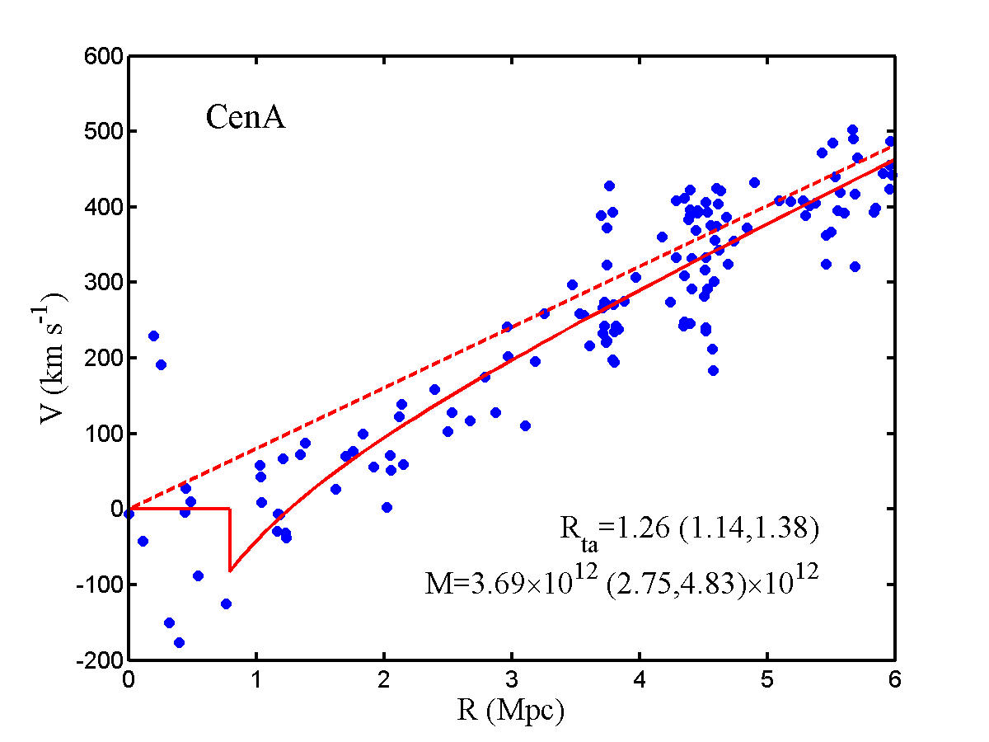 | 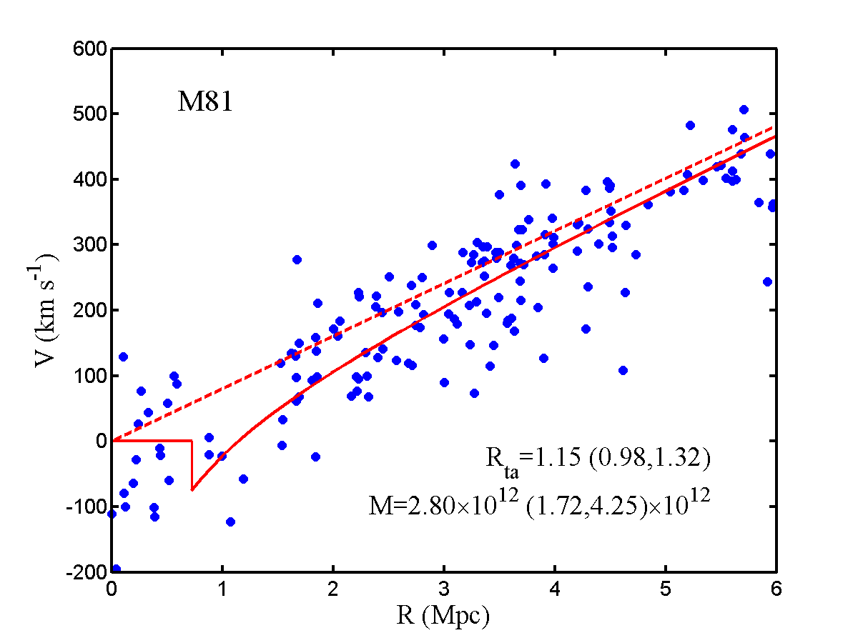
Figure 4: Hubble diagrams for dominant groups in the Local Volume.

The deviations from the pure Hubble expansion can be expected due to gravitational action of nearby groups, as well as by Virgocentric and Great Attractor flows. We used simple spherically symmetric model to estimate influence of nearby groups on kinematic of the Local Volume. This method allows us to measure the masses by deviation of velocities from uniform Hubble flow on scale about 1 Mpc. This method is independent from mass estimations based on virial theorem.
A sample of 229 galaxies with photometric distances less then 7 Mpc have been considered. In our model we tried to find simultaneously the position of the center mass of the Local Group, turn-around radii for five nearby groups, as well as Hubble constant. Derived zero velocity radii are 0.86 Mpc (Local Group), 1.26 Mpc (Cen A), 0.65 Mpc (M 83), 1.15 Mpc (M 81) and 0.78 Mpc (IC 342) wich correspond to masses 1.2×10¹², 3.7×10¹², 5.1×10¹¹, 2.8×10¹² and 8.7×10¹¹ sollar mass respectively. The figure 4 show the Hubble diagrams for dominant groups plotted from its centers. It is clearly seen that simple spherically-symmetric model describes the velocity field in the vicinity of massive groups quite well.
The large scale deviation of the expansion of the Local Volume are shown in the figure 5. It is a smoothed map of the Hubble “constant” versus of direction on the sky in the supergalactic coordinates. The influence of nearby groups on the motion of the galaxies is taken into account. The black bullets show the galaxies with positive peculiar velocity and open circles represent object with negative velocity. The Milky Way plane is shown by grey region. Small dots correspond to the distribution of the galaxies on the scale about 40 Mpc. The huge concentration of points near supergalactic plane with longitude about 103° is the Virgo cluster, the center of the Local Supercluster. The large scale deviation from the uniform Hubble flow is caused by tidal disturbance by the mass distributed outside the bounds of the Local Volume including the Virgo cluster and the Great Attractor. The lack of galaxies on high supergalactic latitudes makes it impossi
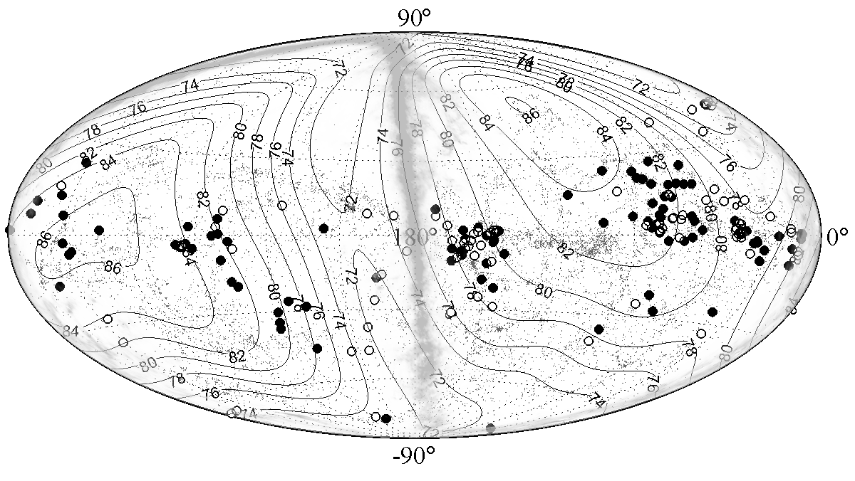Figure 5: All sky map of the Hubble parameter. The bullets show a retreating galaxies and open circles show a retardation objects.

ble to estimate the peculiar motion near the north supergalactic pole, but the velocity field is good constrained in the plane of Local Supercluster. The residual peculiar velocity field has been estimated using the tensor of the local Hubble constant with principal values 72:76:92 km s⁻¹. The major axis is roughly aligned in direction Virgo-antiVirgo, but slightly inclined to the plane of the Local Supercluster.

3. Conclusion

Despite of the high inhomogeneity of galaxy distribution in the Local Volume the Hubble flow is quite cold with line of sight velocity dispersion for field galaxies σ_{field} = 43 km s⁻¹. The expansion of galaxies near massive groups shows clear signature of retardation of galaxies in the gravitational well of these groups. These effect gives us opportunity to estimate the masses on scale about 1 Mpc. The residual peculiar velocity field can be fitted by the tensor of local Hubble “constant” which represents the influence of surrounding mass on velocity field in the Local Volume.

This work was partially supported by RRBR grant 07-02-00005, 07-02-00792, 08-02-00627.

References

- Karachentsev I.D., Karachentseva V., Hutchmeier W. et al. Mining the Local Volume // arXiv:0710.0520 [astro-ph]
- Karachentsev I.D., Karachentseva V.E., Hutchmeier W.K., Makarov D.I. A Catalog of Neighboring Galaxies // AJ. 127, 2031 (2004)
- Karachentsev I.D., Makarov D.I The Galaxy motion relative to nearby galaxies and the local velocity field // AJ. 111, 794 (1996)
- Karachentsev I.D., Sharina M.E., Makarov D.I. et al. The very local Hubble flow // A&A. 389, 812 (2002)
- Karachentsev I.D., Makarov D.I., Sharina M.E. et al. Local galaxy flows within 5 Mpc // A&A. 398, 479 (2003)
- Lee M.G., Freedman W.L., Madore D.F. Stellar populations in the dwarf elliptical galaxy NGC 185 // AJ. 106, 964 (1993)
- Makarov D., Makarova L., Rizzi L. et al. Tip of the Red Giant Branch Distances I. // AJ. 132, 2729 (2006)
- Rizzi L, Tully R.B., Makarov D. et al. Tip of the Red Giant Branch Distances I. // ApJ. 661, 815 (2007)
- Karachentsev I.D., Dolphin A., Tully R.B. et al. Advanced Camera for Surveys Imaging of 25 Galaxies in Nearby Groups and in the Field // AJ. 131, 1361 (2006)
- Karachentsev I.D. The Local Group and Other Neighboring Galaxy Groups // AJ. 129, 178 (2005)

